***REPORT***

***ON***

***RURAL AGRICULTURAL WORKS EXPERIENCE(RAWE)-2019***

**FACULTY OF AGRICULTURE**

**UTTAR BANGA KRISHI VISWAVIDYALAYA**

**PUNDIBARI, COOCHBEHAR,**

**WB- 736165**

*Dedicated*

*to*

*all the 'Peasants'*

*of*

***D.K.KUTHI,***

***Pundibari,CoB***

***2019***

|  |
| --- |
| **UTTAR BANGA KRISHI VISWAVIDYALAY**  **FACULTY OF AGRICULTURE**  **PUNDIBARI, COOCHBEHAR (WB)**  **---------------------------------------------------------------------------------------------------**  ***CERTIFICATE***  *This is to certify that the work and experience recorded in the report entitled, “Rural Agricultural Work Experience (RAWE)-2019” under Student-READY programme-2019 performed at the village D.K.Kuthi, Pundibari, Coochbehar-ll , submitted by the students to 8th Term B.Sc.(Ag.)Hons.-2019 of Uttar Banga Krishi Viswavidyalaya as a part of RAWE Programme is a bonafide work carried out under your supervisions and guidance. To the best of our knowledge, information presented in the report is authentic which were compiled from the collected primary data obtained through field works/survey. Any chapter or portion of this report has not been published or sent for publication elsewhere.*  *Assistance and services received during this job from different persons and organizations have been duly acknowledged.*  *We hope a bright future of our students.*  **Dr. Kausik Pradhan**  **Central Level Coordinator (RAWE)**  **Associate Professor, Department of Agricultural Extension**    **Dr.Gobinda Mula**  **Local Level Coordinator (RAWE)**  **Assistant Professor, Department of Agricultural Economics** |

**ACKNOWLEDGEMENT**

***We express our heartiest gratitude to our honourable Vice Chancellor, Dr. Chirantan Chattopadhyay for taking interest and all necessary arrangements including our stipend in this RAWE pro****g****ramme. We are extremely grateful to our Dean, Faculty of Agriculture Prof. (Dr.) Tapan Kumar Hath, who acted like an academic gurdian and also kept constant touch with us throughout the tenure and endeavoured to make this course successful.***

***We are very much indebted to have Dr. Kausik Pradhan as our RAWE Central Level Co-ordinator who organized this course, guided us, motivated us, encouraged us and ensured our academic benefits out of it. We would like to pay our sincere gratitude to Dr. Gobinda Mula as our Local Level Co-ordinator who had always played a benevolent role in materializing the entire programme . We are also thankful to all the Professors and Heads of all the Departments who actively participated in our orientation programme and supervised us in performing Participatory Rural Appraisal (PRA) and Field and also shared their experiences for our benefits. They have also guided us how to prepare the report for evaluation.***

***We extend our special thank to all the members of KrishiRatna Farmers Club, who have assisted us in manifold activities to effectuate the village attachment programme and acted as our local guardian. We are indebted to all the farmers of D.K.Kuthi village who participated and supported our work experience programme without whom this programme could not be organized successfully. We will be highly grateful to all the Local Level Co-ordinators for their continuous effort in correcting and midifying the manuscript to make this report final.***

***Lastly but not the least, we will remain thankful to office staff of Dean (F/Ag.) and those all who directly or indirectly helped and co-operated us in accomplishing this academic exercise successfully.***

**CONTENT**

|  |  |  |  |
| --- | --- | --- | --- |
| **Sl. No.** | **Subject** | **Page No.** | |
|  |  |  |  |
|  |  | **From** | **To** |
| 1 | **Introduction** |  |  |
| 2 | 1. **Rural Agricultural Works Experience (RAWE)** |  |  |
|  | **Concepts** |  |  |
| **Basic information of the study area (Village)** |  |  |
| **A. Space Analysis** |  |  |
| a. Transect Work |  |  |
| b. Social Map |  |  |
| c . Natural Resource Map |  |  |
| d. Hydrological Map |  |  |
| **B. Time Analysis** |  |  |
| **a.** Time line |  |  |
| b. Time Trend Analysis on Fertilizer Requirement Per Unit Area |  |  |
| c. 1. Seasonality Diagram of Agricultural Crops |  |  |
| c. 2. Seasonality Diagram of Horticultural Crops |  |  |
| d. 1. Daily Work Schedule of Men in Village |  |  |
| d. 2. Daily Work Schedule of Village women |  |  |
| **C.FLOW ANALYSIS** |  |  |
| a. Venn Diagram |  |  |
| b. Mobility Map |  |  |
| c.1. Flow Chart Diagram of Agricultural Crops |  |  |
| c.2. Flow Chart Diagram of Horticultural Crops |  |  |
| d.1. Cause Effect Analysis of Late Blight Of Potato |  |  |
| d.2. Cause Effect Analysis of Brinjal Fruit and Shoot Borer |  |  |
| **D. Decision Analysis** |  |  |
| a. Matrix Ranking on Preference of Rice Variety |  |  |
| b. Matrix Ranking on Crop Preference of the Villagers |  |  |
| c. Matrix Ranking on Agricultural Problem Prioritization |  |  |
| 1. **DEPARTMENT WISE FIELD STUDY ANALYSIS (Field Study)** |  |  |
| • Department of Extension |  |  |
| • Department of Statistics |  |  |
| • Department of Agronomy |  |  |
| • Department of Pomology and Post Harvest Technology |  |  |
| • Department of Soil Science |  |  |
| • Department of Plant Pathology |  |  |
| • Department of Genetics and Plant Breeding and Seed Technology |  |  |
| • Department Of Entomology |  |  |
| • Department ofAgricultural Economics |  |  |
| • Department of Animal Science and Fishery |  |  |
|  | * Department of Biochemistry |  |  |
| **3** | **Scope for Entrepreneurship Development** |  |  |
| **4** | **Summary, Conclusion & Recommendations** |  |  |

**1. INTRODUCTION**

**Student READY (Rural Entrepreneurship Awareness Development Yojana) Programme**

Modern agriculture has transformed itself from “way of life” to “agri-business” which leads to development of “Entrepreneurship” in a most feasible manner. Thus, the student **READY** Programme was initiated by the Hon’ble Prime Minister of India on 25th July, 2015. The term **READY** refers to “Rural and Entrepreneurship Awareness Development Yojana” and the programme was conceptualized to reorient graduates of Agriculture and allied subjects for ensuring and assuring employability and develop entrepreneurs for emerging knowledge intensive agriculture. It also envisages the introduction of the programme in all the Agricultural Universities as an essential prerequisite for the award of degree to ensure hands on experience and practical training. This programme includes five components i.e. Experiential Learning, Rural Awareness Works Experience, In-Plant Training / Industrial attachment, Hands-on training (HOT) / Skill development training and Students Projects. All these components are interactive and are conceptualized for building skills in project development and execution, decision-making, individual and team coordination, approach to problem solving, accounting, quality control, marketing and resolving conflicts, etc. with end to end approach.

**Components Covered**

* Rural Agricultural Work Experience
* In-Plant Training / Agro Industrial attachment
* Experiential Learning/Hands-on-Training

**Component I: Rural Agricultural Work Experience**

The Rural Agricultural Work Experience (RAWE) helps the students primarily to understand the rural situations, status of agricultural technologies adopted by farmers, prioritize the farmers’ problems and to develop skills and attitude of working with farm families for overall development in rural areas. The students may be placed in the villages adjacent to the University establishments like College, Krishi Vigyan Kendra, Regional Research Station, Regional Research Sub-Station etc. under its jurisdiction.

**Component-II: In-Plant Training / Agro Industrial Attachment (AIA)**

Technology and globalization are ushering an era of unprecedented change. The need and pressure for change and innovation is immense. To enrich the practical knowledge of the students, in-plant training shall be mandatory for a period of up to 3 weeks. In this training, students will have to study a problem in industrial perspective and submit the report. Such in-plant training will provide an industrial exposure to the students as well as to develop their career in the high tech industrial requirements. The students may be placed in Agro-and Cottage industries include Seed / Sapling production, Pesticides-insecticides, Post-harvest-processing-value addition, Agri-finance institutions, etc. and Commodities Boards for 3 weeks.

**Component-III : Experiential Learning Programme (ELP)/ Hands on Training (HOT)**

Experiential Learning (EL) helps the student to develop competence, capability, capacity building, acquiring skills, expertise, and confidence to start their own enterprise and turn job creators instead of job seekers. This is a step forward for “**Earn while Learn**” concept. Experiential Learning is an important module for high quality professional competence and practical work experience in real life situation to Graduates. The module with entrepreneurial orientation of production and production to consumption pattern is expected to facilitate producing **Job Providers** rather than **Job Seekers**.

It may be mentioned here that present report has been prepared for Component-I (RAWE). The reports on Component-II and Component-III will be submitted separately.

Of late, use of technologies plays an important role while producing different brands and qualities of agricultural products to fulfil the requirements of the market. Though agriculture is the backbone of Indian economy, still it remains a risky business and complex in nature and, thus, it demands much more attentions. It is seen that due to immense application of improved agricultural technologies, India has experienced a golden era of agricultural development through Green Revolution. But it is also the fact that the technological gap was present between the present practices of farmer and the recommended practices, generated from different research institutions. It is the evident that only 19 per cent of technologies of Green Revolution have been adopted at the farm level. So, it is always durable that detail study on existing resources, technologies, production, market and interests of all stakeholders is relevant to have an idea on the existing practices and futures scopes of further development. As such, new innovations are expected to appear to apply in agricultural business in future. This concept has been incorporated in the agricultural education system in India.

In India, agricultural education system aims at producing skilled and expert human resources. Thus, it is made an essential requirement that before obtaining the under-graduate degree in agriculture, the students will be exposed to the field situations to learn the farming communities and compare their class room learning in field situations. Based on the study, students are required to use their innovative idea and propose alternative development strategy on different aspects of agriculture including entrepreneurship development.

In view of above, Uttar Banga Krishi Viswavidyalaya has arranged this RAWE programme. It is, thus, expected that with the existing teaching, research and extension climate, the present report will try to explain the different aspects of analytical study and findings obtained Rural Agricultural Work Experience (RAWE) which is based on the participatory methodology and has been a meeting place of theory and practical studies. This programme is performed by the under-graduate students for partial fulfilment of degree to B.Sc.(Ag.)Hons.-2018.

**SPECIFIC OBJECTIVES**

The following specific objectives were delineated for the present Rural Agricultural Work Experiences (RAWE):

* To provide an opportunity to the B.Sc.(Ag.)Hons. students for reorienting their subject matters knowledge through work experiences in local situation.
* To know socio-economic status of the rural people in the particular area.
* To enumerate the local livelihood status of the people by the students for getting information regarding people's farm experiences.
* To emphasize the communication linkage between the organization, agricultural university and local people.
* To develop confidence and competency of the students and local people for solving the problems related to farm enterprises with the help of local resources.

**LIMITATIONS of the study**

* Inadequate time limit.
* Small size of target respondents.
* Homogeneity of target people or farm entrepreneurs.
* Very little fund allotment of the course.
* Information of crops only from a single season
* **RURAL AGRICULTURAL WORKS EXPERIENCE (RAWE)**

**CONCEPT**

Rural Agricultural work experience (RAWE) is a clear defined concept which is embedded with the concept of Participatory Rural Appraisal (PRA) as well as Participatory Learning and Action (PLA).The sharing of ideas and experiences had been incorporated in the concept of RAWE. The information generated from RAWE has been used by the rural people as well as by the erudite scientists of the research stations for solving the problem in different specific agro-climatic regions. The principle of seeking diversity in rural level utters the drivers information regarding different crop enterprises as well as human enterprises. The information regarding different arena had been collected through RAWE for utilizing it to solve the problems of local area after analyzing and blending with the scientific information. It supports a strong rationale for solving the local problems with the help of local resources.

RAWE also helps to gather information from the remotest areas which implies for offsetting the spatial biases. There are several concepts and methodology embedded in RAWE. Among them PRA and PLA are the two pillars. The work has been conducted with the help of PRA methodology. For this reason the information generated from farm work experience are very much valid as well as reliable in given context.

Due to cross checking and triangulation among the people, the information are very much sustainable in particular local situation. Not only that the learning of different technologies occur through sharing the experiences among the farmers as well as subject matter specialists.

The intrinsic essence of RAWE is that the experience learnt by the rural people within their local situation with the help of their own local knowledge, amalgamated with the recommended package of practices for solving their own problem by in-sighting their local resources available in their own situation.

***Orientation class***

**There was an orientation programme of about 2 days i.e. from 6th to 7th February,2019.The main aim of orientation was to aware the students about this work which is to be done in the village during village attachment programme. The programme was held with the presence of our *Dean sir, Dean(Post Graduate) sir, Associate Dean sir* any many more dignitaries of our university. The programme was conducted by all *Central and Local Level Coordinators*(our respected and dear teachers) of RAWE.**

**During this all the students were grouped imto 3 groups containing 18 to 23 number of members each and allotted with 3 no. of villages viz*. Dakshin Kalarayer Kuthi, Petvatta Chandan Chowra and Sajerpar Kathalbari.***

***Students of 8th Term, B.Sc.(Ag.)Hons.-2019 (Group-B)***

***List of the Students of Group-B***

1. ABHRADEEP SARKAR

2. AMRITA KUMAR SARKAR

3. SAMIUL ISLAM SHAIKH

4. ARINDAM SARKAR

5. BISWAJIT DUTTA

6. BRATATI KANJILAL

7. DEBANJAN DAS

8. MD. FIROZ MONDAL

9. SANDIP LOHARA

10. MITADRU CHANDA

11. KUMAR MRIMAY NARAYAN

12. NASRIN PERWEEN

13.PIYALI DAS

14. SK. RABIUL ALAM

15. ROUNAB SARKAR

16. SAHINA PERWEEN

17. SALMA SAHANI

18. SNEHASIS DEBSHARMA

19. SUMIT MAITY

20. TAKBIR ALI

21. SANDEEP ROY

22. SAMRAT PAUL

23. DIPANKAR ROY

**Some basic information about the village:**

* **Village- Dakshin Kalarayer Kuthi**
* **Panchayat-Pundibari Gram Panchayat.**
* **Block- Coochbehar-ll**
* **District- Coochbehar**
* **Position: Latitude: ${26}^{°}24^{'}16.3"N$**

**Longitude: ${89}^{°}22^{'}40.8"E$**

**The study area of D.K.Kuthi was selected for the following reasons –**

**●** The ample opportunity to found innovative farm entrepreneur.

●Farmers' indigenous technology.

● Scope for improving the local rural situation.

● Profuse natural resource.

● Diversified demographic features.

● Different types of farm entrepreneur.

● Greater scope to get information from agricultural university.

● Lastly, easy accessibility.

**DEMOGRAPHY:**

|  |  |  |
| --- | --- | --- |
| Sl no | Items | Total numbers |
| 1 | Total household | **645** |
| 2 | Total population | **2646** |
| 3 | Total male | **1347** |
| 4 | Total female | **1209** |
| 5 | SC | **539** |
| 6 | ST | **1** |
| 7 | Child population | **332** |

**Percentage of farmers**

|  |  |  |  |
| --- | --- | --- | --- |
| Sl No | Farmers | NoS | Percentage |
| 1 | Marginal | 1380 | 84% |
| 2 | Small | 230 | 14% |
| 3 | Medium | 25 | 1.7% |
| 4 | Large | 4 | 0.3% |

**I. DEPARTMENT OF AGRICULTURAL EXTENSION**

**1.1. Participatory Rural Appraisal (PRA)**

**Participatory methods and tools are mainly used for agro eco system analysis. PRA is one of that.**

**Participatory -Means that people are involved in the process - a “bottom-up” approach that requires good communication, skills and attitude of project staff.**

**Rural - The techniques can be used in any situation, urban or rural, with both literate and illiterate   
people.**

**Appraisal - The finding out of information about problems, needs, and potential in a village. It is the first stage in any project.**

**PRA is a methodology for interacting with villagers and seeking their participation in putting forward their point of views about problem analysing and equalizing the information to acquire learning. It takes into account the peoples indigenous knowledge.**

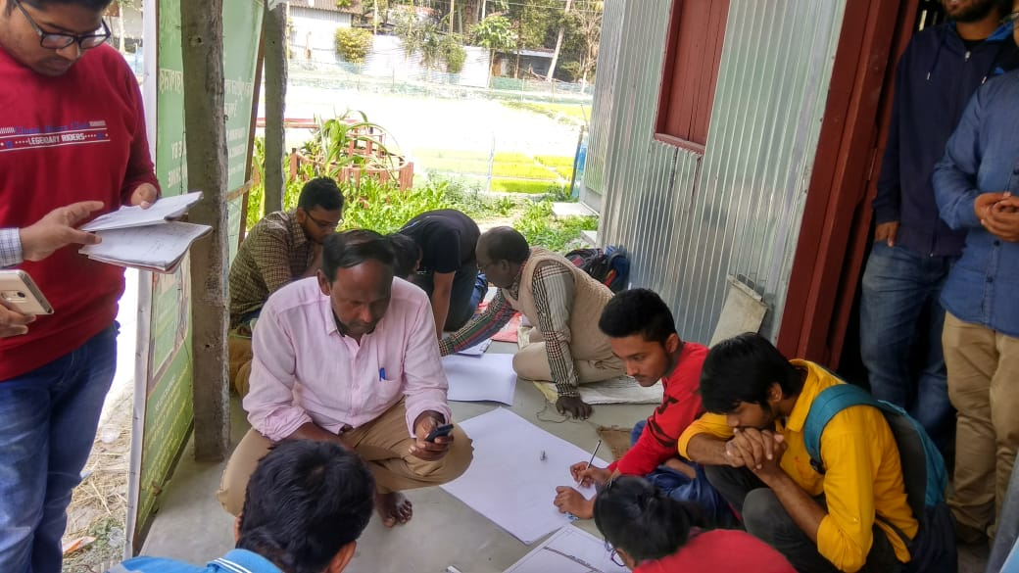

**1.1.1.Principles**

**● Respecting people’s knowledge and learning from them. ➢ Listening to the disadvantaged.**

**● Optimal ignorance: Do not collect data, which you do not need. ➢ Flexibility: PRA does not stick to fixed plan to action.**

1.1.2.Aims of PRA:

* To build up a permanent “people first” attitudes in the minds of the participants. To show   
   that “people are capable agents to change their own lives” but require limited outside   
   assistance.
* To establish a notion of “respect” to the people’s knowledge in the life of professionals and   
   their institutions.
* To provide simple analytical tools to analyze rural situations.
* To show some of the analytical tools to the community in the field setting and understand   
   their suitability to farmer situation.
* To enhance participant’s ability to plan with the community.

1.1.3. DATA COLLECTION METHODOLOGY:

Proceeding started with Ice-Breaking. An icebreaker is a [facilitation](https://en.wikipedia.org/wiki/Facilitation_(business)) exercise intended to help members of a group begin the process of [forming](https://en.wikipedia.org/wiki/Forming-storming-norming-performing) themselves into a [team](https://en.wikipedia.org/wiki/Team). Icebreakers are commonly presented as a game to "warm up" the group by helping the members to get to know each other. They often focus on sharing personal information.

The data were collected with the help of pre-tested interview schedule constructed by the teachers/scientists of the University for generating the data with regard to individual farm entrepreneur. In case of collecting group information through utilising or administering, following PRA tools have been exercised**.**

* 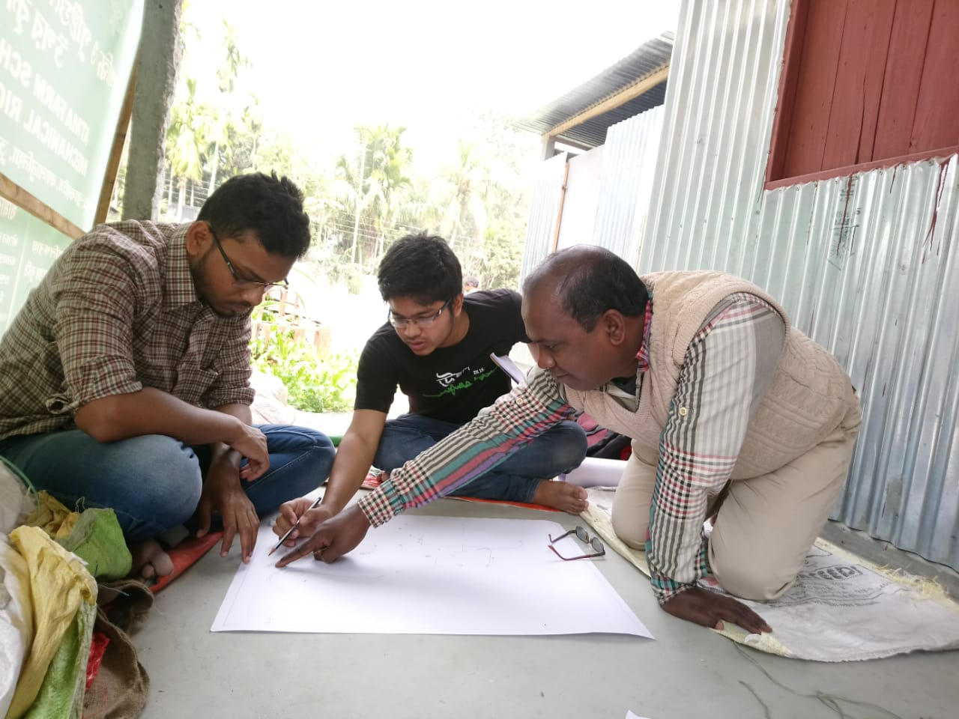Transect Walk
* Social Map
* Hydrological Map
* Resource Map
* Time Line
* Venn diagram
* Mobility Map

To collect the secondary data regarding the village and block profile including their agro-  
ecosystem, agro-climate, marketing infra-structure and banking system the students were taken the help of Block Development Office, Agriculture Development Office and Panchayat Office.

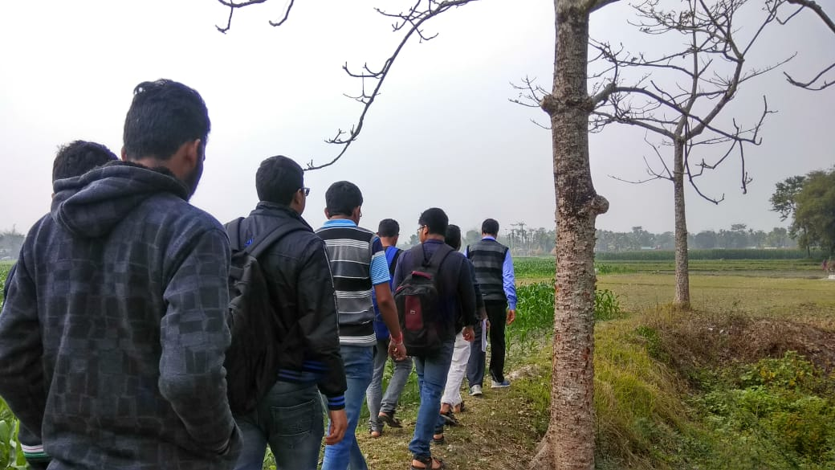

**1.2. TRANSECT WALK:**

* The researcher and key informants conduct a walking tour through areas of interest to   
   observe, to listen, to identify different zones or conditions, and to ask questions to identify   
   problems and possible solutions.
* With this method, the outsider can quickly learn about topography, soils, land use, forests,
* watersheds, and community assets.

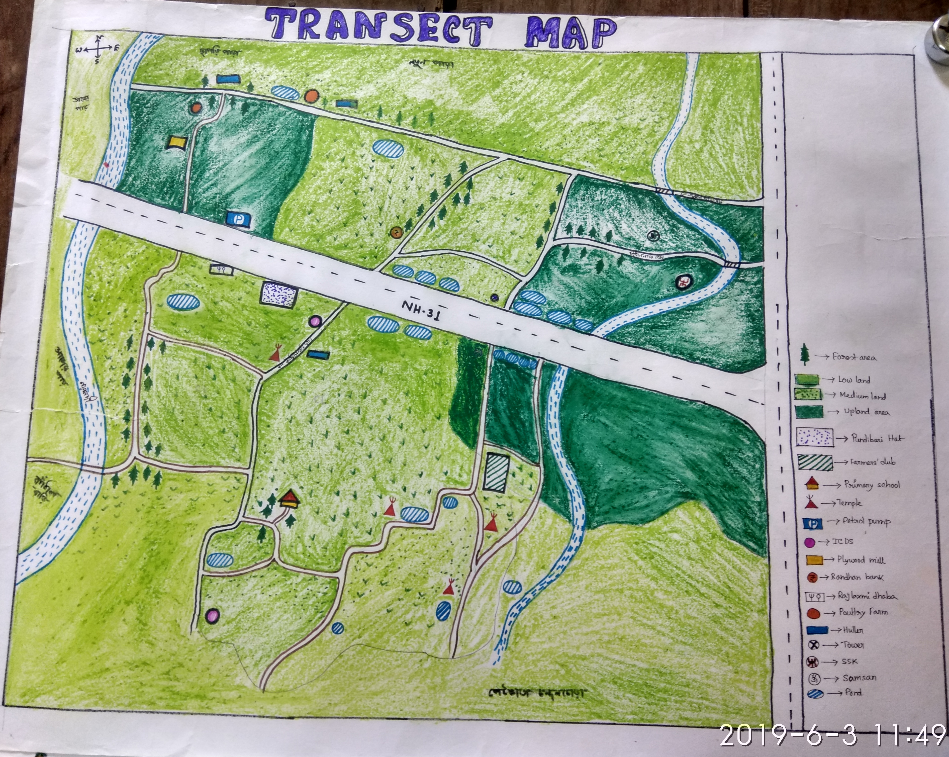

**Findings:**

**◆** We able to know various facts about village like their credit resource, water resource and hazards, community resource, differences in house hold, village infrastructure, Land use pattern, Agricultural production etc.

**1.3.SOCIAL MAP:**

This map is a graphic representation of the cognitive (perceived) image depicts the whole picture pertaining to certain place or location. Therefore, proportions, scales and dimensions tend to distort but with a high level of detailing and accuracy can be obtained

Learning objectives of social map are :

* To have an overview of the villagers perception about all their social resources and micro environment.
* To gain insight from the villager about their practice of resources utilization spatially

**Components :** ▪ Road.

* Household.
* Village institution.   
  ❑ Para/mahalla.   
  ❑ Caste.
* Occupation.
* Religion distribution.
* Rural leaders.
* Any other important rural features**.**

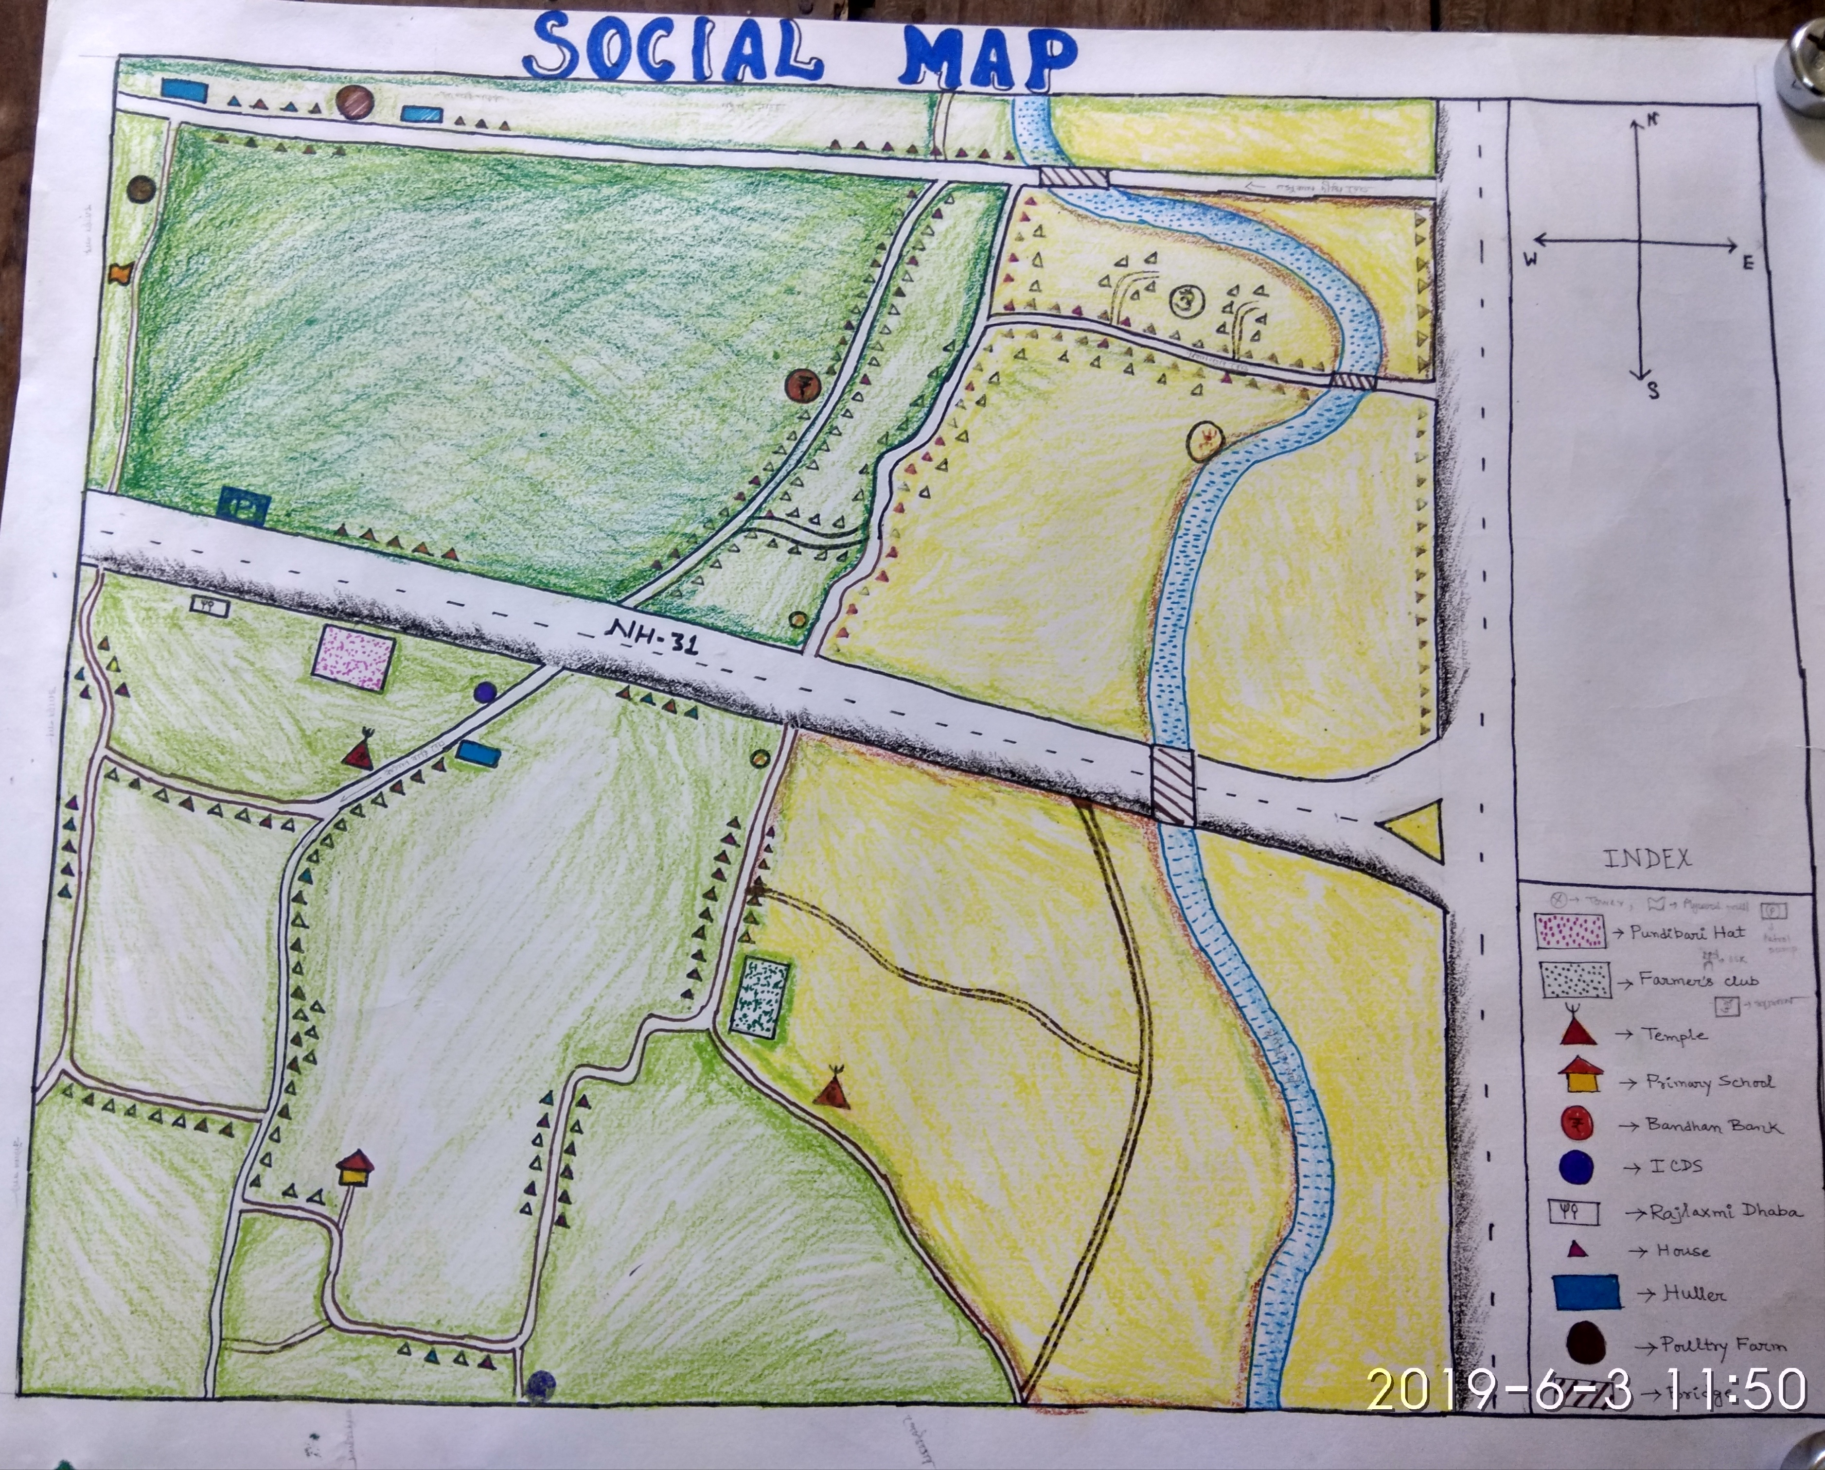

?

Findings:

* Among them most of the houses are kaccha except 50-55 concrete houses.
* There are one Primary school, one Sub-health centre, one ICDS, one Farmers' club, one Krisak Mandi and one Temple.
* All portion of this village is covered with electricity.
* Most of the households of the village have sanitary toilet.
* There are 100 villagers who are also member of the self help group.
* Their main occupation is cultivation.
* From the social map, we observed that it is a developing village.
* There are about 645 households in this village.
* They are small & marginal farmer.
* In recent times, the agriculture shows much more developed.

**1.4. Natural Resource Map**

This map in a graphic representation of the cognitive (perceived) image depicts the whole picture pertaining to certain place or location with major components like Land type (topography), soil types, enterprises, water resources, cropping sequence, pasture land, problematic area (if any) and other related items.

*Learning objectives*

✓ To have an overview of the villagers' perception about all their natural resources and micro-environment.

✓ To gain insight from the villager about their practice of resource utilization spatially.

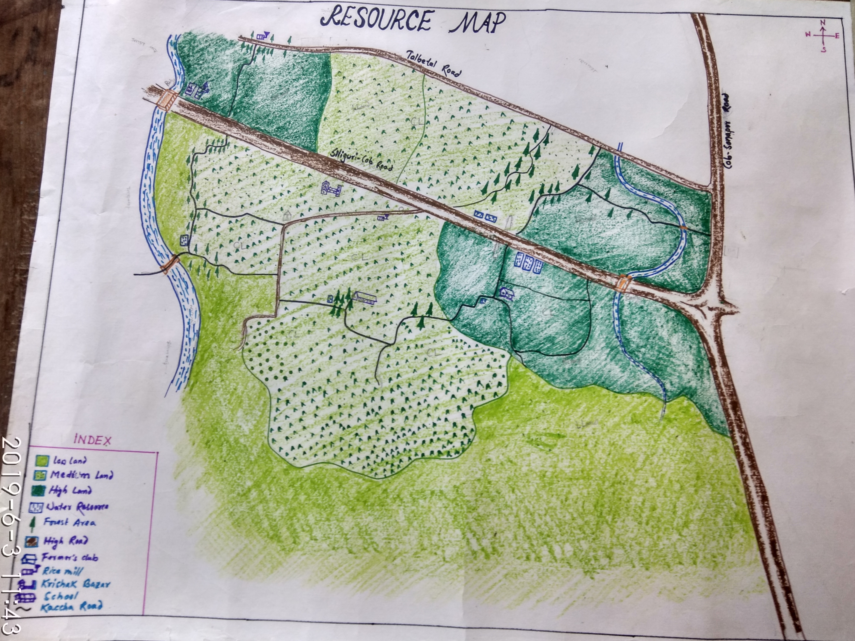 Methods

The people who know the area and topic of the natural resource map exercise and willing to share their knowledge had been chosen for the work.

**1.5. HYDROLOGICAL MAP:**

Hydrological map showing such hydrological features as rivers and streams; the purpose and content of these maps vary according to the country of their origin. Some maps are used as supplements to a detailed written.

Since hydrology embraces the many subsystems relating to water, the maps may be   
constructed for each individually or may combine the features of more than one subsystem.

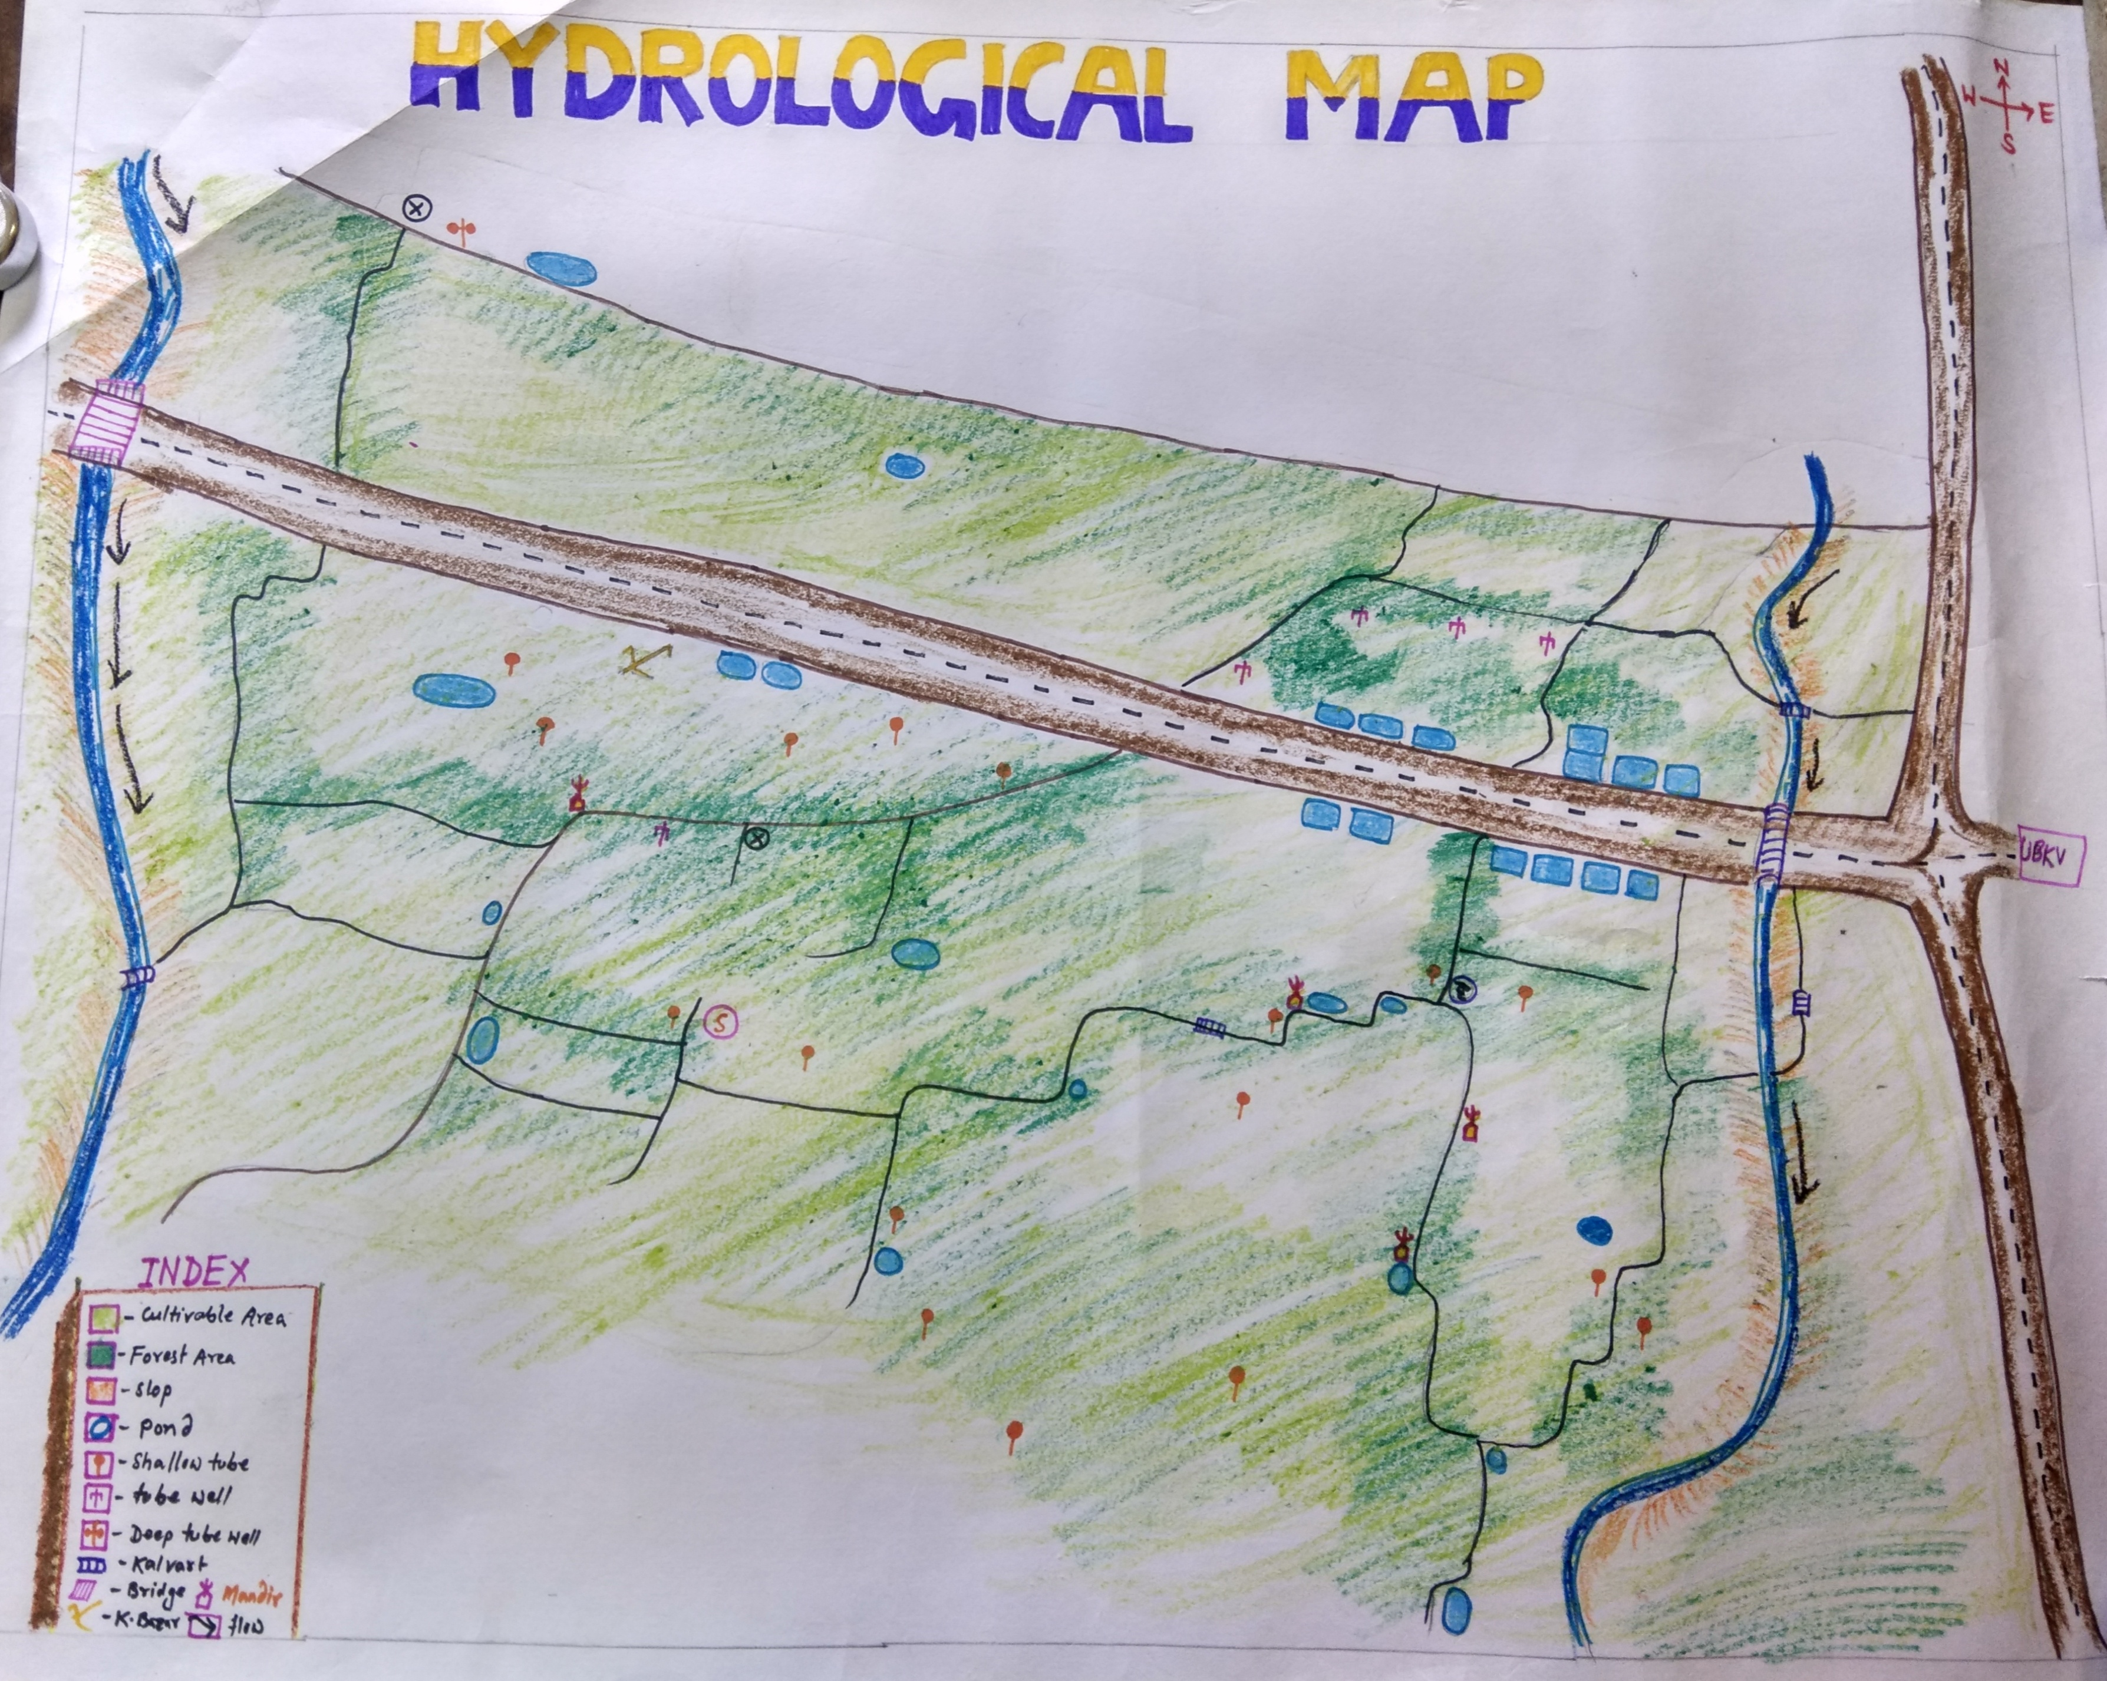

**)**

1.6.MOBILITY MAP

Mobility map is a method used to explore the movement pattern of an individual, a group, or a community. Where people go and for what reason? How frequent are the visits, what is the distance, and is importance about the place visited?

The mobility map is a representation of people’s perception of movement patterns and the reasons for them.

Mobility map shows thatpeople of this area move all over India for different purposes 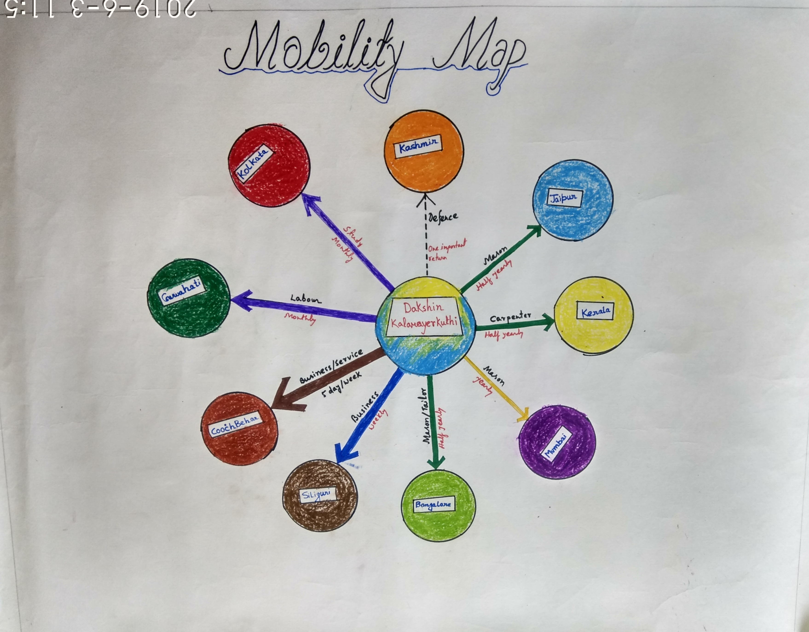but majority of them go outside to arrange their livelihood of his own and family.

1.8.TIME LINE

The facilitators meet small groups of villagers and discuss with them the most important events in the community’s past and prepare with the information a historical timeline which serves as the base for further work. It is important to involve different groups of the communities to get their usually different perspectives. The timeline with basic events can be used to focuss discussions on problems, social and technological innovations or on communities history of co operations and activities which helped them to solve in past problems successfully**.**

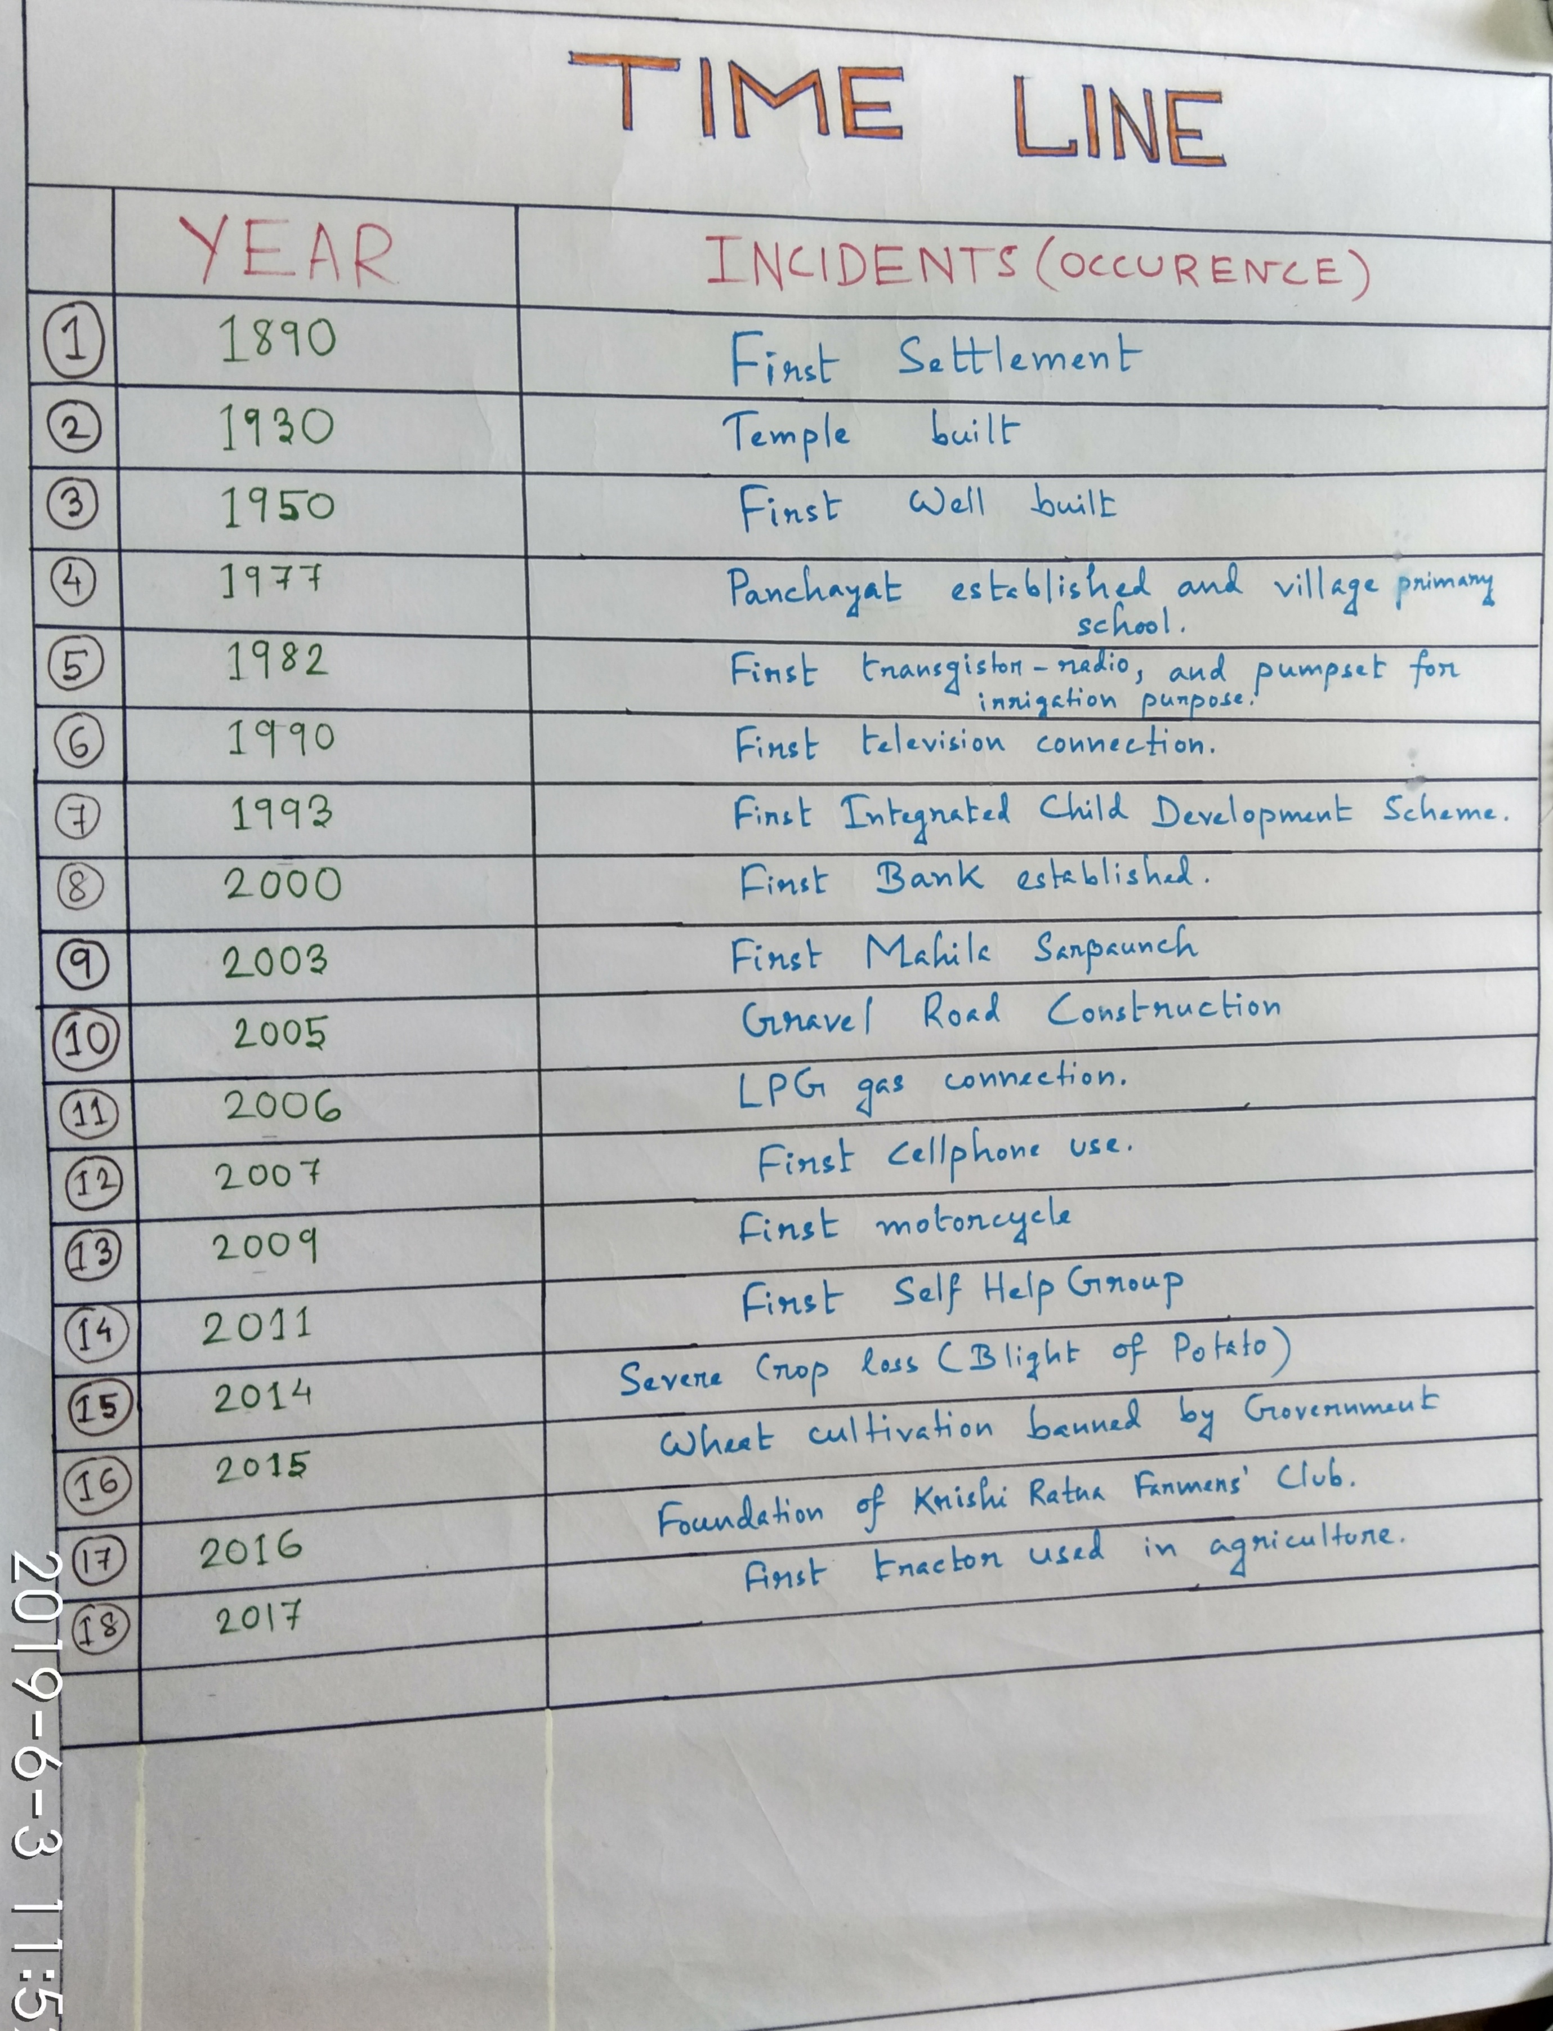

1.10**. TIME TREND:**

Time trend designs are a form of longitudinal ecological study and can provide a dynamic view of populations health status. Like other ecological studies the data are collected at a population level and can be used to generate hypothesis for further research,rather than demonstrating causalty.

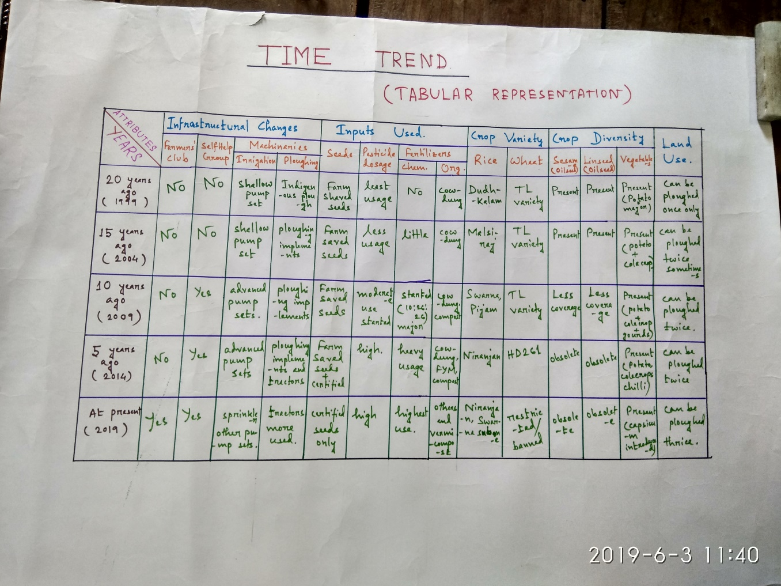

1.10. VENN DIAGRAM: 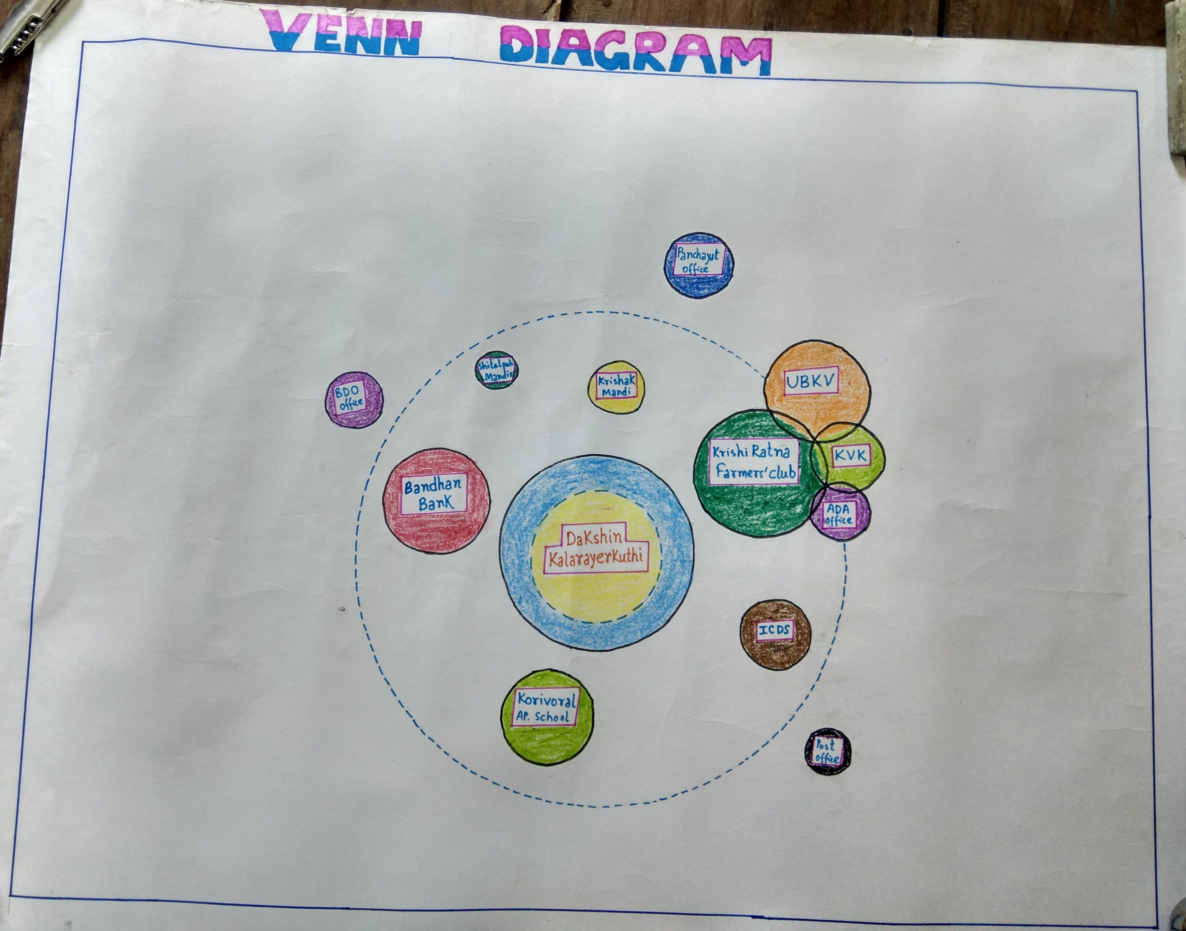The Venn Diagram on Institutions shows institutions, organisations, groups and important   
individuals found in the village, as well as the villagers view of their importance in the community.   
Additionally the Diagram explains who participates in these groups in terms of gender and wealth.

**II. DEPARTMENT OF STATISTICS**

**LAY OUT AND RBD EXPERIMENT**

# Introduction

***Design*** is the master plan specifying the methods and procedures for collecting and analyzing the needed information in a research study. The researcher selects participants and divides them into 2 or more groups having similar characteristics and then applies the treatment(s) to the groups and measures the effects upon the groups.

A ***randomized complete block design*** is an experimental design for comparing *t* treatments in *b* blocks. The blocks consist of *t* homogenous experimental units. Treatments are randomly assigned to experimental units within a block, with each treatment appearing exactly once in every block.

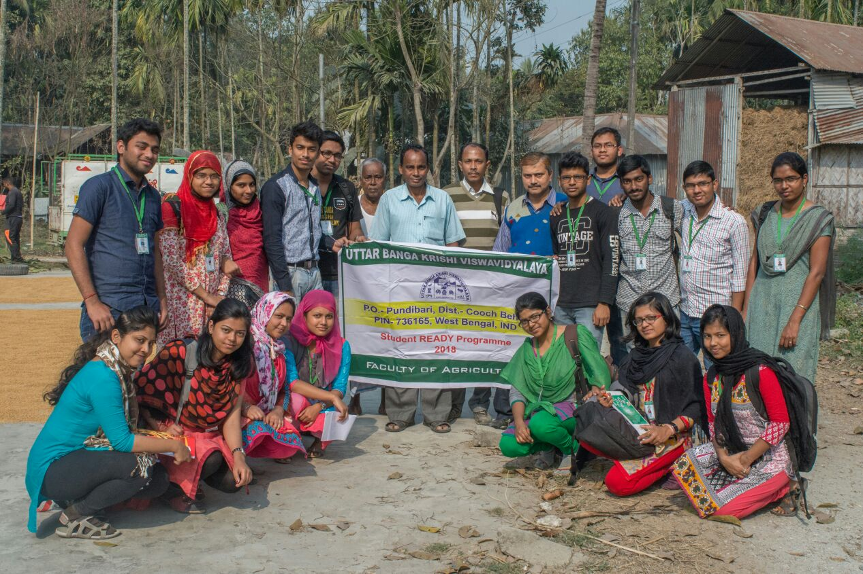

# RBD design

### Objectives

* To study the RBD experiment In the farmers field (for boro rice)
* To know the actual urea requirement in the farmers field condition.

***PRINCIPLE:***

* The experiment design which controls the fertility variation in one direction only is known as randomized block design.
* Most commonly used design in field experiment.
* When the experimental field is heterogeneous.

***ADVANTAGES:***

* The design is useful for comparing t treatment means in the presence of a single extraneous source of variability.
* The statistical analysis is simple.
* The design is easy to construct.
* It can be used to accommodate any number of treatments in any number of blocks.

***DISADVANTAGES:***

* The design is useful for comparing t treatment means in the presence of a single extraneous source of variability.
* The statistical analysis is simple.
* The design is easy to construct.
* It can be used to accommodate any number of treatments in any number of blocks.

***EXPERIMENTA DETAILS:***

i) RBD Design.

ii) Total area of the field: 21x17.5mxm.

iii) Total number of treatment: 5.

iv) Total number of replication: 4.

v) Total number of plot: 20.

vi) Size of the individual plot: 3.5x5.375mxm.

vii) Fertility direction of the field: west to east(according to the respected farmer)

viii) Blocking: North to south (perpendicular to the fertility gradient of the field)

### Fertilizer doses

1. Total amount of P2O5 requirement(SSP): 281.25kg/ha.

So, for the each plot(18.375mxm) requirement is 517g.

At the time of field preparation(basal)P2O5: 387.75 g.

Rest at the time of first top dressing: 135.25g.

1. Total amount of K2O requirement(MOP): 100kg/ha.

So, for the each plot(18.375mxm)requirement: 187.75g at the time of field preparation.

1. Total nitrogen in the form of (urea): first half at the time of field preparation and remaining 1/4th at the time of first top dressing(21DAS) and last 1/4th part at second top dressing(42DAS).

#### Lay out

* The whole field is divided into same size and shape.
* Blocking done perpendicular to the direction of fertility gradient of the field.
* The number of plots is equal to the product of treatment and replications.

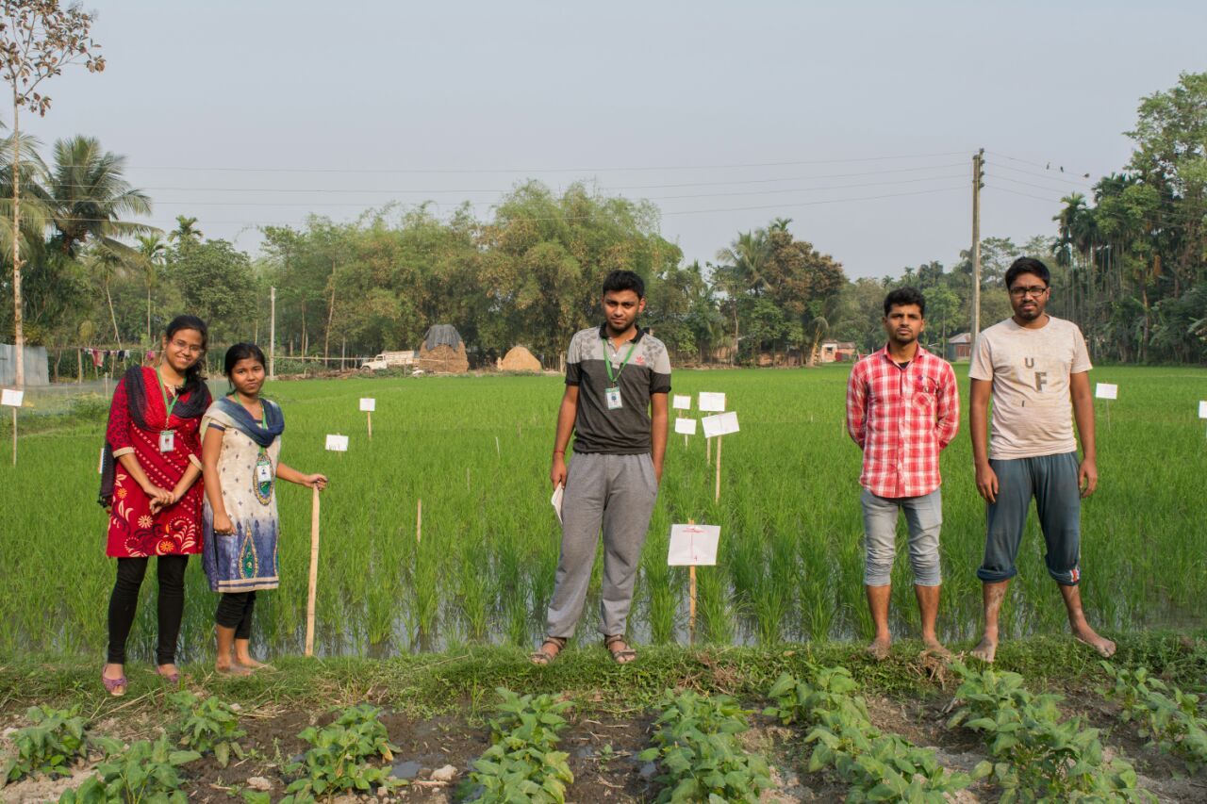

Size of the filed

|  |  |  |
| --- | --- | --- |
| **17.5 m (NORTH)** | | |
| **21 m (WEST)** |  | **21 m (EAST)** |
| **(South)17.5 m** |

Plot size

|  |  |  |  |  |  |
| --- | --- | --- | --- | --- | --- |
| **1717.5 m** | **B1** | **B2** | **B3** | **B4** | **17.5 m** |
| *3.5 m x 5.25 m* |  |  |  |
|  |  |  |  |
|  |  |  |  |
|  |  |  |  |
|  |  |  |  |
| **21 m** | | | |

**Fertilizer dose (Urea)**

|  |  |  |  |  |
| --- | --- | --- | --- | --- |
| **t1** | 100 Kg/ha |  | T1 | 398gm/18.375 mxm |
| **t2** | 115 Kg/ha |  | **T2** | 459gm/18.375mxm |
| **t3** | 130 Kg/ha |  | **T3** | 519gm/18.375mxm |
| **t4** | 145 Kg/ha |  | **T4** | 579gm/18375mxm |
| **t5** | 160 Kg/ha |  | **T5** | 639gm/18.375mxm |

Table 1: Write matter/problem

|  |  |  |  |
| --- | --- | --- | --- |
| **B1** | B2 | **B3** | **B4** |
| T2 | T4 | T1 | T3 |
| T4 | T2 | T3 | T1 |
| T1 | T5 | T2 | T4 |
| T3 | T3 | T5 | T2 |
| T5 | T1 | T4 | T5 |

T1: 398gm/18.375mxm

*T2: 459gm/18.375mxm*

*T3: 519gm/18.375mxm*

*T4: 579gm/18.375mxm*

*T5: 639gm/18.375mxm*

### Conclusion

* Our main objective to know how RBD is done in field has fulfilled.
* Yield level varies in different plots due to different dose of fertilizer.
* Different Yield level helps to know us what is the actual fertilizer requirement.
* But due to short of time we are unable to do the crop cutting experiment and final yield calculation.

**III. DEPARTMENT OF AGRONOMY**

**Learning objectives**

**●** To study the existing cropping system, constraints and possible recommendation

● To analyse the production practices of existing major field crops and technological gap.

● To assess the weed infestation and their management

**STUDY OF** **CROPPING PATTERN CONSTRAINTS/CHALLENGES OF CROP PRODUCTION &THEIR RECCOMENDATION″**

**Cropping pattern -** Proportion of total cropped area under various crops at a point of time in a particular geographical area.Cropping pattern is the key to success for farmers in rural villages who depend on agriculture for their livelihood.

* Kharif crop-Aman rice/Ash gourd/cucurbits/okra.
* Rabi crop-Boro rice/local vegetables pea/mustard/wheat/tomato/lathyrus/brinjal/lentil/tomato/maize/potato.
* Pre kharif-Rice/jute/okra/maize/cauliflower.
* **Learning Objectives** 1.Maximization of net income of farmer.  
  2.To identify development pathway and drivers of changes.  
  3.To identify labour use pattern and income from farm and non farm activities.   
  4.To identify productivity /profitability/labour requirement and seed/ seed subsidies in changing cropping pattern.

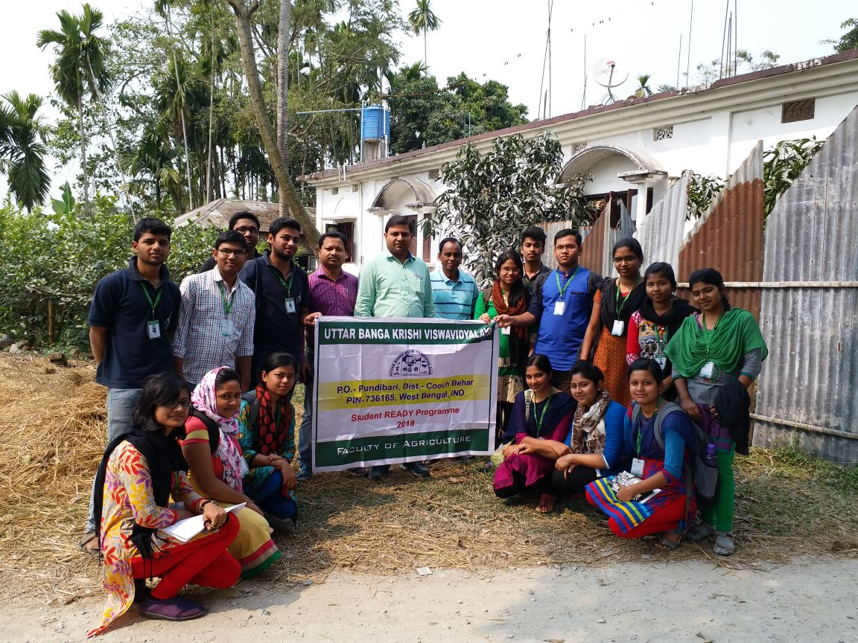

|  |  |
| --- | --- |
| *Crops* | * Constraints |
| Wheat | * lack of proper land levelling, seed treatment. * lack of government support. * climate not suitable for wheat production. |
| Potato | * highly prone to late blight infestation. * lack of seed treatment. * lack of quality seed. * lack of proper storage structure. |
| Maize | * dominance of sandy soil leads leaching and percolation loss. * Lacking of knowledge of organic manure use. |
| Mustard | * Alterneria blight infestation more. * High weed population of argemonmexicana. |
| Tomato | * Fruit borer infestation more. * Late blight infestation more. * Lack of proper disease and pest infestation. |
| Cole crops | * Cabbage head blight infestation more. * Lack of quality seed. * Lack of government support. |

|  |  |
| --- | --- |
| Crops | Recommendation (focus the major 3-4 points of intervention only) |
| Rice | * To adopt test based nutrientsapplication. * To adopt proper plant protection measures. * Use of high yielding variety of rice. * Follow stubble mulching for soil moisture conservation. * Application of boron in form of Borex@ 10 to12 kg/ha and Zn inform of Znso4@ 25kg/ha. |
| Wheat | * Use of certified seed. * Proper seed treatment with carboxin and vitavex@2-3gm/kg seed to avoiding loose smut. * Apply 25% nutrient through organic sources. * Collection of rain water in plastic tank to minimise the problem of irrigation. |
| Potato | * Proper pest and disease management practices. * Seed treatment should be done with Mancozeb@ 2.5gm/kg insufficient quantity of water for 30 minutes. * Provide quality seed. * Spray Mancozeb@3gm/Lit of water it five days interval to reduce the Late blight infestation. |
| Maize | * Provide high yielding disease resistant variety. * Provide government support. * Soil test based nutrient supply. * Add 25 to 30% organic manure in field to conserve nutrient and moisture. |
| Mustard | * Proper land levelling . * Spray Mancozeb@ 2.5-3kg in 1000lit water/ha. |

**POSSIBLE RECOMMENDATIONS FOR IMPROVING CROPPING PATTERN**

* introduction of IFS by integration of interprises like poultry, duckery, mushroom cultures, apiculture, pisciculture with farming system. Example - Rice-Duck system subject to assured water supply throughout the year.
* Here major portion are small and marginal farmer by introducing IFS it provides income throughout the year.
* Farmers became economically benefitted. Production of rice and rearing of duck simultaneously increases income throughout the year.
* It maintains sustainability within production system.
* Intrduction of legume crops within cropping pattern.
* Incorporation of line 1quintal/bigha two year interval.
* Application of Ash in field.
* Application of green manuring crops during rest period.

Cropping Intensity

Cropping intensity refers to raising of a number of crops from the same field during one agriculture year. Increasing food and other agricultural demands can be meet up either expanding the net area under cultivation or intensifying cropping over the existing area. The net sown area of the country has risen by about 20 per cent since independence and has reached a point where it is not possible to make any appreciable increase. Thus; raising the cropping intensity is the only viable option left.

**Details of information about crops grown**

|  |  |  |  |  |  |  |  |  |
| --- | --- | --- | --- | --- | --- | --- | --- | --- |
| *No. of the Respondens* | *Total cultivable land of respondents* | | *Kharif crops* | *Area cultivated (Bigha)* | *Rabi crops* | *Area cultivated (Bigha)* | *Pre kharif crops* | *Area cultivated (Bigha)* |
| *1* | *4* | *Rice* | | *3* | *Wheat Potato* | *2*  *2* | *Maize* | *3* |
| *2* | *5* | *Rice* | | *4* | *Potato* | *3* | *-* | *-* |
| *3* | *5* | *Rice* | | *5* | *Brinjal Tomato* | *2*  *1* | *Maize*  *Boro rice* | *3*  *2* |
| *4* | *5* | *Rice* | | *3* | *Tomato Potato Pea Brinjal* | *1*  *3*  *0.5*  *0.5* | *Pointed gourd* | *0.5* |
| *5* | *5* | *Rice* | | *5* | *Potato Mustard* | *4*  *1* | *-* | *-* |
| *6* | *6* | *Rice Brinjal* | | *5*  *1* | *Tomato cabbage*  *Pea Brinjal Cowpea* | *1*  *1*  *1*  *1*  *0.5* | *-* | *-* |
| *7* | *2.5* | *Rice* | | *2.5* | *Lentil* | *2.5* | *Boro rice* | *2.5* |
| *8* | *2.5* | *Rice* | | *2.5* | *Tomato* | *0.3* | *Maize*  *Okra* | *0.75*  *0.5* |
| *9* | *4* | *Rice* | | *3* | *Tomato*  *pea Brinjal* | *2*  *1*  *1* | *okra* | *1* |
| *10* | *5* | *Brinjal* | | *3* | *Mustard Pea* | *4*  *1* | *Maize* | *3* |

Cropping Intensity (CI) = (Gross Cropped Area / Net Cropped Area) X 100

Gross Cropped Area of the village =

(3+2+2+4+3+5+2+1+3+2+3+1.625+1+3+0.5+0.5+0.5+5+4+1+5+1+1+1+1+1+0.5+1+2.5+2.5+2.5+2.5+0.3+0.75+0.5+3+2+1+1+1+3+4+1+3)= 92.175

Net cropped area of the village =(4+5+5+5+5+6+2.5+2.5+4+5) = 44

Overall Cropping Intensity of the village = (92.175/44) X 100 = 209.4%

Comment

Though cropping intensity of the village (209.4%) is above the national average (142%) still there is a huge scope to increase the cropping intensity by introducing short duration varieties of crop in the fallow period.

**PACKAGE OF PRACTICES OF MAJOR CROPS**

Name of the crops under consideration: Potato and Mustard

**POTATO**

**1.Variety used**

**Farmer’s practice** – Kufri jyoti, Punjab Jyoti, Holand, Certified seed from Bhutan

**Recommended practice** – Kufri Jyoti, Kufri Pukhraj, Kufri Chandramukhi & Kufri Ashoka

**Technology Gap** –Lack of knowledge about early and long duration varieties

**Suggestions** - Use Kufri Pukhraj and Chandramukhi under late sown condition and Kufri Jyoti under timely sown condition

**2. Sources of seed**

**Farmer’s practice** – Dealer, Jateswar market, Retailer

**Recommended practice** – Certified seed dealer, Any Govt. certified seed agency, KPS

**Technology Gap** – Lack of awareness among the farmers about importance of quality seed or planting materials

**Suggestion** –Tubers showing any surface borne disease like scab, wart, should be sorted out. It is advisable to use certified seed for good yields

**3. Time of sowing**   
 **Farmer’s practice** – November-December

Last week of November to 15th December

**Recommended practice –** 2nd week of November to 1st week of December

**Technology Gap** – Timely sowing can help to attain optimum yield

**Suggestion** - Use short duration varieties like Kufri Ashoka (70-80 days) and Kufri Lauvkar (75-80 days) under late sown condition

**4. seed rate, Tuber size, Seed treatment**

|  |  |  |  |  |
| --- | --- | --- | --- | --- |
| Operations | Farmer’s practice | Recommended practice | Technology Gap | Suggestion |
| Seed Rate | 10-15 q/ha | 20-25 q/ha | Improper seed rate | Use adequate seed rate for getting optimum yield |
| Tuber size | 20-25 g | 30-50 g | Lower weight tubers used by farmers | Use appropriate wt. of tuber for planting |
| Seed treatment | _ | 1. Tubers may be treated in Mancozeb @ 3 g/Kg of seed  2. Tubers may also be treated with Plantomycin @ 1g/5 Kg of seed to eliminate any bacterial infection | Lack of knowledge about seed treatment among the farmers | Use seed treatment to control seed borne diseases up to 25% |

***5.* Manure and Fertilizer Application**

**Farmer’s practice:** FYM @ 10-20 kg/ha, 10:26:26 @ 90-100 kg/Bigha ,Urea @ 10-20kg/Bigha as basal dose

**Recommended practice:** FYM @ 20-30 t/ha, N:P:K @ 100-200 : 60-80 : 100-120 kg/ha

**Technology Gap**: Improper use of fertilizer particularly phosphorus and FYM

**Suggestion:** Farmers are advised to follow the recommended dose of phosphorus and FYM. More nitrogen should not be used and it should be applied in 3 split doses. If possible use Vermicompost instead of FYM.

1. **Irrigation Scheduling**

**Farmer’s practice:** 1st at 30 DAS, 2nd at 45-60 DAS

**Recommended practice**: 8 irrigation at 7 days interval starting from 30 DAP

**Technology Gap:** Lack of proper knowledge about irrigation scheduling

**Suggestion:** Use moisture conservation techniques(mulching) and apply organic manure

**7. Plant Protection Scheduling**

**Farmer’s practice:** Indofil M 45 i.e Mancozeb @100-150 g/bigha, Krilaxyl for late blight, Delphos

**Recommended practice :** Mancozeb formulation @3g/lit of water alternated with Copper hydroxide (Kocide) @ 2 g/litre of water before disease appearance for late blight control. After disease appearance application of Cymoxanil + Mancozeb (Curzate M 8) @ 1.5 g/Litre of water or Trifloxystrobin+tebuconazole (Nativo) @ 1 g/litre of water in case of heavy infection.

**Technology Gap** : Farmers have inadequate information about the protection measures

**Suggestion :** They may use resistant varieties, alternate spraying with different types of chemicals, they may also destroy the infected plant parts

**8.Yield**

**Farmer’s practice :** 2280-2470 kg/Bigha

2000 kg/Bigha

**Recommended practice :** 4000-5000 kg/Bigha

**Technology Gap :** Present yield is below the expected yield due to lack of awareness and insufficient knowledge about package of practice

**Suggestion** : They may follow proper scientific technique of cultivation, use of high yielding variety suitable for this particular village situation

**MUSTARD**

**1.Variety used**

**Farmer’s practice:** Keshri Gold, Pan 70,B-9

**Recommended practice:** M-27, Pusa Mustard-29

**Technology Gap:** All the farmers are not aware about the new varieties which is suitable for this village

**Suggestion:** As the soil of the region is acidic, so acid tolerant variety (M-27, Pusa Mustard-29) may be grown

**2. Sources of Seed**

**Farmer’s practice**: KPS, Jateswar Market Fertilizer Shop, Farmer’s seed

**Recommended practice:** Certified seed dealer, Any Govt. certified seed agency, KPS

**Technology Gap:** Some of the farmers have lack of information about quality seed

**Suggestion:** They may use certified seed and diseases free seed for their cultivation.

**3.Time of Sowing**

**Farmer’s practice:** Last week of November to 1st week of December, 2nd week of December

**Recommended practice:** 1st fortnight of October

**Technology Gap:** Improper knowledge about optimum time of sowing

**Suggestion**: Farmers may be advised for timely sowing practice to get high yield and less disease pest infestation

**4.Method of Sowing**

**Farmer’s practice:** Broadcasting

**Recommended practice**: Line sowing

**Technology Gap**: Inadequate knowledge about proper method of sowing

**Suggestion:** Farmer’s may be advised to use improved method of sowing for lowering seed rate and getting optimum yield

**5. Manure and Fertilizer Application**

**Farmer’s practice:** 10:26:26 @ 20-30 kg/bigha

Zn @ 2 kg/bigha FYM @ 10-15 kg/bigha

**Recommended practice:** N:P:K @ 60-90:60:40

FYM @ 15-20 t/ha

**Technology Gap:** Improper use of fertilizer and manure

**Suggestion:** Farmers are requested to follow proper doses of FYM and fertilizer

**6. Irrigation Scheduling**

**Farmer’s practice**: One irrigation at 30 DAS

**Recommended practice**: Two irrigations at pre bloom and pod filling stages

**Technology Gap:** Lack of proper information about irrigation scheduling

**Suggestion:** Farmers may follow recommended irrigation scheduling which is more beneficial for the crop

**7. Plant Protection Scheduling**

**Farmer’s practice:** Rogor 30EC and Imidachlopid 20EC @ 5ml/drum (15 lit of water) applied at 3 drum/ bigha 2-3 times at 15 days interval

**Recommended practice:** Apply copper oxychloride (Blitox) @ 4g/lit of water in alteration with chlorothalonil (Bravo) @ 2g/lit of water and difenoconazole (Score) @ 1 ml/litre of water at 7 days interval for 2-3 times

**Technology Gap:** Lack of awareness about plant protection measures

**Suggestion:** Farmers may use resistant varieties, follow proper protection measures, burn the affected plant part after harvest

**8. Yield**

**Farmer’s practice:** 120-160 kg /bigha

**Recommended** **practice:** 20-25 q/ha

**Technology Gap:** Present yield is below the expected yield due to lack of awareness and insufficient knowledge about package of practices .

**Suggestion:** They may follow proper scientific technique of cultivation, use of high yielding variety suitable for this particular village situation.

**Weed Diversity And Their Management-**

Learning objective

To study intensity of occurrence of weeds, damage and control management by the respondent in the area under study. Besides, Documentation of different weed sp. found in cultivated crops and also to find out the technological gap between the traditional practices and scientific approaches of weed management

**Introduction**Weed is a plant out of place. There are 30,000 species of weeds out of which nearly 18,000 cause serious damage in different crops resulting considerable losses to agricultural production.  
**Causes of yield loss**



Methodology

* By interacting with farmers we got information about the weeds that are associated with the crops grown at that area.
* We studied the village during the harvesting of winter seasons crops, and sowing time of prekharif crops. The crops which are available at that time in the village are

1. Rice 6. Tomato
2. Maize 7. Brinjal
3. Mustard 8. Cabbage
4. Potato
5. Okra

Weeds Of Rabi And Summer(Zaid) Crops

1. Common name: Jungle rice

Botanical name: *Echinochloacolonum*

Infested crops: Rice, Maize etc.

Characteristics: Grasses, Apophytes(indigenous), Multisession,annual weed

1. Common name: Barnyard grass

Botanical name: *Echinochloacrusgalli*

Infested crops: Rice, other cereals

Characteristics: Grasses, Monocot,  
 Annual, weed.

1. Common name: Mexican prickly   
   poppy

Botanical name: *Argemone  
Mexicana*

Infested crops: Mustard, Potato etc.

Characteristics: Annual, Alien  
(Foreign), weed.

1. Common name: Bathua

Botanical name: *Chenopodiumalbum*

Infested crops: Potato, brinjal,chilli,cabbage,

cauliflower etc.

Characteristics: Broad leaf,winter season, annual.

Use: Used as leafy vegetable.

1. Common name: Bon begun

Botanical name: *Solanumnigrum*

Infested crops: Maize, Brinjal, tomato, etc.

1. Common name:Purple nut sedge

Botanical name: *Cyperusrotundas*

Infested crops: Almost all crops.

Characteristics: It is a perennial sedge. It is one of the world worst weed, can be found in 92 countries and 52 crop fields.

1. Common name: Kantanotey

Botanical name:*Amaranthusspinosus*

Infested crops: Mustard, Brinjal, tomato, okra.

Common name: Senji

1. Botanical name: *Melilotussp.*

Infested crops: PotatCommonname:Bunopalak

Botanical name: *Rumex*sp.

Infested crops: Potato, Cabbage, tomato, okra etc.

Characteristics: Winter season, annual

1. Common name: Kesud weed.

Botanical name: *Spilanthessp*.

Infested crops: Can be found in Mustard, Potato,okra,brinjal, tomato etc. field.

1. Common name: Goat weed

Botanical name: *Ageratumconyzoides*

It infests both cropped and non-cropped area found throughout theyear.

**Weed Management Adopted By Farmer** **Indigenous Method**

* **Hand weeding:** They practice hand weeding by means khurpi, nirani, etc.
* The farmers incorporate the weeds by using country plough before sowing of any crop.mostly after 20-25 days after sowing and another 40-45 days after sowing depending upon crop duration and type of crops.
* Most of the farmers cut the weeds along the bunds and feed to their domestic animals.

**Conventional Method**

* Preparatory tillage: In these method farmers generally incorporate the weed by using tractor drawn mould-board or disc plough.

**Herbicidal**  **Control**

* Most of the farmers of Hedayetnagar village use Glyphosate, trade name Round Up @ 80 ml/ tank.
* They use Quizalofop Ethyl 30 ml / tank , trade name- targa super. it is very effective against doob grass.
* They also use Clodinafop-propargyl @ 20 gm/ tank trade name – Avtaar.
* In potato field farmers use Metribuzine @ 0.5 kg/ bigha which is available under the trade name of Sencor.

**Recommended weed management practice**

1. **Preventive measure :**Weed prevention comprises all measures that deny the entry and establishment of weeds in an area.

* Control weed in the nurseries.
* Use of pure and clean and certified seed.
* Use clean farm machineries and farm animals.
* Use well decomposed farm yard manure.plant/weed quarantine law.

1. **Cultural method**

* **Crop rotation:** Crop rotation refers to growing of different crop in sequence on the same piece of land. certain weed sp. prefers to grow in certain crop field. The growth of these kind of weeds can be suppressed by a change of crop.
* **Stale seed bed technique:** The objective of this technique to induce germination of weed seed before sowing of crops so that 2-3 flushes of germinated weeds are destroyed.
* **Good crop husbandry:** These include proper planting method, sowing of crop at proper time, careful application of fertilizer, manure etc.
* Mulching and cover cropping also helps in suppression of weed flora.

1. **Physical method**

* Hand weeding, hand hoeing
* Tillage (off –season tillage/summer plough)
* Soil solarisation
* Mowing
* Burning
* Flooding

**Technological Gap**

* Inadequate knowledge about the intensity of yield loss caused weed infestation.
* They always focus in disease and insect pest management but doesn’t pay much attention in weed management. Where as weed causes more yield loss than others.
* Most of the farmers using old herbicides.
* Lack of knowledge about proper doses for application of herbicides.
* Lack of knowledge about the pre and post emergence application of herbicides. Most of farmers does not follow pre-emergence application. They apply herbicides when weed flora emerges out.
* Lack of knowledge about adequate soil moisture conditions for herbicides application.Butachlor works efficiently in moist condition.
* Sometimes the farmers use same tank for herbicide use which has used for insecticides and fungicides spray earlier. Flood zet and flood fan are ideal for herbicides spray.
* Lack of sufficient fund.

**Suggestion**

* Awarness on crop damage by weeds: One estimate suggests that weed causes 37% yield loss whereas yield loss caused by disease is 22% , by insect 29 % ,and by other 12%. So farmers should pay proper attention in controlling of weeds.
* Proper identification of weed flora.
* Use proper dose of herbicide. Consult with experts regarding selection and recommendation of herbicides.
* Don’t use same spraying tank which has used for insecticide/fungicide spraying earlier, these may reduce the efficacy of herbicide.
* Try to maximized the use of non-chemical methods of weed management.
* Alternate utilization and commercialization of weed sp: 1.Compost preparation by weed biomass. 2.Some weeds may be cultivated as leafy vegetable. 3. Biogas production from weed sp.

**WATER MANAGEMENT :**

**Learning Objective**

● Management of water based on the soil &crop environment to obtain better yield by efficient use of water without any damage to environment .

● The application of water to plants is made naturally through rainfall & artificially through irrigation .

**Irrigation:** Artificial application of water to the soil for the purpose of crop growth or crop production in supplement to rainfall & ground water combination

**SOURCE of irrigation**:lifting groundwater by well,pump,motor.

▪CANAL

▪RIVER WATER

▪River bed use for nursery bed preparation ofboro rice.

▪Diara cultivation of cucurbitaceous crop in riverbank.

**CROPS ARE GROWN IN HEDAYETNAGAR USING IRRIGATION WATER :**

* Rice (boro)
* Maize
* Mustard
* Cauliflower
* Tomato
* Brinjal
* Okra
* Potato
* Cabbage etc.

**IRRIGATION METHODS USE IN HEDAYETNAGAR**

***FLOODING***: Water is allowed from the channel into the entire field. Standing water is present atleast to a small depth, spreading of water is easy .

***BED/BRODER METHOD***

In this method field is leveled&d divided into a small beds surrounded by bunds of 15 to 30cm high.Small irrigation channels are provided between two adjacent row or bed .

**ADVANTAGES:**

* Suitable for most of the soil texture including sandy loam ,loam& clay soils .
* Large supply of water

**FURROW METHOD**

* Adopt to crop grown in ridge &furrow .
* Water infiltrates into the soil & spreads laterally as it flows through the furrow .



**PROBLEMS** :

* Irrigation moderately available
* Maximum water loss due to percolation& seepage loss.
* No modern method of irrigation (like-Sprinkler,drip )
* Efficiency is poor as even distribution of water is not possible .
* Sometimes excess application leads to deep percolation loss & leaching of nutrients .
* Maximum farmer uses pump so cost is more .
* **RECOMMENDATION** :
* Canal can be made by concrete as loss of infiltration can be minimise .
* Farmers may use more number of motors in place of pumps
* Farmer can use SRI system in rice production ,it require less amount of water .
* Farmer may be trained with modern method of irrigation for efficient water use & get more yield .

**IV. DEPARTMENT OF pomology & post harvest technology**

**BACKGROUND OF CULTIVATION**

* Mainly the indigenous knowledge is applied in it’s small scale to raise the plants .
* These thoughts were inherited by descent from their forefathers.
* They hardly need any pesticide & modern chemicals to spray **.**

***ONE CASE STUDY :***

1. One farmer was found to cultivate mango in it’s lawn .
2. He applied following nutrients :

* Cow dung , urea
* SSP ,MOP

3 He used no specific source & schedule of irrigation .

1. Unfortunately the crop plants were found infested with the following –

* Diseases –Fruit dropping ,Malformation &Anthracnose
* Pests –Stone weevil ,Fruit fly

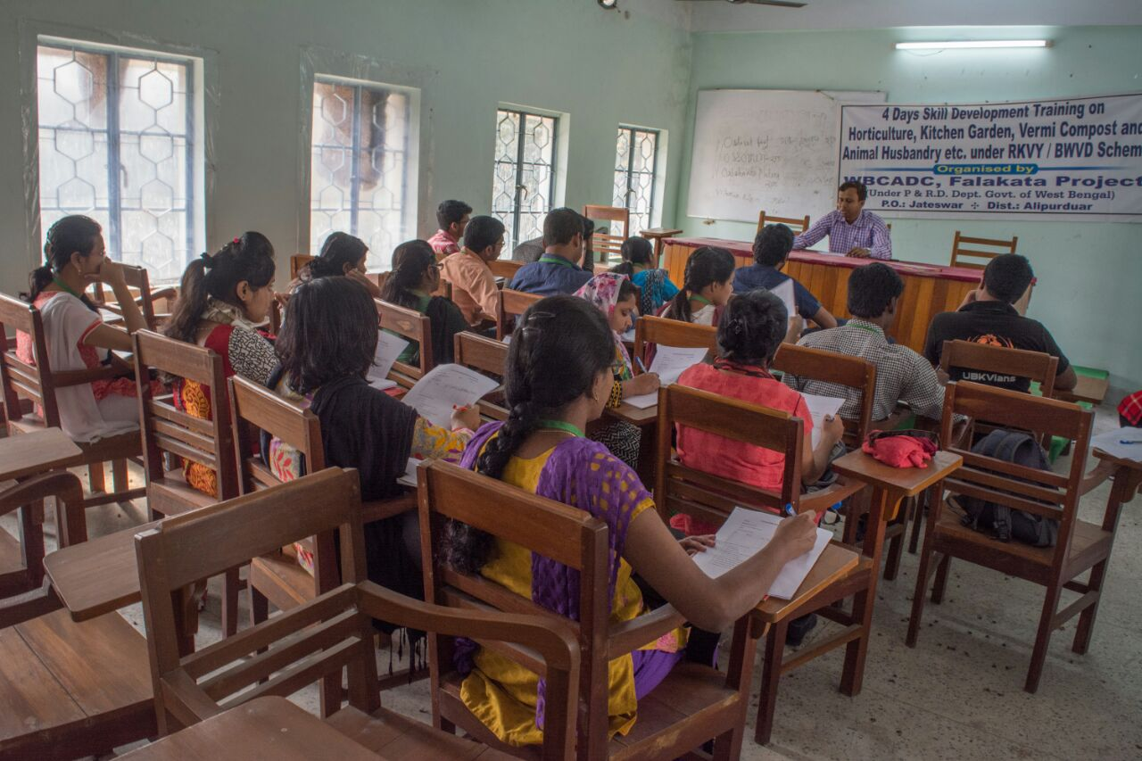

**RECOMMENDATIONS**

* Varieties can be used in some cases
* Undulating regions should be levelled
* KPS or ADA can be consulted in case any serious problem arises

**Other observations**

* ON its household scale the entire village performed well
* Area not being well known for fruit cultivation no major steps can be recommended to farmers
* Good to see the farmers utilizing their lands for raising respective staple crops instead of wasting behind cultivating non productive fruit crops

**Matrix Ranking**

***STUDY ON FRUIT CROPS***

|  |  |  |  |  |  |
| --- | --- | --- | --- | --- | --- |
| Fruit crops | Planting Materials | Source | No. of Plants | Method of Harvesting | Yield |
| Mango | Seedlings | CADC | 21 | Shaking | 20Kg |
| Litchi | 1stseedlings,then layering from previous plant. | CADC | 11 | Hand Picking | 80-100Kg |
| Jamun | Seedlings | Neighbour | 06 | Shaking | 10Kg |
| Barmese  Grape | Seedlings | Relative house | 05 | Hand Picking | 50Kg |
| Jack Fruit | Seedlings | Neighbour | 19 | Hand Picking | 30 Pcs |
| Guava | Seedlings | CADC | 10 | Hand Picking | 25 Kg |
| Ber | Seedlings | Market | 04 | Shaking | 2Kg |
| Papaya | Seedlings | Neighbour | 02 | Hand Picking with sickle | 30Kg |
| Banana | Sucker | Neighbour | 10 | Hand Picking with Sickle | 1400 pcs finger |

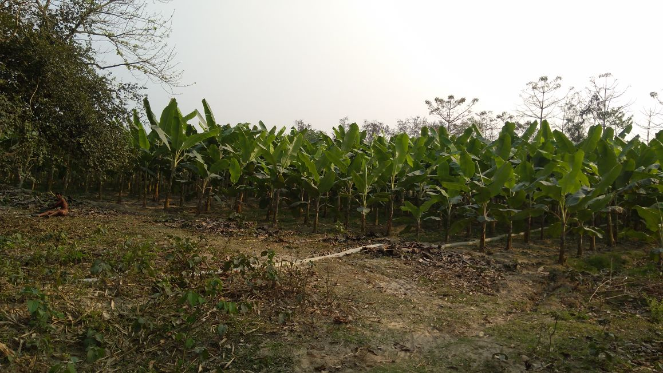

**V. DEPARTMENT OF soil science**

Soil Health

The continued capacity of soil to function as a vital living system,by recognizing that it contains biological elements that are key to ecosystem function within land.use bounderies …it presents the soil as a finite non-renewble dyanamic living sources..

Objectives

1. To evaluate the overall soil health  
   ii) To identify the problems of this area soil   
   iii) To suggest the appropriate management practices  
   4. 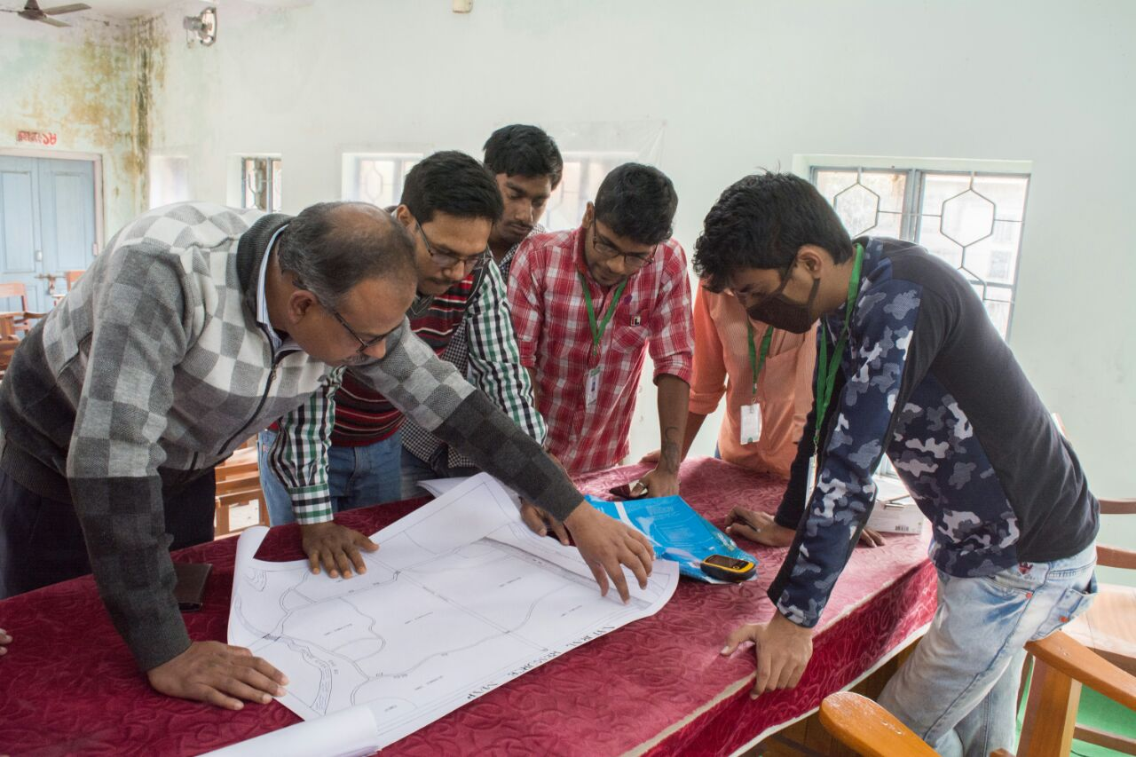

Processes of judging the soil health

**1.**Physically-

**soil texture by feel method-**The soil is rubbed between thumb and fingers under wet condtion.sands feels gritty & its particles can be easely seen.silt when dry feels like flour & talcum powder.clay particles feel very plastic & exibit stickyness when wet & hard under dry condition..

1. Observation by naked eyes -   
    colour of soil denotes the organic matter content.water status etc.  
    the status of soil after erosion, severity of erosion, destruction of soil structure   
   vegetation cover over the land,  
   presence of soil clods  
   3. Aasking questions to farmers  
   4. Analytical process  
    we collected 40 samples by auger from different points of the village..  
   a) ph is calculated by ph meter with 1:2.5 soil:solution ratio  
   b) organic matter by walkey & Black method  
   c) N is calculated

|  |  |  |
| --- | --- | --- |
| 1 Earth worms | 2 | Few worm holes or casting |
| 2 Erosion | 2 | Moderate,signs of sheet & rill erosion,some top soil blows |
| 3 Tillage ease | 4 | Plow field in higher gear,soil flows,falls apart,melllow |
| 4 soil structure | 4 | Crumb.granular |
| 5.Colour(moist) | 0 | Tan,light yelow,orange,or light grey |
| 6.compaction | 2 | Soil packs down,this hardpan or plough layer |
| 7 Ilfiltration | 2 | Water soaks in slowly,some run off or puddling after heavy rain |
| 8 Drainage | 4 | Water moves in good rate |
| 9 Water retention | 2 | Soil is drought prone in dry weather |
| 10 Decomposition | 2 | Slow rotting or residues & manures |
| 11 Soil fertility | 2 | Fertility not balanced,needs help |
| 12 Feel | 2 | Smooth or grainy.compresses when squeezed |
| 13 Surface crust | 0 | Hard,cracked when dry,compacted |
| 14 surface cover | 2 | Little residue,mostly burned |
| 15 Hardness | 2 | Firm,breaks up between fingers under moderate pressure |
| 16 Smell | 2 | No odour or mineral smell found |
| 17 Soil texture | 4 | Loamy |
| 18 Aeration | 4 | Soil is open,porous,breaths |
| 19 Biological activity | 0 | Little,no signs of soil microbes |
| 20 Topsoil depth | 2 | Shallow |

Analytical properties  
soil

|  |  |  |
| --- | --- | --- |
| 21 Organic matter | 0 | Less than 2%(1..14) |
| 22 pH | 2 | 6.5 |
| 23 soil test N | 2 | Below recommended levels,needs extra input |
| 24 Micronutrients | 2 | At minimum level or not balanced |
| **25 Crops appearance** | **2** | **Overall crop is light green,small,in a thin stand** |
| 26 Nutrient deficiency | 4 | Crops shows sign of severe deficiencies |
| 27 Seed germination | 2 | Uneven,seed must be planted deeper |
| 28 Growth rate | 2 | Uneven,late to mature |
| **29 Roots** | **2** | **Shallow,at hard agles,development limited,few fine roots** |
| 30 Stem | 2 | Thin,leaning to one side |
| 31 Leaves | 2 | Small,narrow,light green |
| 32 Resists drought | 2 | Plants suffer in dry weather ,slow to recover |
| 33 Resists pests diseases | 0 | Damaged severely |
| 34 Mature crop | 0 | Seed head or pod misshaped,grain is not ripen shriveled,poor colour |

Analytical properties  
Plant

|  |  |  |
| --- | --- | --- |
| 35 Yield | 2 | Grain 2-6 ton/acre |
| 36 Feed value | 2 | Unbalanced in energy,protien or minerals may require supplements |
| 37 Test weight | 2 | average |
| 38 Cost of production and profit | 2 | Profits are variable,yields maintained with high input costs |

Animals

|  |  |  |
| --- | --- | --- |
| 39 Human health | 2 | Occasional health problems,slow recovery time |
| 40 Animal health | 2 | Occasional,performance average |
| 41 Wild life | 0 | Signs of wild life is rare,animals do not appear healthy |

Water(analytical properties

|  |  |  |
| --- | --- | --- |
| 42chemicals in ground water | 2 | Found in groundwater bellow the allowble levels |
| 43 surface water | 4 | Clear & clean |

soil health scorInterpreting e card results

Dividing the total data by the total number of questions answered(43) average value is 2…so,

Health category is impaired

healthy score 3-4

impaired score 1.5-2.5

unheathy score 0-1

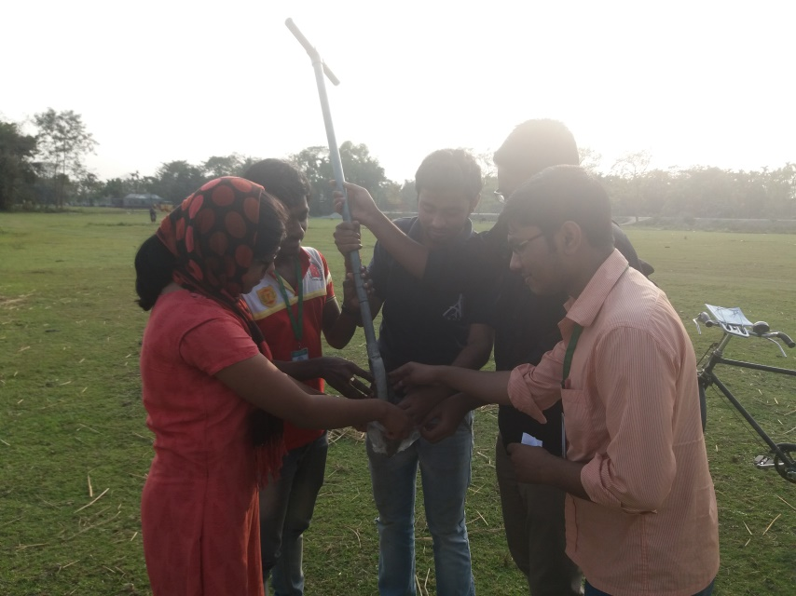

Problems of this area (Soil Health Map ?)

i) Soil is slightly acidic, so sugarcane, barley, oats are not cultivated

ii) Lack of ca, Mg ,Mb etc essential nutrients

iii) Not using lime materials

iv) Lack of awareness of necessity to reclaim acid soil

v) Irrigation is not available through the year, Cropping pattern so they don’t cultivate legumes after high feeding crops like maize

vi) If for some months also all farmers are not getting Govt help in irrigation

vii) So for them costly cultivation

viii) lack of contact with Govt persons

ix) though presence of KPS,ADA all farmers are not getting certified seed, subsidy in fertilizers, crops loans etc

x) Cooperative attitudes from the farming community may help solve many of their problems including soil.

**Recommendation**

1. More awareness programme about more green manure use , less use of inorganic fertilizer, inm need to be started

b) More contact with kps, ada,ubkv,bank is needed

c) for getting govt policy farmers have to be united , so one farmers’ club is very necessary

d) for farmers bengali leaflet or book with recommendation about variety , fertilizer , time of sowing , management practices with hedayetnagar atmosphere specific

**VI. DEPARTMENT OF PLANT PATHOLOGY**

DISEASE status of STANDING FIELD CROPS

**Introduction:** Plant pathology deals with the study of plant diseases and their management. The diseases are mainly caused by Bacteria, Virus, Fungus and other microorganisms.

Here are some common plant diseases which were observed during field study and are described below.

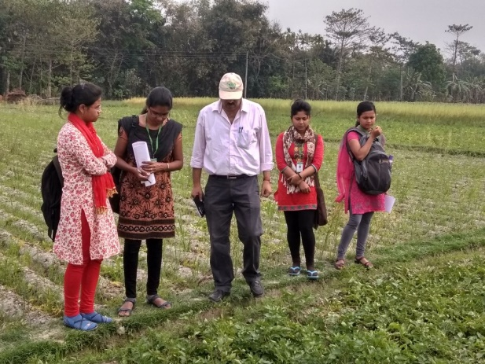

***Objective***

▪ To identify various severe diseases appeared in different crops and evaluate their severity/intensity.

▪ To develop a clear and practical knowledge about the symptoms, transmission process and other factors of different diseases.

▪ To suggest probable management practices to control the diseases.

**Disease assessment:General procedure to be followed**

***Incidence:***

a.The proportion or percentage of diseased units within a sampling unit.In specific situations,incidence can be the proportion or percentage of diseased leaves on a plant,diseased stalk on a tiller,or diseased trees in a orchard.

b.It refers to the number of plant units that are visibly diseased,usually relative to the total number of units assessed.

***Severity:***

a.The quantity of disease affecting plants within a sampling unit. b.The area or volume of plant tissue that is diseased,usually relative to the total area volume.

**A. Disease Name-Potato late blight (Photo ?)**

**Causal Organism**-Phytophthora infestans

**Symptoms:-**The pathogen causes purplish-brown lesions on the surface of tubers.

Blackish water soaked lesions occur on the leaves and whitish sporulation of the pathogen can be seen around the margin of the lesions, particularly on the underside of the leaf.

The lesions commonly occur at the junction of the leaf and stem where water may accumulate or on clusters of leaves at the top of the stem.

Potato tuber show reddish brown discoloration.

***Disease Scale in Potato***

*0-9 scale rating(leaf blight, rust)*

*0=o-3% damage*

*1=3-6% damage*

*2=6-12% damage*

*3=12-25% damage*

*4=25-50% damage*

*5=50-75% damage*

6=75-88% damage

*7=88-94% damage*

*8=94-97% damage*

*9=97-100% damage*

*Disease Severity=(sum ofAll numerical ratingsx100)/(Number of plants Observed X Highest rating in the Scale)*

|  |  |  |  |  |  |  |  |  |
| --- | --- | --- | --- | --- | --- | --- | --- | --- |
| *Spot No* | *Plant No* | *L1* | *L2* | *L3* | *L4* | *L5* | *Disease Severity* | *Average* |
| *1* | *1* | *1* | *8* | *2* | *4* | *0* | *37.78* | *31.4656* |
| *2* | *4* | *1* | *1* | *9* | *2* |
| *3* | *4* | *8* | *1* | *1* | *0* |
| *4* | *3* | *4* | *7* | *1* | *9* |
| *5* | *6* | *0* | *7* | *1* | *1* |
| *2* | *1* | *0* | *2* | *1* | *0* | *3* | *29.778* |
| *2* | *4* | *0* | *5* | *3* | *0* |
| *3* | *0* | *1* | *5* | *1* | *4* |
| *4* | *6* | *0* | *9* | *4* | *5* |
| *5* | *2* | *0* | *3* | *5* | *4* |
| *3* | *1* | *1* | *3* | *0* | *1* | *4* | *24.44* |
| *2* | *0* | *2* | *1* | *3* | *1* |
| *3* | *3* | *5* | *3* | *1* | *2* |
| *4* | *4* | *1* | *3* | *2* | *0* |
| *5* | *0* | *9* | *3* | *2* | *2* |
| *4* | *1* | *3* | *9* | *4* | *2* | *3* | *29.33* |
| *2* | *9* | *2* | *1* | *3* | *1* |
| *3* | *4* | *2* | *2* | *1* | *3* |
| *4* | *4* | *2* | *0* | *1* | *3* |
| *5* | *0* | *1* | *2* | *1* | *3* |
| *5* | *1* | *3* | *2* | *2* | *3* | *3* | *36* |
| *2* | *2* | *3* | *5* | *9* | *1* |
| *3* | *1* | *2* | *4* | *3* | *5* |
| *4* | *3* | *4* | *5* | *6* | *2* |
| *5* | *2* | *1* | *3* | *4* | *3* |

*So,from the above data the average of the disease severity is=31.4656.*

***Management Practices:***

Here, it is recommended that the integrated management practices should be taken.

Cultural Measures-

a) Clean cultivation

b) Use of resistant cultivars

c) Water in the early morning hours.

d) Removal of crop stubbles from the field.

***Chemical Management Practices***

* Protective spray with Dithane M-45 (Mancozeb) @3g/lit of water in alteration with copper hydroxide 75%WP (Kocide) @2.5g/lit of water at 7 days interval.
* Curative spray should be started immediately after appearance of the symptoms with Metalaxyl 8% + Mancozeb 64% (Ridomil MZ) @2g/lit of water at 7-10 days interval for 2 times.
* If not controlled, apply Cymoxanil 8% + Mancozeb 64% WP (Curzate / Moximate) @1.5g/lit of water for 2-3 times at 10 days interval. If severity is higher apply Dimethomorph 50%WP (Acrobat/ Lurid) @ 1.5g/lit of water
* Trifloxystrobin 25% + Tebuconazole 5%WP (Nativo) @0.75g/lit of water for 2 times at 10 days interval.

**B. Study on Disease Scenario of Tomato (Photo ?)**

The soil of this area promote the peoples to grow various vegetables in their fields.Many farm family earn a lot by cultivating tomato for their own consumption as well as marketing purpose. The main disease occurs in a severe from is the leaf blight disease of tomato.

***Causal Organism and Symptoms***

**Name of the disease-Tomato Leaf Blight**

**Causal Organism**-Phytophthora infestans

**Symptoms**:-

a) Irregularly shaped water soaked lesion can be observed on young leaves.

b) The leaves shrivel and become necrotic and dry.

c) Chocklate brown spots enlarge to cover the whole fruits.

d) Brown lesion can occur on stems and leaf pedicels.

***Disease Scale of Tomato Leaf Blight***

**0-9 scale rating(leaf blight, rust**)

0=o-3% damage

1=3-6% damage

2=6-12% damage

3=12-25% damage

4=25-50% damage

5=50-75% damage

6=75-88% damage

7=88-94% damage

8=94-97% damage

9=97-100% damage

Disease Severity=(sum of All numerical ratings x100)/(Number of plants Observed X Highest rating in the Scale)

|  |  |  |  |  |  |  |  |  |
| --- | --- | --- | --- | --- | --- | --- | --- | --- |
| Spot  No | Plant No | L1 | L2 | L3 | L4 | L5 | Disease Severity | Average |
| 1 | 1 | 2 | 1 | 1 | 2 | 4 | 27.55 | 32.445 |
| 2 | 5 | 4 | 0 | 4 | 1 |
| 3 | 2 | 0 | 1 | 0 | 1 |
| 4 | 2 | 4 | 0 | 7 | 3 |
| 5 | 1 | 2 | 3 | 7 | 5 |
| 2 | 1 | 6 | 5 | 5 | 1 | 2 | 28 |
| 2 | 1 | 2 | 4 | 0 | 2 |
| 3 | 3 | 0 | 1 | 2 | 6 |
| 4 | 2 | 2 | 3 | 3 | 6 |
| 5 | 2 | 2 | 2 | 1 | 1 |
| 3 | 1 | 0 | 1 | 1 | 2 | 2 | 38.67 |
| 2 | 1 | 1 | 2 | 3 | 4 |
| 3 | 5 | 6 | 2 | 3 | 1 |
| 4 | 6 | 6 | 5 | 2 | 3 |
| 5 | 8 | 9 | 6 | 5 | 3 |
| 4 | 1 | 2 | 1 | 0 | 3 | 1 | 35.56 |
| 2 | 4 | 3 | 7 | 1 | 1 |
| 3 | 0 | 1 | 9 | 7 | 2 |
| 4 | 7 | 0 | 6 | 8 | 3 |
| 5 | 7 | 1 | 0 | 4 | 2 |

So from the above mentioned data we get the average of the disease severity which is 32.445

***Management Practices***

Proper management practices should be taken to control the disease.

Cultural Measures-

a) Use of resistant cultivar

b) Water in the early Morning hour.

c) leanliness of crop field by removing crop stubbles.

d) Avoid excess application of nitrogenous fertilizers. Apply in split.

1. **Study on Disease Scenario Of Field Pea (Photo ?)**

Field pea is one of the most cultivated vegetables in this area.Pea is severely affected by rust, anthracnose.Here ,we put the highlight on the severe disease of Pea, Pea rust

**Name of the disease-Pea Rust**

Causal Organism-Uromyces pisi.

Symptoms-

1. Yellow spots having aecia in round or elongated clusters.
2. Pustules develop which are powdery and orange brown in appearance.

Scale used for estimation of disease severity 0-9 scale rating(leaf blight, rust)

0=o-3% damage

1=3-6% damage

2=6-12% damage

3=12-25% damage

4=25-50% damage

5=50-75% damage

6=75-88% damage

7=88-94% damage

8=94-97% damage

9=97-100% damage

Disease Severity=(sum of All numerical ratings x100)/(Number of plants Observed X Highest rating in the Scale)

|  |  |  |  |  |  |  |  |  |
| --- | --- | --- | --- | --- | --- | --- | --- | --- |
| Spot  No | Plant No | L1 | L2 | L3 | L4 | L5 | Disease Severity | Average |
| 1 | 1 | 3 | 2 | 4 | 1 | 7 | 41.78 | 38.813 |
| 2 | 4 | 2 | 3 | 6 | 5 |
| 3 | 2 | 4 | 3 | 6 | 1 |
| 4 | 5 | 2 | 3 | 1 | 4 |
| 5 | 1 | 5 | 4 | 9 | 7 |
| 2 | 1 | 4 | 3 | 2 | 2 | 1 | 39.11 |
| 2 | 2 | 1 | 4 | 2 | 6 |
| 3 | 9 | 7 | 5 | 3 | 2 |
| 4 | 3 | 2 | 6 | 2 | 1 |
| 5 | 1 | 9 | 2 | 5 | 4 |
| 3 | 1 | 4 | 1 | 2 | 6 | 5 | 35.55 |
| 2 | 3 | 5 | 1 | 2 | 3 |
| 3 | 4 | 3 | 2 | 4 | 1 |
| 4 | 3 | 1 | 4 | 5 | 2 |
| 5 | 7 | 5 | 2 | 1 | 4 |

So from the above mentioned data we get the average of the disease severity of Pea rust which is 38.813.

***Management practices***

So proper management practices should be taken.

**Cultural practices**

a) Cleaning of previous crop stubbles.

b) Use of clean,disease free seeds

c) Long crop rotation avoiding beans.

**Chemical measures**-

1. Protective spray with Mancozeb @2 gm/Lt of water

2.Tridemorph 80EC(Kalinin)0.5 ml/let of water or Carboxin 37.5% + Thiram 37.5% (Vitavax Power) @ 2g/lit water at 7-10 days interval for 2-3 times as curative spray

**Cabbage:**

* Damping off, club root, downy mildew, Alternaria leaf spot, black vein are the major fungal infections found in cabbage.

Here we observed mainly Alternaria leaf spot of cabbage.

1. **Alternaria Leaf Spot Of Cabbage (Photo ?)**

**CAUSAL ORGANISM:** *Alternaria brassicicola*

SYMPTOMS**:**

1. The most common symptom of Alternaria diseases is yellow, dark brown to black circular leaf spot with target board like, concentric rings.
2. Lesion centers may fall out, giving the leaf spots a shot-hole appearance.

* **Scales used for estimation of disease severity**
* 0-5 scale rating

0= No disease

1= 0.1-5% damage

2= 5-10% damage

3= 10-25% damage

4= 25-50% damage

5= >50% damage

**Sum of all numerical ratings X100**

* **Disease severity**=------------------------------------------------------------------------------

**Number of plants observed X highest rating in the scale**

|  |  |  |  |  |  |  |  |  |
| --- | --- | --- | --- | --- | --- | --- | --- | --- |
| SPOT NO | L1 | L2 | L3 | L4 | L5 | DISEASE SEVERITY | AVERAGE | |
| 1 | 1 | 3 | 2 | 3 | 2 | **44.8** |  | **41.76** |
| 2 | 4 | 3 | 3 | 2 | 3 |
| 3 | 2 | 3 | 1 | 2 | 1 |
| 4 | 1 | 2 | 1 | 3 | 2 |
| 5 | 3 | 4 | 3 | 1 | 1 |
| 1 | 4 | 1 | 3 | 1 | 1 | **47.2** |  |
| 2 | 5 | 4 | 1 | 4 | 3 |
| 3 | 1 | 2 | 4 | 3 | 1 |
| 4 | 2 | 1 | 3 | 3 | 1 |
| 5 | 2 | 2 | 3 | 2 | 2 |
| 1 | 2 | 2 | 1 | 3 | 1 | **34.4** |  |
| 2 | 1 | 2 | 2 | 1 | 3 |
| 3 | 1 | 1 | 3 | 1 | 2 |
| 4 | 2 | 1 | 1 | 2 | 2 |
| 5 | 1 | 2 | 1 | 1 | 2 |
| 1 | 3 | 2 | 3 | 3 | 1 | **51.2** |  |
| 2 | 4 | 3 | 1 | 2 | 2 |
| 3 | 3 | 4 | 2 | 3 | 2 |
| 4 | 2 | 3 | 4 | 2 | 1 |
| 5 | 3 | 3 | 2 | 2 | 4 |
| 1 | 2 | 1 | 2 | 1 | 2 | **31.2** |  |
| 2 | 1 | 2 | 3 | 1 | 1 |
| 3 | 2 | 1 | 2 | 2 | 2 |
| 4 | 2 | 1 | 1 | 2 | 2 |
| 5 | 2 | 1 | 2 | 2 | 1 |

Average disease severity is quite high

**Recommended management practices**

* The farmer must has to take some measures to control the disease.
* It is advised the farmer to take curative action immediately after noticing 2-3 such spots from next year.
* They should avoid overhead irrigation.
* As preventive spray apply copper oxychloride (Blitox 50WP) @ 3g/lit water is to be applied in alteration with Chlorothalonil (Kavach 75WP) @ 2g/lit of water at 7 days interval for 2-3 times.
* As curative action apply Captan 70% + Hexaconazole 5% (Taqat) @ 2g/lit of water in alteration with Flubendamide 3.5% + Hexaconazole 5% (Origin) @1.5g/lit of water at 10 days interval for 2 times.
* For rice neck blast the farmer is advised to spray Tricyclazole (BAAN/BEAM/Civic) @ 1.5g/lit of water for 2-3 times at 10-12 days interval starting from panicle initiation stage

1. **Alternaria leaf blight of Mustard (Photo ?)**

**CAUSAL ORGANISM:** *Alternaria brassicae*

**SYMPYOMS:**

1. Disease attacks in lower leaves as smaller circular necrotic spots.
2. Leison coalesce to cover large patches showing blightening.
3. Lesions also develop on stems and pods .
4. Infected pods produce small discoloured and shriveled seeds.

* **Scales used for estimation of disease severity**

0-5 scale

0= No disease

1= 0.1-5% damage

2= 5-10% damage

3= 10-25% damage

4= 25-50% damage

5= >50% damage

**Sum of all numerical ratings X100**

* **Disease severity**=---------------------------------------------------------------------------

**Number of plants observed X highest rating in the scale**

**Observation on Alternaria leaf spot of Mustard**

|  |  |  |  |  |  |  |  |  |  |  |  |  |  |
| --- | --- | --- | --- | --- | --- | --- | --- | --- | --- | --- | --- | --- | --- |
| Spot  No | Plant no | L1 | L2 | LL3 L3 | L4 | L5 | L6 6lL6 | L7 | L8 | L9 | L10 |  |  |
| 11 | 1 | 5 | 1 | 1 | 1 | 4 | 3 | 2 | 1 | 4 | 3 | **58.8** | **46.8** |
| 2 | 3 | 5 | 4 | 2 | 2 | 1 | 5 | 3 | 2 | 4 |
| 3 | 2 | 1 | 4 | 5 | 5 | 2 | 4 | 1 | 2 | 3 |
| 4 | 4 | 1 | 1 | 1 | 3 | 5 | 4 | 5 | 3 | 1 |
| 5 | 1 | 3 | 5 | 5 | 3 | 2 | 4 | 5 | 1 | 5 |
| 2 | 1 | 1 | 0 | 3 | 4 | 5 | 2 | 2 | 1 | 2 | 3 | **40.4** |
| 2 | 0 | 2 | 4 | 2 | 1 | 4 | 3 | 2 | 2 | 3 |
| 3 | 1 | 1 | 3 | 2 | 1 | 2 | 3 | 2 | 1 | 2 |
| 4 | 1 | 1 | 2 | 2 | 2 | 1 | 2 | 1 | 1 | 3 |
| 5 | 1 | 2 | 2 | 3 | 3 | 2 | 2 | 1 | 3 | 2 |
| 3 | 1 | 1 | 1 | 2 | 4 | 2 | 1 | 5 | 2 | 1 | 3 | **43.2** |
| 2 | 0 | 0 | 1 | 1 | 2 | 3 | 3 | 4 | 4 | 5 |
| 3 | 0 | 1 | 0 | 0 | 2 | 5 | 3 | 5 | 4 | 1 |
| 4 | 1 | 3 | 4 | 0 | 1 | 2 | 5 | 2 | 3 | 1 |
| 5 | 4 | 5 | 1 | 0 | 2 | 3 | 2 | 1 | 0 | 2 |
| 4 | 1 | 2 | 2 | 0 | 0 | 0 | 1 | 2 | 2 | 1 | 0 | **44.8** |
| 2 | 5 | 5 | 4 | 3 | 4 | 2 | 2 | 2 | 1 | 2 |
| 3 | 5 | 5 | 5 | 4 | 3 | 3 | 2 | 2 | 2 | 1 |
| 4 | 4 | 2 | 3 | 2 | 3 | 3 | 4 | 1 | 0 | 0 |
| 5 | 5 | 5 | 4 | 3 | 2 | 2 | 1 | 0 | 0 | 0 |

* **Recommended management practices**
* It is advised the farmer to take curative action immediately after noticing 2-3 such spots from next year.
* Use of disease free seed should be preferred.
* Collect and burn the affected plant parts after harvest.
* Deep ploughing should be done.
* Avoid irrigation at flowering and pod formation stage.
* As preventive spray apply copper oxychloride (Blitox 50WP) @ 3g/lit water is to be applied in alteration with Chlorothalonil (Kavach 75WP) @ 2g/lit of water at 7 days interval for 2-3 times.
* As curative action apply Zineb 68% + Hexaconazole 4% (Avtar) @ 2g/lit of water in alteration with Flubendamide 3.5% + Hexaconazole 5% (Origin) @1.5g/lit of water at 10 days interval for 2 times.
* For rice blast the farmer is advised to spray Tricyclazole (BAAN/BEAM/Civic) @ 1.5g/lit of water for 2-3 times at 10-12 days interval starting from panicle initiation stage.

1. ***Study on Disease Scenario Of Lentil***

**Wilting of Lentil** (Photo ?)

CAUSAL ORGANISM**:** *Fusarium oxysporum f.sp. lentis*

**SYMPTOPS:**

1. The disease appear in the field in patches at both seedling and mature stage.
2. Seedlings show drooping followed by drying of leaves.
3. Drooping of top leaflets occurs in mature stage.

**Estimation of disease incidence**

No**. of affected plants X 100**

* **Disease Incidence= ------------------------------------------------**

**Total no. of plants observed**

**Observation on Lentil wilt**

|  |  |  |  |  |  |
| --- | --- | --- | --- | --- | --- |
| Spot no | No of plants observed | No of plants wilted | Disease Incidence | Average | |
| 1 | 186 | 8 | 4.30 |  | 12.058 |
| 2 | 156 | 15 | 9.61 |  |
| 3 | 190 | 12 | 6.31 |  |
| 4 | 168 | 43 | 25.60 |  |
| 5 | 152 | 22 | 14.47 |  |

**Recommended management practices**

* The disease incidence is moderate and the farmer should take appropriate measures.
* High yielding variety Maitrayee is recommended for cultivation.
* Early sowing lessens disease severity.
* Seed treatment with microbial consortium (viable colony forming unit 1010/g of talc formulation) containing Rhizobium, phosphate solubilizing bacteria and Trichoderma @5g/ kg of seed.
* As curative spray apply Trifloxystrobin 25% + Tebuconazole 5% WP (Nativo) @0.75/ lit of water in alteration with Penconazole 10%EC (Topas) @ 1.5ml/lit of water starting from when the incidence is around 5%.

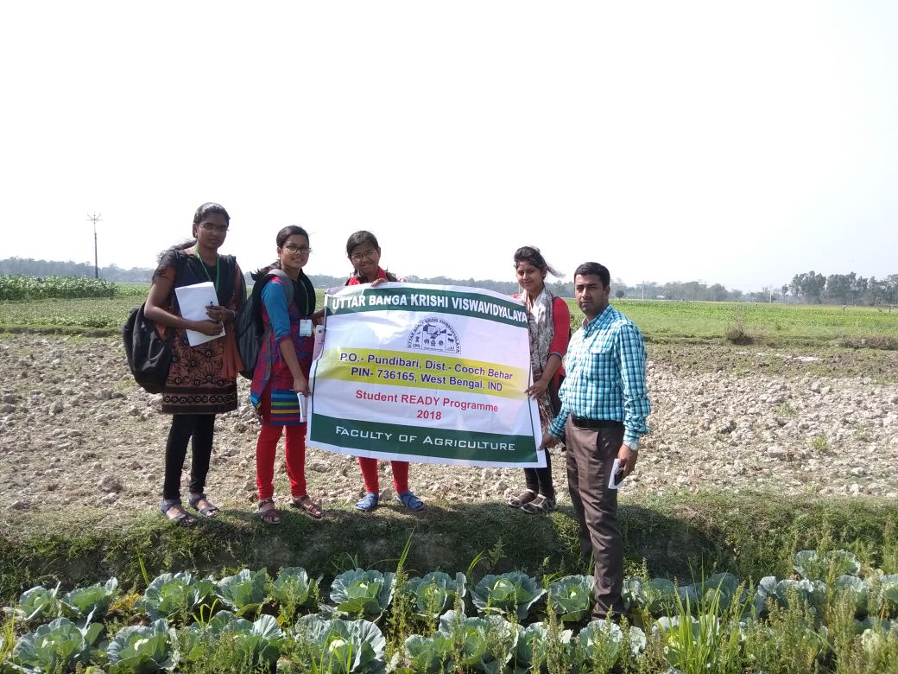

**CONCLUSION**

* From above information we conclude that farmers of these village need more improved practices to overcome diseases.
* Farmers should follow proper seed treatment as prevention is better than cure.
* They should be acquainted with the proper knowledge of crop diseases.
* They should be encouraged to include newer group of fungicides with proper doses in their package of practices.
* So that they can recognize the disease at right time and take necessary measure against it.
* Thus they can increase productivity.
* Beside all these an awareness programme should be held to inform the farmers about the Integrated Disease Management.

**VII. DEPARTMENT OF genetics & PLANT BREeDING**

**OBJECTIVE**

* To know about the vegetative propagation methods used
* Best varieties grown in different season
* Visit to crop improvement experiments to get acquainted with

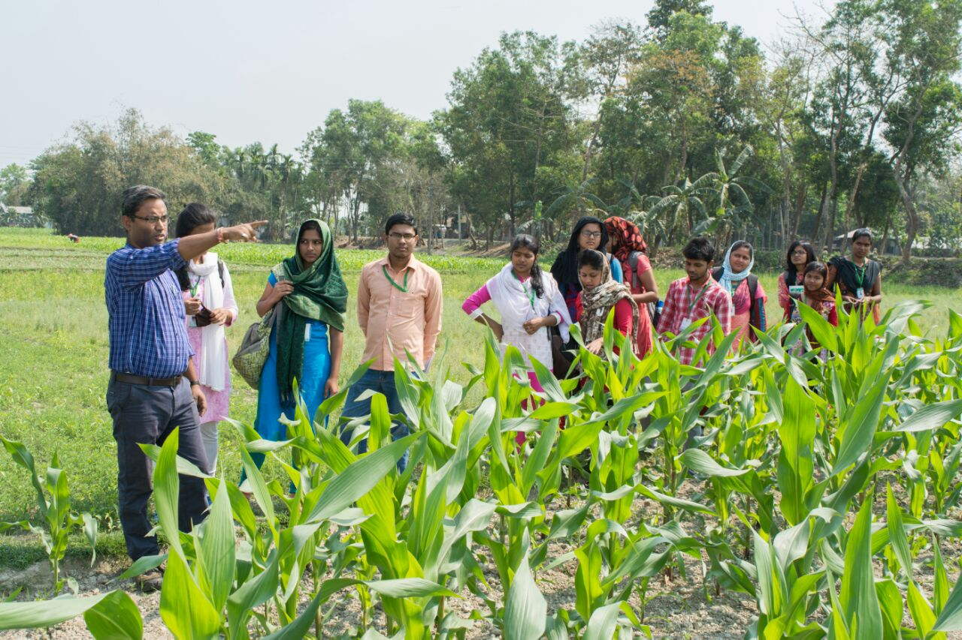

**Vegetative methods followed**

|  |  |  |
| --- | --- | --- |
| **Sl.no** | **crops** | **methods** |
| 1 | banana | sucker |
| 2 | mango | Grafting |
| 3 | potato | tuber |
| 4 | Burmese grape | layering |
| 5 | citrus | Stem cutting |

These are the various methods of vegetative propagation followed in this village.

Majority of the fruit crops grown here are propagated through vegetative methods and they are maintained as such.

**SEASONAL DISTRIBUTION OF CROPS IN THE VILLAGE**

* **Rabi:** mustard, Chili, cabbage, cauliflower, tomato, brinjal, potato, pointed gourd, rice, Maize.
* **Khariff- Rice**, okra, brinjal, bottle gourd.
* **Pre- khariff:-** lentil,jute,maize.,Okra.

**Best varieties grown** (Give yield for best varieties)

1. **Cereals**

**Aman rice**: Niranjana (yield ), swarna(yield ), Jamuna(yield ), Masuri(yield ), Ranjana(yield ).

**Boro rice**: Ananda(yield ), Parijat(yield ), NW 10(yield ).

**Maize**: DKC-9081(yield ), TATA(yield ), PAC-740(yield ).

1. **PULSES (Give yield)**

**LENTIL**: Moitree, Local varieties

**Field pea**: local varieties.

1. **VEGETABLES Give yield)**

**POTATO**: Punjab (Jyoti), Holland

**TOMATO**: Thrishool, Abija.

**CHILLI**: Eagle, Local varieties.

**CABBAGE:** Mid season variety, Local variety.

**CAULIFLOWER:** Local variety.

Most of the varieties of vegetables are of local varieties and they are cultivated for last few years.

1. **OILSEEDS**:

**MUSTARD:** B-9(Vinoy), PAN-69.

1. **FIBRE CROPS:**

**JUTE:** Tossa (JRO-878), Navin.

1. **FLOWER CROPS:**

Flower crops like chrysanthemum and marigold are cultivated for Religious ceremony and household purpose irrespective of good varieties.

1. **PLANTATION CROPS**:

**ARECANUT**: sumangala, bangla

**COCONUT:** Here instead as plantation crop coconut is grown as fruit crop of unknown variety. Here coconut is not cultivated on commercial scale

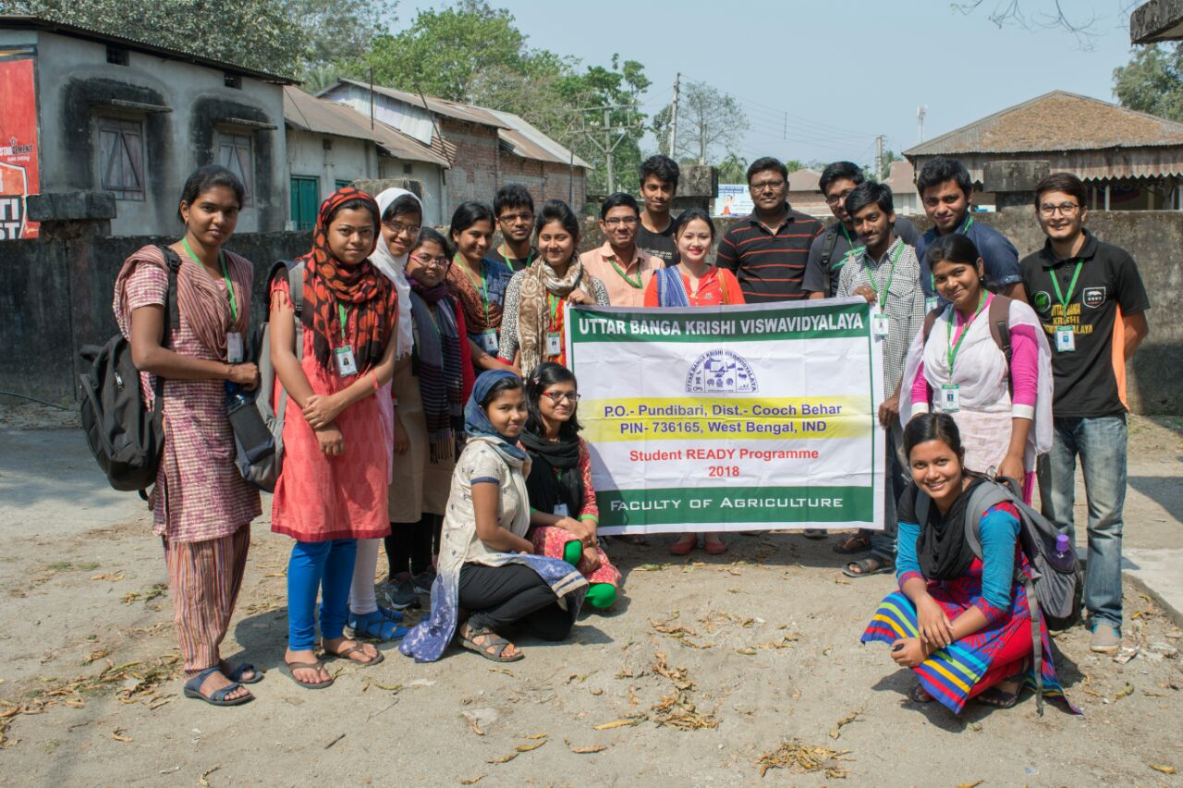

**CONCLUSION:**

* Farmers should conduct the agricultural offices for exposure to improved technologies, newly released varieties and their characters.
* Proper method of recording data should be practiced.
* Better screening methods should be adopted.
* The profitability of the crops can be increased by adopting proper Package of practices aided by proper application of manures and Fertilizers and minimizing the use of chemical fertilizers.
* Fertility status of soil should be maintained and cropping pattern should be changed at least every 2 years with incorporation of leguminous crops.

.

**VIII. DEPARTMENT OF SEED TECHNOLOGY**

Learning Objectives

* To study the major crops cultvated in this village
* To identify differenent source from where farmers get seed
* To understand the problems faced by the farmers regarding seed
* To study the ease of availability of quality seed in the village

**Why Quality Seed ?**

* Quality seed alone increases the yield by 15-20 per cent.
* Quality seed expresses full potential yield of the genotype under favorable cultivation environments.

**Different seed sources**

|  |  |  |  |  |  |  |
| --- | --- | --- | --- | --- | --- | --- |
| **Sl no** | **Name of the farmer** | **crop** | **Seed source** | | | |
| From other farmer | Farm saved seed |  | c/s |
| 1 | Farmer-I | Mustard |  |  |  | ⃝ |
| Potato |  | ⃝ |  |  |
| Maize |  |  |  | ⃝ |
| rice |  | ⃝ |  |  |
| 2 | Farmer-II | rice |  |  |  | ⃝ |
| okra |  |  |  | ⃝ |
| musur |  |  |  | ⃝ |
| potato |  |  |  | ⃝ |
| 3 | Farmer-III | rice |  |  |  | ⃝ |
| potato |  |  |  | ⃝ |
| mustard |  |  |  | ⃝ |
| 4 | Farmer-IV | rice |  |  |  | ⃝ |
| maize | ⃝ |  |  |  |
| rice |  | ⃝ |  |  |
| okra |  | ⃝ |  |  |
| cabbage |  |  |  | ⃝ |
| 5 | Farmer-V | potato |  |  |  | ⃝ |
| maize |  |  |  | ⃝ |
| mustard |  |  |  | ⃝ |
| garlic |  | ⃝ |  |  |
| 7 | Farmer-VI | maize |  |  |  | ⃝ |
| lentil |  |  |  | ⃝ |
| mustard |  |  |  | ⃝ |
| potato |  |  |  | ⃝ |
| 8 | Farmer-VII | mustard |  |  |  | ⃝ |
| rice |  |  |  | ⃝ |
| 9 |  | rice |  |  |  | ⃝ |
| maize |  |  |  | ⃝ |
| potato |  |  | ⃝ |  |
| tomato |  |  |  | ⃝ |
| 10 |  | maize |  |  |  | ⃝ |
| rice |  | ⃝ |  |  |
| cabbage |  |  |  | ⃝ |
| potato |  |  | ⃝ | ⃝ |
|  |  |  | | |  | |
|  |  | |
|
|
|
|  | |
|
|

**Classes of seed**

**NUCLEUS SEED**

**CERTIFIED SEED**

**TRUTHFULLYLABELLED SEED**

**FOUNDATION** **SEED**

**BREEDER SEED**

**Farm saved seed**

**Seeds from others**

* Farmer prefer certified seed comparing to other seed source.Hybrid seed are used mainly in case of maize and vegetable crops
* Regarding to the seed quality apects they are very concern to check whether the packet have certification tags.
* But the main problem is that some dealer used to sell low quality seed with a certification label.

*Problems faced by the farmers regarding seed*

* Inadequate availability of seed in desired amount
* Hybrid seeds have to be replaced year after year
* High purchasing cost
* Hybrid seeds require high amount of other inputs like fertilizer
* Hybrid varieties require improved practise

**Crops cultivated and their seed source**

1. MAIZE

Seed source ; hybrid seed

ii) RICE

SEED SOURCE ;Certified seed,farm saved seed

Varieties;Ranjana 819,Ranjith,yamuna 804 of PAN COMPANY

Nilanjana,Parijath of suphala company

1. MUSTARD

SEEED SOURCE;

VARIETY;pan 17

1. TOMATO

SEED SOURCE;Hybrid seed(F1)

Variety;TO-848

1. Cauliflower

Seed source;hybrid

Varieties:swarna,summer king

1. Potato

Seed source:farm saved seed,retailer

Varieties;jyoti,punjab lal

1. **Cabbage**

Seed source:farm saved seed,hybrid seed

Storage structures

Plastic bags

Gunny bags

Bamboo baskets

Heaps on floor in the corner of house

Seed treatment

Application of fungicides, insecticides, or combination of both

To disinfect them from seed born pathogenic organism and storage insects

|  |  |
| --- | --- |
| Crop | Chemical used by the farmer |
| Rice | Chlorpyriphos 3g/kg of seed |
| Cruciferous vegetables | Captan 1.5 to 2,5 g a.i /litre |
| Potato | Mancozeb 4g /litre, |
| Maize | Carbandazim 2g/litre  (Keep it in table) |

Intervention required

▪ Seed should be purchased from trustable sources

▪ Pracitse cultivation of legume crops after exhaustive crops like maize to maintain the soil health.legume crop cultivation reduces the nitrogen requirement

▪ Hybrid seed should be replaced every year.otherwise due to seggregation of character the cultivar may fail to give the desired yield

▪ Application of different inputs should be only to the required amount

▪Seed treatment using biofertilizers and bioprotectants will reduce the disesase incidence

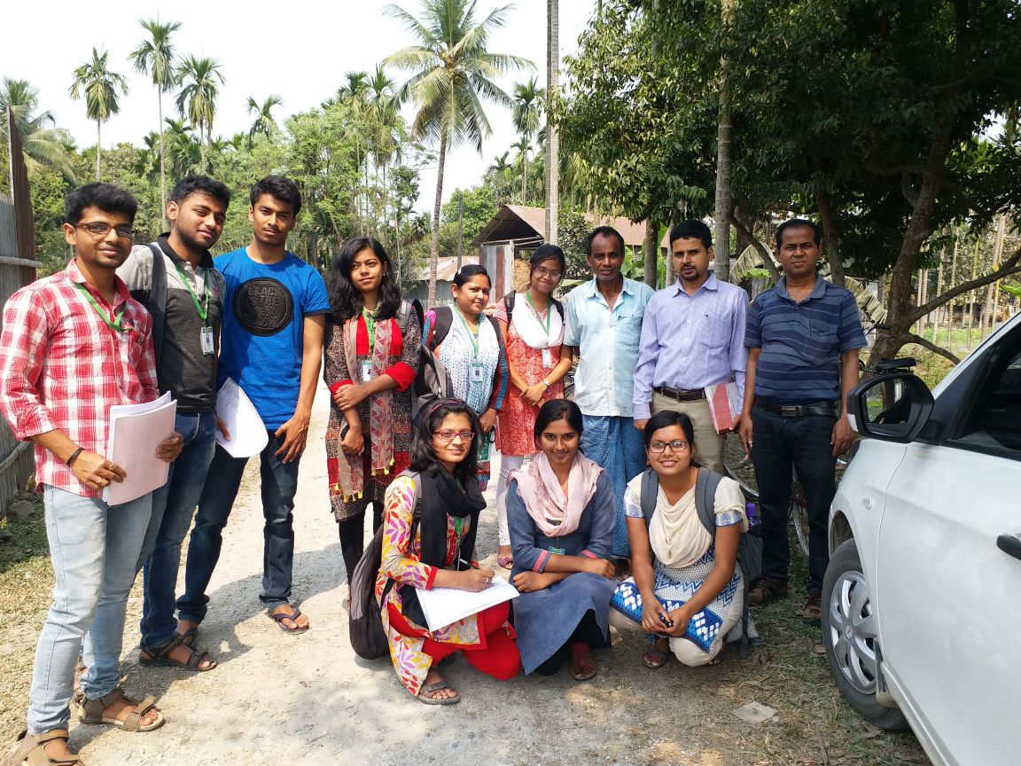

**IX. DEPARTMENT OF entomology**

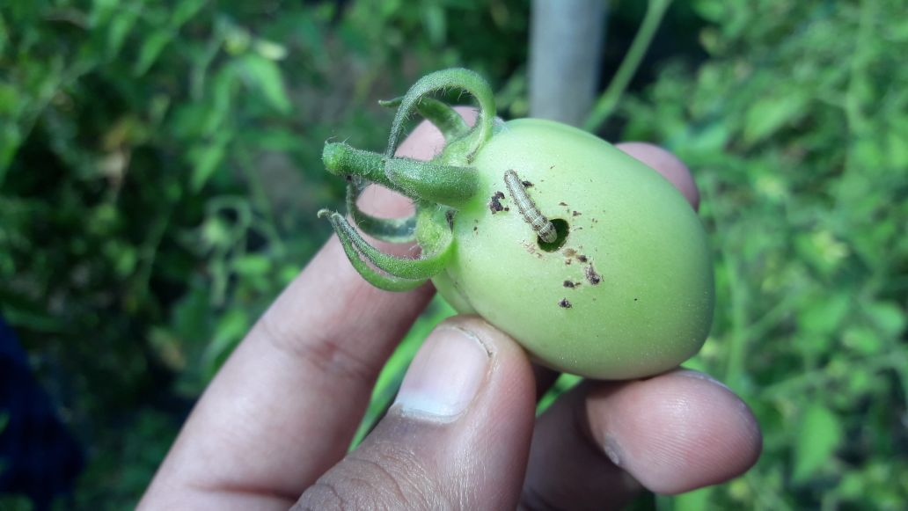

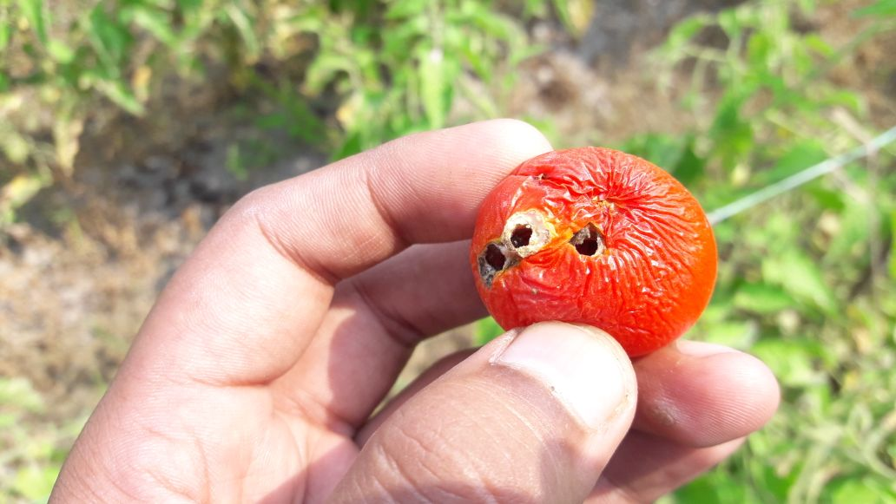

1. TOMATO:

Tomato fruit borer (*Helicoverpa* a*rmigera*)

**SYMPTOM OF DAMAGE:**

* Caterpillar bore the fruit and make the fruit unfit for consumption and marketing.

MANAGEMENT PRACTICE FOLLOWED BY FARMER:

* Application of lamda cyhalothrin@4ml/lit of water**.**

RECOMMENDATION:

* Application of Profenofos 50 EC @ 1.5L/ha
* Removal of crop debris
* Proper time of sowing
* Removal of infected plant parts
* Don’t apply same group of insecticides

1. MUSTARD: (Photograph)

Mustard aphid ( *Lipaphis* *ersyimi* )

SYMPTOM OF DAMAGE:

* Larvae feed on leaves
* It suck the plant sap and as a result curly leaf tip with poor pod set
* Ultimately reduction of yield

MANAGEMENT PRACTICE FOLLOWED BY FARMER:

* Application of Dimethoate(Banned insecticide) @ 5mL/L of water

RECOMMENDATION:

* Application of carbaryl 0.1%
* Application of methyl parathion 0.025%
* Removal of weed from the field
* Crop rotation
* Removal of infected plant parts from the field

1. BRINJAL: (Photo ?)

Fruit and shoot borer (Leucinodes orbonalis)

DAMAGE SYMPTOM:

* Larva bores into tender shoots resulting in drying of tip
* It also bores into developing fruits and bore hole plugged with excreta in brinjal fruit can be observed
* Damaged fruits unfit for marketing

MANAGEMENT PRACTICE FOLLOWED BY FARMER:

* Application of aldicarb@ 5ml/L of water

RECOMMENDATION:

* Application of systemic insecticide like chlorntraniliprole @ 2ml/L of water
* Setting up of pheromone trap (Lucinlure)
* After harvest of crop left over fruits and plants to be collected and destroyed before sowing of new crops
* If infestation is observed in the field before fruit formation remove and destroy affected shoot tip

1. CABBAGE AND CAULIFLOWER: (Photo ?)

Diamond back moth ( Plutella xylostella)

DAMAGE SYMPTOM:

* Mining and skeletanization of leaves
* Larvae also feed on cabbage and cauliflower

MANAGEMENT PRACTICE FOLLOWED BY FARMER:

* Application of lamda cyhalothrin @ 3ml/L of water, DBM resistant to this insecticide

RECOMMENDATION:

* Application of deltamethrin @ 10 g a.i.or cartap hydrochloride @ 175 g a.i./ha 22 days after planting and repeated twice at 10 days interval
* Use of Beauveria bassiana based biopesticides to control DBM
* Removal of infected plant parts
* Removal of crop debris
* Planting of non infected planting materials

1. OKRA: (Photo ?)

Leaf minor (Liryomyza sp.)

DAMAGE SYMPTOM:

* Zigzag leaf mines in okra leaf resulting in curling of the leaf
* Drying of terminal leaf

MANAGEMENT PRACTICE FOLLOWED BY FARMER:

* Application of carbaryl @ 4ml/L of water

RECOMMENDATION:

* Application of indoxacarb 14.5 SC @ 2ml/L of water
* Don’t apply same group of insecticides repeatedly
* Planting of healthy plant material
* Burning of infected plant parts
* Don’t apply high dose of nitrogenous fertilizer

*NEMATODE INFESTATION* OF RICE SEEDLING

1. In rice seedling root knot nematode(Meloidogyne *graminicola*) infestation is found (Photo ?)

DAMAGE SYMPTOM:

* Main diagnostic symptom is the formation of ‘root gall’ on root of rice seedling
* Stunted growth
* Yellowing of plant
* Wilting of plant

MANAGEMENT PRACTICE FOLLOWED BY FARMER:

* Before sowing the crop farmers dry their seeds on concrete floor under sunlight

RECOMMENDATION:

* Treatmentof nursery by carbofuran @ 0.1 kg a.i./ sq.meter
* After 40 day after transplanting apply Carbofuran@ 1kg a.i./ha
* Soaking of seed in 0.1%solution of carbosulfan25EC is also effective
* Neem cake can be used for nursery treatment

1. NEMATODE INFESTATION OF GARLIC (Photo ?)

In garlic Root knot ( Meloidogyne incognita) infestation is found

DAMAGE SYMPTOM :

* Stunted growth
* Yellowing of foliage
* Main diagnostic symptom is‘pig tail’ symptom of leaf and root gall formation on root of garlic

MANAGEMENT PRACTICE FOLLOWED BY FARMER:

* Only some farmer apply nematicide like carbofuran @ 3kg a.i./ha

RECOMMENDATION:

* Growing of antagonistic crop like mustard, marigold
* Don’t apply flooding irrigation when nematode attack the crop
* Before sowing the crop, soaking the seedling in systemic nematicide like oxamyl

Hedayetnagar has some inadequate and improper storage structure. The normally found storage structure in above mention village is given below

DULI:

* This structure is commonly found in the house hold for storing small amount of grain

Advantage:Easy to handle,

Easy for taking out grains for daily consuming purpose.

* Disadvantage:It is more succeptable to infestation of storage pest,Viability & vigour is reduced, Rodent infestation is high
* PLASTIC BAG:
* This structure is also found for temporary storing of grain like mustard, maize,rice etc

Advantage:it is moisture proof, storage pest can not easily penetrate through it ,it is easy for handeling as well as for transportation

Disadvantage:this is heavily infested by rodents

* STORE ROOM (Photo ?)

This storage structure is also found at Hedayetnagar for storing “kalo nunia dhan”

* Description :The floor is made up of concrete. On the floor the grain is kept . Around the grain a border is given. It has three wall & a window. The roof is made up of tin

Advantage It is easy for regular monitoring , ,

* Disadvantage: Initial investment is high for establishment this type of storage structure , it is more prone to damping of the grain

TYPES OF STORAGE PESTS

PRIMARY PESTS (Photo ?):

1.Rice Weevil

2.Pulse beetle

3.Potato tuber moth

SECONDARY PESTS:

1.Red flour beetle

*STORAGE PEST:*

* Here very little level of store grain pest is found
* In rice weevil(Sitophilus Oryzae) infestation is found
* In maida ,suji flour beetle(Tribolium castaneum) infestation is found
* In pulse Pulse beetle( Callosobruchus chinensis) infrestation is found

In potato ,potato tuber moth ( Phthorimea operculella) infestation is found

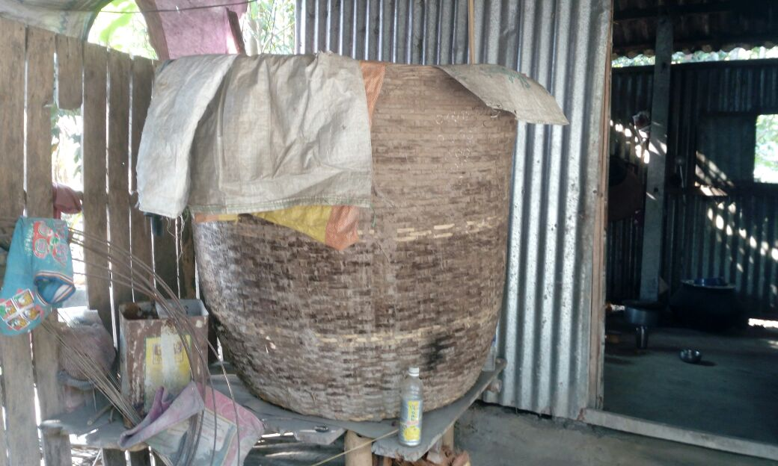

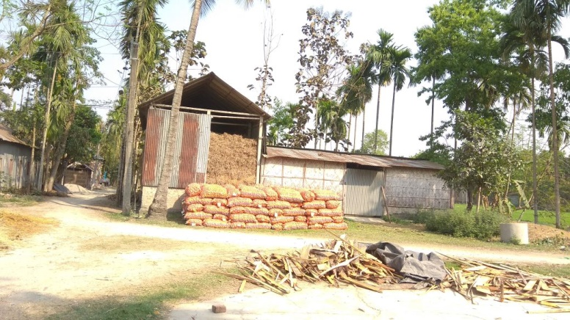

* RECOMMENDATION:

During storing the grain moisture content should be below 10%

* The storage structure should be clean
* The grain must be kept on the wooden floor ,do not keep the grain directly on the floor
* Proper sanitation must be maintained for storing the grain

|  |  |  |  |
| --- | --- | --- | --- |
| * ***Chemical name***   INSECTICIDEs | **Trade name** | ***Company*** | ***Formulation*** |
| ***1.Dimethoate*** | **Tafgor** | ***TATA*** | ***30%EC*** |
| ***2.Cypermethrin*** | **Ustad** | ***UPL*** | ***10%EC*** |
| ***3.Fenvelarate*** | **Tatafen** | ***TATA*** | ***20%EC*** |
| ***4.Bifenthrin*** | **Imperial** | ***ADMA*** | ***10%EC*** |
| ***5.Chloropyriphos*** | **Chloro-20** | ***JU PESTICIDE*** | ***20%EC*** |
| ***6.Imidaclorpid*** | **Confidor** | ***CRYSTAL*** | ***17.8%SL*** |
| ***7.Lamda cyhalothrin*** | **Agent plus** | ***INDOFIL INDUSTRIES LTD*** | ***5%EC*** |
| ***7.Fipronil*** | **Regent** | ***BAYER*** | ***5%SC*** |
| ***8.Thiaclorpid*** | **Alanto** | ***BAYER*** | ***27.1%SC*** |
| ***9.Spiromesifen*** | **Oberon** | ***BAYER*** | ***22.9%SC*** |
| ***10.Chlorpyriphos+cypermethrin*** | **Hamla-550** | ***GHARD CHEMICAL LTD*** | ***(50+5)%=55%EC*** |
| ***11.Spinosad*** | **Conserve** | ***NAGARJUNA AGROCHEMICAL.LTD*** | ***45%SC*** |
| ***12.Flubendiamide*** | **Fame** | ***BAYER*** | ***39.35%SC*** |
| ***13.Chlororantraprole*** | **Coragen** | ***E.I.DUPON INDIA LTD*** | ***18.5%SC*** |
| ***14.Chlorpyriphos50%EC+cypermethrin5%EC*** | **Double star** | ***SWAL CORPORATION .LTD*** | ***55%EC*** |
| ***15.Profenofos40%EC+Cypermethrin4%EC*** | **Profex super** | ***NAGARJUNA AGROCHOM. LTD*** | ***44%EC*** |
| ***16.Cypermethrin3%EC+Quinalphos20%EC*** | **Viraat** | ***UPL*** | ***23%EC*** |
| ***Chemical name*** | **Trade name**  FUNGICIDE | ***Company*** | ***Formulation*** |
| ***1.Propineb*** | **Antracol** | ***BAYER*** | ***70%WP*** |
| ***2.Thiophanate methyl*** | **Roko** | ***NIPON SODA CO. LTD*** | ***70%WP*** |
| ***3.Metalaxyl+Mancozeb*** | **Matco** | ***INDOFIL INDUSTRIES .LTD*** | ***72%WP*** |
| ***4.Carbendazim+Mancozeb*** | **SAAF** | ***UPL*** | ***75%WP*** |
| ***5.Azoxystrobin+Mancozeb*** | **Delma** | ***SWAL*** | ***75%WP*** |
| ***6.Fenamidone+Mancozeb*** | **Sectin-60WG** | ***BAYER*** | ***60%WP*** |
| ***7.Mancozeb*** | **Indofil-M-45** | ***INDOFIL*** | ***75%WP*** |
| ***8.Carbendazim*** | **Bavistin** | ***CRYSTAL CROP PROTECTION PVT.LTD*** | ***50%WP*** |
| ***9.Captan*** | **Captaf** | ***TATA*** | ***50%WP*** |
| ***10.Hexaconazole*** | **Contaf plus** | ***TATA*** | ***5%SC*** |

|  |  |  |  |
| --- | --- | --- | --- |
| **Chemical name** | **Trade name** | **Company** | **Formulation** |
| **1.Ethoxysulfuron** | **Sunrice** | **BAYER** | **15%WP** |
| **2.Propaquizafop** | **Agil** | **ADMA** | **10%EC** |
| **3.Atrazine** | **Atrafil** | **INDOFIL INDUSTRIES .LTD** | **50%WP** |
| **4.2,4-D sodium salt** | **2,4-D** | **Nagurjana** | **80%wp** |

**Agro-Ecosystem Analysis**

**INTRODUCTION:**

* **AESA** is an approach,which can be gainfully employed by extension functionaries and farmers to analyze the field situations with regards to pests,defenders,soil conditions plant health and the influence of climatic factors and their relationship for growing a healthy crop.
* The Integrated Pest Management has been evolving over the decades to address the deletorious impacts of synthetic chemical pesticides on environment ultimately affecting the interest of the farmers.The economic Threshold Level (ETL)was the basis for several decades but in modern IPM (FAO 2002)emphasis is given to AESA where farmers take decisions based on large range of field observations.
* Decision making in pest management requires a through analysis of the agro-ecosystem. Farmers has to learn how to observe the crop,how to analyze the field situation and how to make proper decision for their crop management.This process is called the **AESA.**

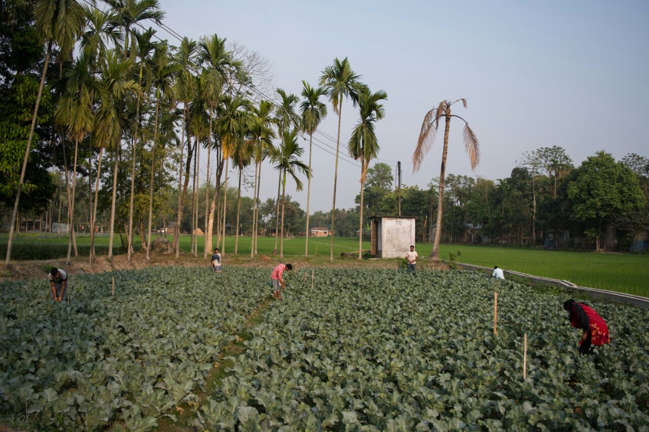

**COMPONENTS:**

The basic components of AESA are:

▪ Plant health at different stages.

▪ Built in compensation abilities of plants.

▪ Pest and defender population dynamics.

▪ Soil conditions.

▪ Climatic factors.

▪ Farmers past experience.

**HOW AESA HELP US IN DECISION MAKING IN PEST MANAGEMENT:**

AESA is one of the most important decision making tools now-a-days, it helps farmers very efficiently in managing crop against harmful pests by making timely decision.

**TIMELY DECISION***:*AESAlearns farmers to make timely decision.

**BASED ON ALL OBSERVATIONS*:*** AESAhelps in making decision based on all observations i.e.abiotic and biotic factors.

**PAST EXPERIENCES ARE CONSIDERED:**AESAhelps to make decision considering farmer’s past experiences*.*

**KNOWLEDGE ABOUT SEASONALVARIBILITY:**AESAhelps to determine seasonal variability about Pest number,severity & incidence.

**PRINCIPLES:**

* Grow a healthy crop.
* Observe the field regularly.
* Plant compensation ability.
* Understand the conserve defenders.

**STRATIGIES OF AESA:**

1.DO NOTHING

2.INCREASE RESISTANCE

3.REDUCE SUSCEPTIBILITY

4.COMBINATION OF BOTH 2+

**AESA METHODOLOGY**

* Go to field and make 5 blocks (1 block in ach corner and 1 in middle).
* Observe the plants in those blocks(1m*1m)keenly and record about observations.
* Observations contain Biotic & Abiotic factors both-

|  |  |
| --- | --- |
| * BIOTIC FACTORS | * ABIOTIC FACTORS |
| 1.Plant—growth stage,number of leaves / branches, number of affected leaves | 1.Water |
| 2. Pest: | 2. Weather |
| 3.Defenders |  |
| 4. Rats |  |
| 5.Weeds |  |
| 6.Disease |  |

* Change the blocks weekly clockwise or anticlockwise.
* Take data about weekly observations
* Calculate P:D(Pest:Defender)ratio in field condition
* At the very end make a conclusion about field condition
* Recommendation should be given about appropriate strategy should be taken.

**P:D (PEST:DEFENDER) RATIO**

*It means the number of biological control agents i.e. natural enemies per pest in that particular field condition.

*It is only applicable in case of absolute measure.

**FIELD OBSERVATION DURING AESA IN CAULIFLOWER FIELD:**

|  |  |  |  |  |
| --- | --- | --- | --- | --- |
|  | OBSERVATION 1 | OBSERVATION 2 | OBSERVATION 3 | OBSERVATION 4 |
| Crop | **Cauliflower** | **Cauliflower** | **Cauliflower** | **Cauliflower** |
| Date | **5.03.18** | **12.03.18** | **19.03.18** | **26.03.18** |
| Growth Stage | **Seedling** | **Vegetative** | **Vegetative** | **Heading** |
| Weather Condition | **Bright Sunny Day, moderate cool climate** | **Bright Sunny Day, moderate cool climate** | **Bright Sunny Day, hot weather** | **Bright Sunny Day, very high temperature** |
| Soil Health | **Almost adequate moisture** | **Little bit lacking of moisture** | **Moisture is less than adequate** | **Moisture deficiency** |
| No of plants/sq.m.(ave of 5 blocks) | **25** | **30** | **24** | **27** |
| No of leaves/plant(ave. of 5 blocks) | **11** | **18** | **20** | **25** |
| No of affected leaves/sq.m.(ave of 5 blocks) | **8** | **17** | **18** | **22** |
| No of pests/sq.m.(ave of 5 blocks) | **5** | **7** | **10** | **12** |
| No of natural enemies/sq.m .(ave of 5 blocks) | **2** | **4** | **4** | **7** |

**P:D Ratio in this particular field(average):**

**(5+7+10+12):(2+4+4+7)=34:17=2:1**

**PESTS OBSERVED-**

1.Flea beetle

2.White fly

3.Leaf webber

**NATURAL ENEMIES OBSERVED-**

**1.Spider**

**2.Some beetle**

**WEEDS OBSERVED-**

**1*.Cynodon dactylon***

**2*.Argemone maxicana***

**WEEDS SEEN IN NEARBY FIELDS*-***

**1.*Echinocloa colonum***

**2*.E.crusgelli***

**STRATIGIES TO BE TAKEN:**

**P:D RATIO is not good in this case,Moisture stress is there; this may cause some pests attack in future and cause disease incidence.**

**---so,INCREASING RESISTANCE through assuring moisture availibility and some changes in fertilizer dose**

**and using resistant varieties is the proper management strategy for this field.**

**ADVANTAGES OF AESA OVER ETL:**

|  |  |
| --- | --- |
| AESA | ETL |
| * 1.Damaged by a density of pest can be predicted to some extent. | * 1.Damage by a density of pests can not be predicted at all. |
| * 2.It is based on both biotic and abiotic factors | * 2.It does not consider plant compensation ability,abiotic factors |
| * 3.It gives importance on natural enemies. | * 3.It does not gives importance on natural enemies |
| * 4.It is a very scientific modern tool in decision making | * 4.this is a conventional method of pest management |

**RECOMMENDATION:**

* AESA is a very scientific observation and it helps in decision making properly more than the conventional methods.So use of AESA instead of other methods in decision making for pest management AESA is suggested through 4 important stratigies.

**X. DEPARTMENT OF AGRICULTURAL ECONOMICS**

**INTRODUCTION:**

* *CROPPING SYSTEN ECONOMICS*  implies to study the production & economic parameter of each crop individually & also as a whole.
* And it also includes socio-economic, demographic issue of the farming community.
* *CROPPING SYSTEM*  is the pattern & management to derive benefits from a given resource based on under specific environmental condition.
* *eg :*  jute- aman paddy-vegetables
* maize-paddy-mustard
* rice-wheat

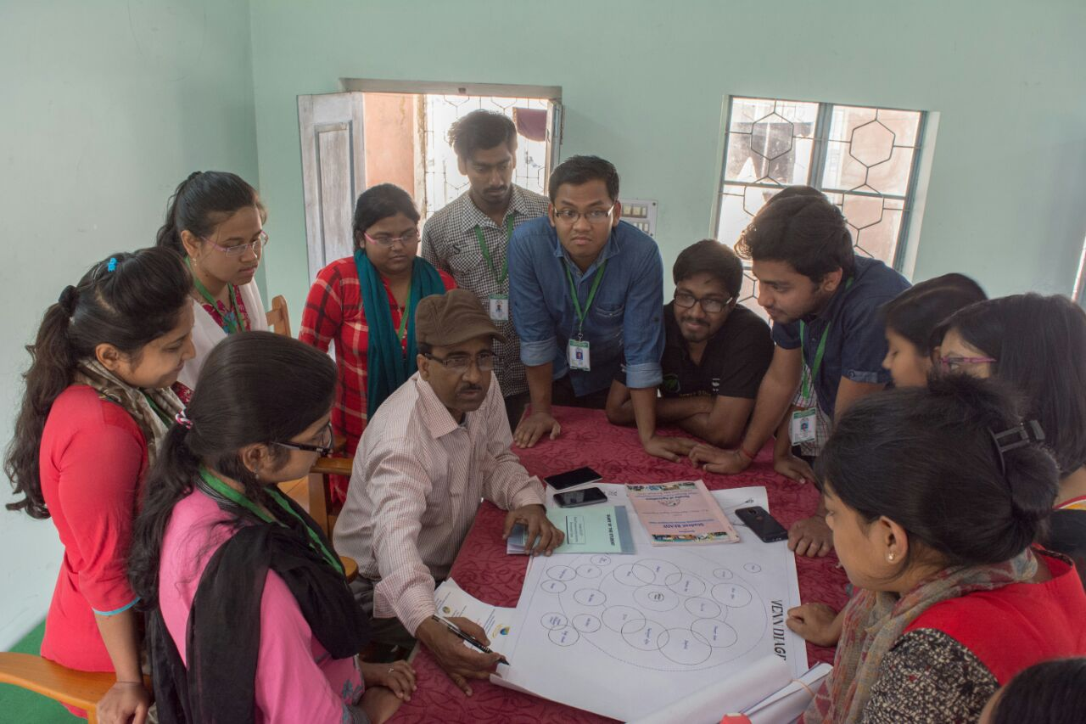

**objective**

1. The study tries to trace out different economic parameter of cropping system & analysis

upon them

2. Analysis of different factors responsible influencing the yield loss.

**Land details**

**Average land olding of Hedayetnagar is 5bigha.**

**Source of Information**

|  |  |  |
| --- | --- | --- |
| **Source** | **Score** | **Rank** |
| **KPS** | **38/90** | **3rd** |
| **Fertilizer shop/Dealer** | **77/90** | **1st** |
| **University** | **0** |  |
| **N.G.O./Club** | **0** |  |
| **BANK** | **7/99** | **5th** |
| **TV/RADIO** | **5/90** |  |
| **NEIGHOUR** | **42/90** | **2nd** |
| **MOBILE** | **8/90** | **4th** |

**Cosmopolitanism**

**Perception about yield gap**

|  |  |
| --- | --- |
| Responses by the farmers | Frequency |
| Yes in all crops | 20 |
| Yes in some crops | 60 |
| No, not in any crop | 20 |
| Can’t understand | 0 |

General factors underlying yield gap

|  |  |  |  |  |
| --- | --- | --- | --- | --- |
| Possible Factor | Frequency distribution | | | |
| **Fully agreed** | **Partially agreed** | **Not agreed at all** | Can’t tell |
| Lack of orientation towards improved crop culture | **40** | **56.6** | **3.33** | 0 |
| Lack of awareness about improved package of practices | **53.33** | **36.667** | **6.667** | 0 |
| Lack of sufficient family manpower | **43.33** | **53.33** | **3.33** | 0 |
| Lack of manpower at time of crop operation (Migration problem) | **56.667** | **30** | **16.67** | 0 |
| Lack of managerial ability (instinct) | **56.66** | **30** | **16.67** | 0 |
| Lack of co-ordination / fellow feelings among themselves | **6.66** | **43.33** | **46.66** | 0 |
| Adverse climate situation | **36.66** | **43.33** | **16.66** | 0 |
| Illiteracy / little education of the farm family head (decision making personnel) | 30 | 40 | 30 | 0 |

Technical factors underlying yield

|  |  |  |  |  |
| --- | --- | --- | --- | --- |
| Possible Factor | Frequency distribution | | | |
| **Fully agreed** | **Partially agreed** | **Not agreed at all** | Can’t tell |
| Lack of improved technological know-hows | **53.33** | **46.67** | **0** | 0 |
| Lack of zone-specific technological know-hows | **56.66** | **43.36** | **0** | 0 |
| Lack of seed of suitable variety of crop  If yes, name the crops… | **30** | **50** | **20** | 0 |
| Poor quality of soil/land (Barren / salty) | **3.33** | **53.33** | **40** | 3.33 |
| Lack of irrigation water (availability / accessibility) | **20** | **36.66** | **43.33** | 0 |
| Situation of land (Low/ High land) | **30** | **26.66** | **43.33** | 0 |
| High disease and pest infestation | **53.33** | **36.67** | **10** | 0 |
| Low availability of insecticides / herbicides | **20** | **53.33** | **26.67** | 0 |
| Low availability of Organic Manure at disposal | **23.33** | **50** | **23.33** | 3.33 |
| Size of holding (Small) | **40** | **20** | **20** | 0 |
| Low availability of mechanical power (Tractor / Power Tiller) during crop season | **33.33** | **23.33** | **53.33** | 0 |
| Lack of Market facilities (keeping unsold goods, standard weighing device etc.) | **36.66** | **30** | **33.34** | 0 |
| Lack of for-warning system (weather, disease, price etc.) | 50 | 36.67 | 13.33 | 0 |

Financial factors underlying yield gap

|  |  |  |  |
| --- | --- | --- | --- |
| Possible Factor | Frequency distribution | | |
| Fully agreed | Partially agreed | Not agreed at all | | Can’t tell |
| Lack of capital/finance for crop cultivation | 40 | 56.67 | 3.33 | | 0 |
| Lack of capital/finance at right time | 56.66 | 36.67 | 6.67 | | 0 |
| Lack of crop insurance | 43.33 | 53.33 | 3.33 | | 0 |
| Lack of knowledge about Financial Institutions (Bank, Co-Operatives, etc.) | 56.67 | 30.00 | 13.33 | | 0 |
| High (input) cost of cultivation | 63.33 | 33.33 | 3.33 | | 0 |
| High initial investment for crop cultivation (for infrastructure etc.) | 43.33 | 46.67 | 10.00 | | 0 |
| (Lack of incentive due to) low harvest price | 26.67 | 56.67 | 16.67 | | 0 |
| Price volatility/instability (both input/ output) | 66.67 | 16.67 | 16.67 | | 0 |

**General factors for reducing yield gap**

|  |  |  |  |  |  |
| --- | --- | --- | --- | --- | --- |
| Suggestions | Urgently needed | Needed but later | Partially Needed | Not needed | Cannot tell |
| Increasing the extension net-work by Govt./University officials | **56.67** | **23.33** | **16.67** | **0** | 3.33 |
| Conducting Regular Training Programmes on technological know-hows | **40.00** | **6.67** | **46.67** | **6.67** | 0 |
| Development of knowledge/ information kiosk at the nearest village centre | 63.33 | 6.67 | 26.67 | 3.33 | 0 |

Technical factors for reducing yield gap

|  |  |  |  |  |  |
| --- | --- | --- | --- | --- | --- |
| Suggestions | Urgently needed | Needed but later | Partially Needed | Not needed | Cannot tell |
| Timely availability of inputs (certified seed, fertilizer etc.) | 60 | 13.33 | 20 | 6.66 | 0 |
| Establishment/Increasing of Regulated Markets | 43.33 | 26.66 | 26.66 | 3.33 | 0 |
| Development of forwarning system for disease, pest, price etc. | 50 | 26.66 | 20 | 3.33 | 0 |
| Arrangement for regular testing of soil | 36.667 | 13.3 | 40 | 6.67 | 3.33 |
| Messaging through Mobile on crop culture etc. | 26.6 | 23.1 | 29.97 | 9.99 | 9.99 |

Financial factors for reducing yield gap

|  |  |  |  |  |  |
| --- | --- | --- | --- | --- | --- |
| Suggestions | Urgently needed | Needed but later | Partially Needed | Not needed | Cannot tell |
| Availability of credit in time | 39.96 | 26.64 | 29.97 | 3.33 | 0 |
| Arrangement of Crop Insurance facility | 23.31 | 33.3 | 33.3 | 9.99 | 0 |

CONCLUSION:

* It reveals from the presentation that existing cropping system is to some extent efficient,
* The major cropping system flow is MAIZE-AMAN-MUSTARD/VEGETABLEs in this region.
* To reduce this yield gap more effort should take on

forecasting system,

availability of modern cultivation practices

& easycredit system for cultivation

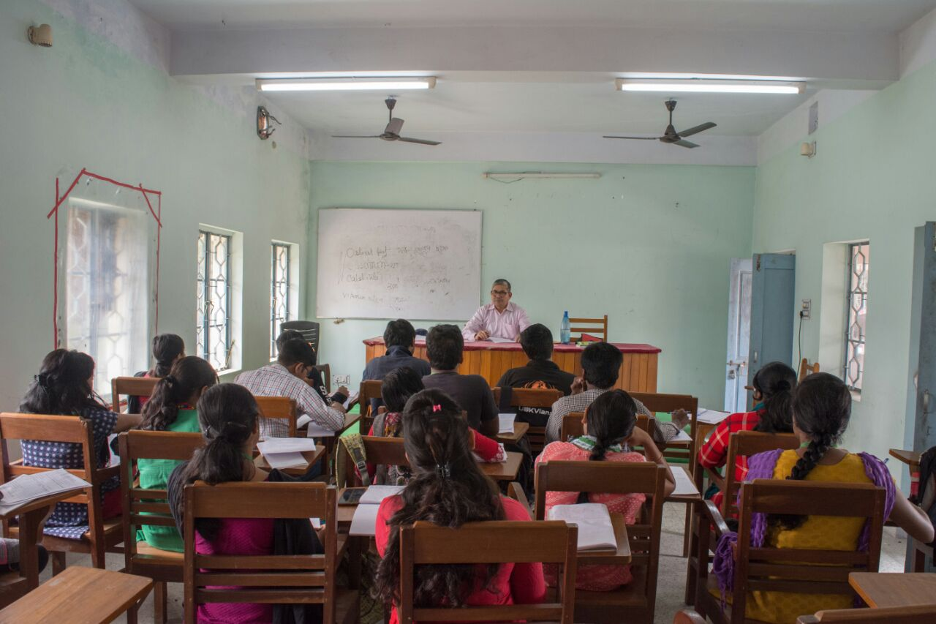

**XI. ANIMAL SCIENCE & FISHERY**

LIVESTOCK AND POULTRY PRODUCTION AND THEIR MANAGEMENT

**OBJECTIVE:**

* Information on available LIVESTOCK & POULTRY resources ,their role in AGRICULTURE (IFS) economic importance including women empowerment.
* To be acquainted with the available animal feed resources (conventional & unconventional), fodder production ,availability of grass and grassland ,existing farmers’ practices of feeding to animals & poultry.
* To know the challenges including diseases in changing scenario for addressing it through proper plan.

**INTRODUCTION:-**

*THE ROLE OF LIVESTOCK IN VILLAGE ECONOMY AND OTHER RELEVENT ISSUES*

Livestock plays an important role in village economy. Livestock contributed 16% to the income of small farm households .Livestock provides not only food for their producers ,but also a range of other products which could be sold or consumed by the livestock owner to provide income nutrition and fuel. The major products of livestock include meat , milk ,egg, manure which is used as fertilizer or fuel ,fiber .In addition to these products livestock serve as an asset and may provide a reserve that can be converted to cash in times of need.

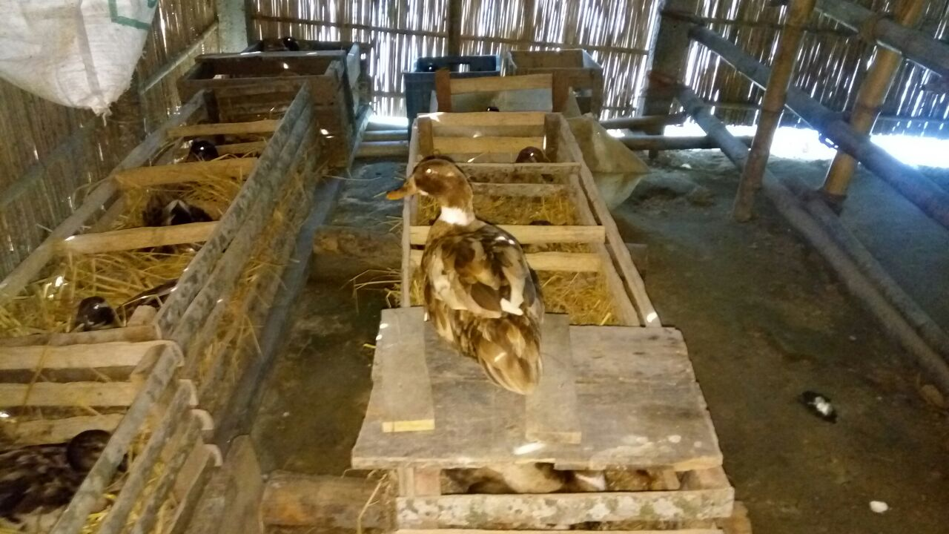

**Some questionnaire which are..**

**What is the percentage of people having livestock in this village?**

1. **How many of them are having cross bred?**
2. **How many of them are having desi bred of cow?**
3. **How many poultry farms are there in this village?**
4. **Apart from having cow,poultry,what are the other livestocks they are having?**
5. **Their method of disease management.**
6. **Whether they are getting any Govt. benefit or not& what the benefit they want ?**

**TABLE NO.- 1**

**Animal resources ,available**

|  |  |  |  |  |  |  |
| --- | --- | --- | --- | --- | --- | --- |
| **TABLE 1.**  **ANIMAL SP.** | **% OF FARM FAMILY REARING LIVESTOCK** | **PURPOSE OF REARING** | **PRODUCTION ON OF MILK/EGG/MEAT** | **APPROX. INCOME PER UNIT OF PRODUCTION/ANIMAL** | **ECONOMIC INPUT(RS)** | **OUTPUT(RS)** |
| **1.COW** | ***85%*** | Domestic purpose(milk purpose) | 3-4 lt./cow/day | 40Rs/lt. milk | 50-60RS./day | 6000/month |
| **2.DUCK** | 30% | Egg purpose | 25-30 egg/day | 6Rs./egg | Not required | 4500/month |
| **3.BROILER** | 4% | Meat purpose | 2500kgmeat/2000Broiler | 200rs/broiler | Not required | 30000-40000/month |
| **4.GOAT** | 60% | Meat purpose(for selling0 | 10-12KG Meat/goat | 5000-6000Rs/goat | Not required | 5000-6000Rs./goat |

**TABLE NO. 2: LIVESTOCK ON PERCENTAGE BASIS.**

|  |  |  |  |  |  |  |  |
| --- | --- | --- | --- | --- | --- | --- | --- |
| **SL.NO.** | **ANIMAL SP.** | **CROSS BRED(%)** | **MALE(%)** | **FEMALE(%)** | **DESI(%)** | **MALE(%)** | **FEMALE(%)** |
| **1.** | **COW** | **30%** | **5%** | **25%** | **80%** | **30%** | **50%** |
| **2.** | **GOAT** | **_** | **_** | **_** | **60%** | **20%** | **40%** |
| **3.** | **DUCK** | **_** | **_** | **_** | **20%** | **10%** | **10%** |
| **4.** | **PIGEONPEA** | **_** | **_** | **_** | **10%** | **5%** | **50%** |

**RESULT & DISCUSSIONS**

Management practices in the field of housing,feeding, health care ,general care & disease management practices etc. were observed. The result of the study pertaining to farming practices followed by the farmers are presented under following sub-headlines...

**HOUSING SYSTEM & MATERIALS USED FOR ITS CONSTRUCTION**

The findings related to the housing system of the cattle , poultry, duck followed by the respondents are presented in the table 3.

A close look at the table shows that all the farmers reared their livestock in intensive system of rearing .

The roof of the shed was mainly constructed with tin (94%).

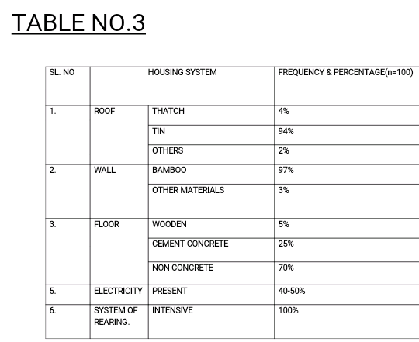 Majority of the farmers (80-85%) used bamboo for the construction of side walls.

Most of the cattle shed were constructed with locally available materials & floor was non concrete .

A small percentage of farmers fitted electricity in their cattle shed.

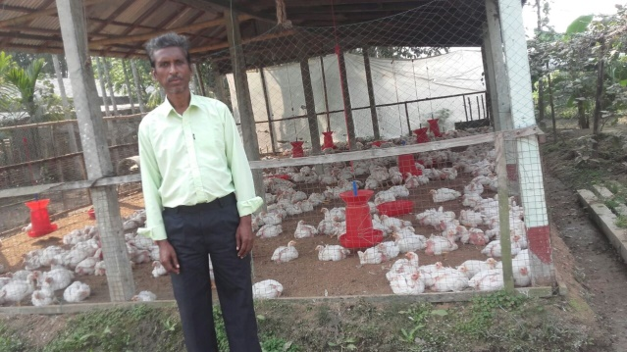

**FEEDING PRACTICES**

The respondents of Hedayetnagar village practiced good feeding system . It can also be seen that green fodder + concentrate feeding was practiced by some (40%) dairy farmers while most of the farmers use green grass ,rice straw, boiled rice water, corn grain to their livestock. Most of them fed 2-3 kg concentrate per day to their lactating cow. Dry fodder was not available in the study area. The most common concentrate mixture consisted of bran ,wheat flour ,oilcakes & salt . Most of the respondents supplied feed 3 times a day . The respondent did not practice fodder cultivation which might be due to lack of cultivable land & irrigation facility.

**HEALTH CARE PRACTICED BY FARMERS**

* Most of the respondents were going for vaccination against contagious disease prevalent in area such as FOOT &MOUTH disease and KHORAI disease .
* In case of poultry RANIKHET disease& CHICKEN POX which are highly prevalent in Hedayetnagar village.
* It was observed that in most part of the study area ,veterinary doctors were not available when needed by the farmers.
* TIME OF VACCINATION ,INTERVAL , DURATION ......which are given in the following chart no..4
* **VACCINATION SCHEDULE FOR CATTLE**

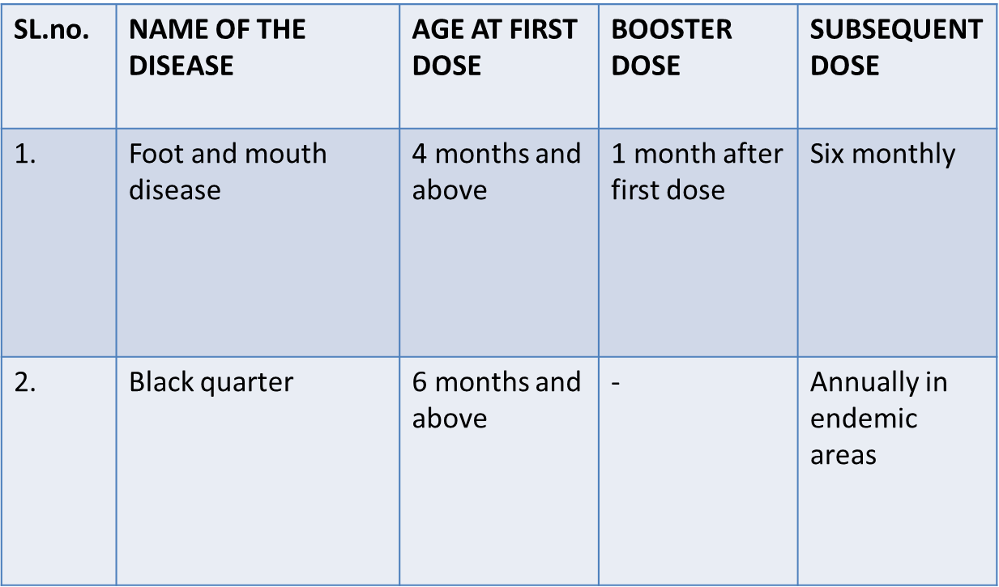

* VACCINATION SCHEDULE FOR BROILER

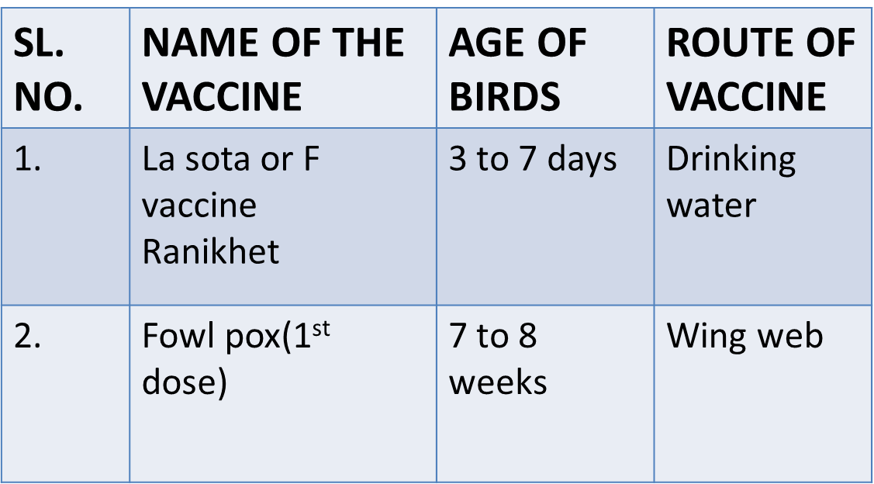

**MEDICINES FOR CURING DISEASE OF BROILER**

**KLEANTECH**

**Most powerful biocide ,effective at broad range of ph. range 2-11.very effective on BIOFILMS,prevent regrowth.**

**INNOCLEAN-**

Effective against a wide range of bacteria,viruses,fungi and protozoa including almost all poultry pathogens.

Improve water quality ,thereby improves health and productivity.

Economic benefits of livestock

* Income generation-Livestock rearing not only provide nutritional household security to rural families but extra family income also.
* Cattle dung which is widely used as organic manure which is environmentally safe for cultivation.
* Can be used as drought animal in carrying out farm operations such as ploughing and harrowing.

**CONSTRAINTS FACED BY FARMERS OF HEDAYETNAGAR VILLAGE.**

* Lack of improved livestock population.
* Inadequate of dry and green fodder.
* Poor marketing facilities.
* Shortage of adequate veterinary centers.
* Less facility of training
* Low milk production.
* Not satisfactory of meat production.
* Inadequate artificial insemination facilities.

**RECOMMENDATION**

* Feed animal less human food.
* Should keep animals healthy.
* Adopt smart supplements.
* Should feed quality food not quantity.
* Should feed animals less human food.
* Adequate insurance cover to guard high producing animals against risks need to be provided.

Should provide proper artificial insemination facilities

**XII. Report on the ponds and fish farmers and different fishery activities in the village hedayetnagar**

**A General Survey of Fish Farmers in hedayetnagar,Jateswar**

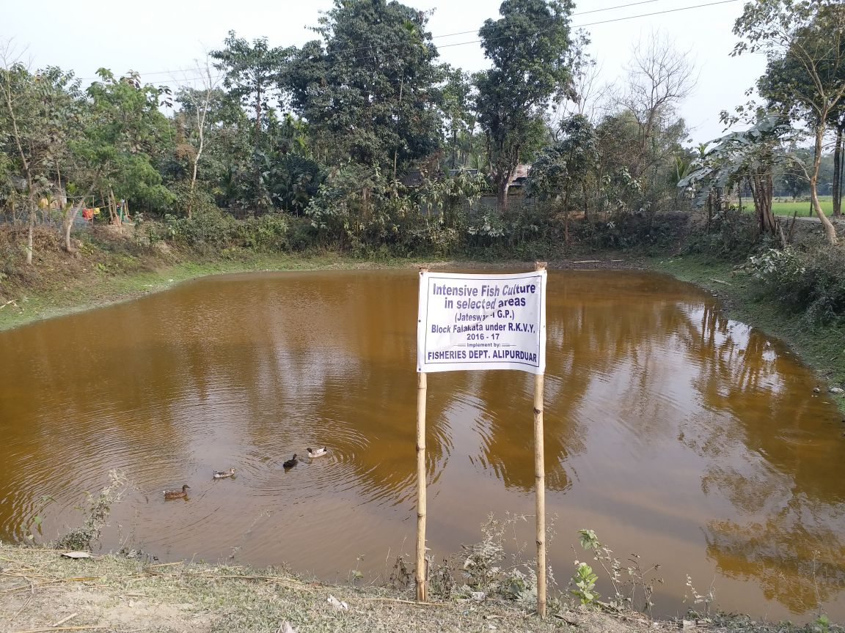

**Objective:**The various objectives identified are-

▪To aware the farmers about the various future prospects of fish culture

▪To provide them with various information about the different diseases which may cause losses.

▪ To encourage them to engage with fish culture in an integrated approach with the other farming system

* **Information of Interviewer:**

|  |  |
| --- | --- |
| **Interviewer Name:** | Ranjeet De Sarkar  Santosh Das  Swapan Bhadra |
| **Date of interview:** | 01/04/2018 |
| **Distance of farm pond from jateswar** | 5 km |

* **General Background Information of pond characteristics:**

|  |  |
| --- | --- |
| **Location** | Roadside |
| **Soil colour and texture** | Light brown and loamy |
| **Water retention capacity of soil** | medium |
| **Nutrient status** | medium |
| **Total pond area:** | 2 bigha |
| **Colour of water** | Light green |
| **Depth of water in pond throughout the year** | 9-10 ft |
| **Type of pond** | perennial |

Fishery activities in pond**: Generally we have seen the culture of indigenous (Rohu,katla,Mrigel)and exotic(silver carp,grass carp,common carp)carps in the same pond under semi intensive**

**fish farming.**

**Objective of composite culture:**

1. **Total ecosystem utilizes.**
2. **Maximum profit ,less labour cost,low input etc.**
3. **More than 4-5 fish cultured at a same time.**

**Fish activity in different layer:**

|  |  |
| --- | --- |
| **Layers of water** | Name of the fish |
| **Upper layer** | Catla |
| **Middle layer** | Rohu |
| **Bottom layer** | Mrigel |

* **Other important activities in pond:**

|  |  |
| --- | --- |
| **Dose and time table for lime application** |  |
| **Fertilizer application** | Urea(1 packet),ssp also used |
| **Source of fish seed** | Mainaguri |
| **Size of fish seed released into pond** | Size is around 2 inches and weighs 5-7 gram |
| **Name of the supplementary feed** | Rice bran,mustard cake etc |
| **No of netting throughout the culture period** | 3 times |
| **Fish disease** | Larnea ,gill rot |
| **First harvesting month and quantity** | After 1-2 months from seeding |

|  |  |
| --- | --- |
| **Species cultured:** | Catla, Rohu, Mrigal,silver carp,grass carp |
| **Years of experience in fish farming:** | 10 yrs |
| **Culture Period:** | 7 – 8 months |
| **Water quality:** | Good, Clear and Slightly greenish in colour |
| **Manures:** | Cow dung, goat, poultry excreta |
| **Feeding rate:** | 2-3times/day |

**XIII. VEGETABLE SCIENCE**

Status of vegetables grown in the study area is as follows :

|  |  |  |  |
| --- | --- | --- | --- |
| **Crop** | **Distribution** | **Growing Month** | **Nutrient (unit/bigha)** |
| Potato | 35% | Nov-Feb | 10:26:26@ 100kg, Urea@10kg, MOP@20kg,Zn@2kg,B@2kg |
| Tomato | 20% | Nov-Feb | 10:26:26@50kg ,Zn@4Kg, B@2kg, FYM@15kg |
| Brinjal | 10% | Sep –March | Urea@20kg, MOP@20kg, SSP@10kg,FYM@12kg |
| Garlic | 5% | Dec-Feb | 10:26:26@10kg , FYM@15kg |
| Cauliflower | 10% | Nov-Feb | 10:26:26@80kg,FYM@20kg SSP@3kg,MOP@1kg |
| Cabbage | 15% | Nov-Feb | 10:26:26@85kg,FYM@20kg SSP@5kg, MOP@3kg |
| Lablab bean | 5% | Oct-March | 10:26:26@16kg,FYM@25kg |

Basis for Selection of Crop

* GENERAL CRITERIA :
* Suitable land availability for particular crop
* Believe in tradition
* Risk bearing ability :Most of the farmer are afraid of taking risk of new crop.
* Resources : Due to limited resource & capital, farmer kept the land fellow
* Previous year experience show some criteria for crop selection
* By gaining the knowledge of other benefitted farmer , some farmer show their interest of cultivation

Specialised Criteria :

For Summer Crop:

* Okra give higher yield in a small area with low cultivation cost.
* Bottle gourd & Spine gourd cultivate in home garden.
* Pointed gourd gives higher profit margin with less cultivation cost & high demand in local market.
* For Winter Season Crop:
* For Garlic ,cabbage , cauliflower along with home garden they cultivated as commercial level with a profitable margin.
* Potato , Tomato , Brinjal are the main vegetables which give farmer a considerable profit margin .

Practice followed by farmer

Preparation of the land

FYM application (LIMITED) & fertilizer application

Sowing of seed (or transplant)

Irrigation

Intercultural operation

Harvesting

MAJOR PROBLEM IN CULTIVATION

* ***General problem*** :
* Lack of good quality seed
* Less irrigation facility
* Non availability of inputs & labour in time
* Lack of modern marketing channel
* No storage facility
* Fluctuation of market price
* High pest & disease infestation
* Soil acidity
* Submergence during rainy season

SPECIFIC PROBLEMS

* POTATO: Late blight infestation , infestation of aphid( M persicae)
* Tomato: Infestation of fruit borer , leaf minor,
* Brinjal: Infestation of FSB Wilting of the plant
* Cabbage: Head rot disease
* Bottle gourd:Infestation of red pumkin beetle(R . ferrugineous)
* Pointed gourd: Wilting of the plant
* Okra: Infestation of Pink boll worm (P. gossypiella)

RECOMMENDATION

* Cultivation of green manure crop
* Crop Rotation
* Avoid application of same group of insecticide
* Soil reclamation with lime per 3 year
* Crop insurance
* Better marketing facility
* Better Storage facility
* Better transportation
* Adaptation of Organic Cultivation practice.
* Use proper dose of agricultural chemical application

Future Scope of Vegetable cultivation

* Source of raw materials for processing industry .
* Source of organic vegetables for export purpose .
* After fulfilling of local market demand, vegetables export to the neighbour states Sikkim & North East States .

There is high demand of vegetables at neighbour country Bhutan

INFORMATION FLOW

**XIV. DEPARTMENT OF BIOCHEMISTRY**

**PESTICIDE USE STATUS IN THE SELECTED VILLAGE**

**Introduction:**

Chemicals which are used to control pest in the field and any other places like domestic purposes etc. In other words, plant protection chemicals (pesticide) are chemicals or mixture of chemicals used for killing, repelling, mitigating, facing or even regulating pest with a view to minimize the damage caused to crops.

**Classification of pesticides:**

1. Insecticides-Control insects

2. Fungicides-Control fungi

3. Herbicides-Control weeds or unwanted plants.

**ROLE OF PESTICIDES USE :-**

* It kills the insects, pests and pathogens.
* It provides farmers to procure higher yield.
* It provides economic benefits to the farming community
* Improve crops livestock
* Nutrition and health improved food safety and security.
* It provides the quick recovery of the infested plant

|  |  |  |  |
| --- | --- | --- | --- |
| **Crops cultivated** | **Pesticides used** | **Pest / Disease** | **Dose** |
| 1) Rice  a) Aman rice  b) Boro rice | a) Furadan  b) Lamdacyhalothrin  c) Cartap  d) Thiodan  a) Chlorpyriphos | -- Yellow Stem Borer  -- Gandhi bug  -- Yellow Stem Borer  -- Yellow Stem Borer  -- Yellow Stem Borer | -- 1.5-2 kg/bigha  -- 20 ml/tank  -- 15 ml/tank  -- 20 ml/tank  -- 20 ml/tank |
| 2) Maize | a) Rogor | --Mites | -- 2 ml/litre |
| 3) Potato | a) Chlorpyriphos  b) Dithane M-45 | -- Potato cutworm  -- Early blight, Late blight | -- 50 ml/bigha  -- 2.5-3 gm /litre |
| 4) Sugarcane | a) Ustad  b) Furadan | -- Semi looper  -- Semi looper | -- 40 ml/tank  -- 1-1.5 kg/ bigha |
| 5) Jute | a) Mancozeb  b) Blitox | -- Stem rot of jute  -- Stem rot of jute | -- 2.5 gm/litre  -- 4 gm/litre |
| 6) Brinjal | a) Imidacloprid  b) Sevin  c) Chloragen | -- Whitefly  -- Fruit & Shoot Borer  -- Fruit & Shoot Borer | --1/2 ml/litre  --1/2 ml/litre  --1/2 ml/litre |
| 7) Pointed Gourd | a) Thiodan | -- Mites | -- 2 ml/litre |
| 8) Ridge Gourd | a) Rogor | -- Mites | -- 2 ml/litre |
| 9) Ginger | a) Dithane M-45 | -- Rhizome Rot | -- 2-3 gm/litre |
| 10) Citrus | a)Rogor | -- Citrus Canker | -- 1ml/4.5 litre |
| 11) Coconut | a) Planofix | -- Bud rot of Coconut | -- 1 ml/4.5 litre |
| 12) Chilli | a) Imidacloprid  b) Sevin  c) Rogor | -- Chilli thrips  -- Chilli thrips  -- Chilli thrips | -- ½ ml/litre  -- ½ ml/litre  -- ½ ml/litre |

**Questions asked to and answers given by the farmers during surveying:**

* How do the farmers decide the use of pesticides for any pest or disease? From whom the farmers know about the dose of any pesticides to be used?

Ans. Some farmers answered that they know from fertilizer dealer of Dhangdhingguri and Pundibari and some from KVK, ADA, KPS and some only from KVK, some from TV show like ‘ANNADATA’ and some from *Gunjara* farmers club and neighbour information also.

* Whether the farmers apply the pesticides per recommended dose and how do they measure it?

Ans. Yes, all farmers apply the pesticides as per recommended dose, and some of them apply the pesticides by measuring in 25ml measuring cylinder and some farmers answered that they measure liquid pesticide by measuring cylinder and dust with balance. Some farmers apply pesticide by bottle cop and some of them apply by idea.

* Do farmers apply herbicide? If Yes, then name the herbicides and crops on which it is used?

Ans. Yes, farmers apply herbicides but not to all crops.

Some farmers answered that in potato field they perform weeding with nirani and some farmers answered that they neither apply herbicide in Brinjal, Chilli, pointed gourd Ginger and Citrus. Some farmers said that Rhino is used to manage Durbagrass (*Cynodon dactylon*) and chapra grass.

**Herbicides used by farmers on different crops**

|  |  |  |
| --- | --- | --- |
| ***Crop*** | ***Herbicide*** | ***Dose*** |
| Rice | Butachlor | 1.5-2 kg/bigha |
| Sugarcane | Prince | 62 ml/tank |
| Maize | Prince | 2 ml/litre |
| Jute | Prince | 100 ml/bigha |
| Ridge gourd | Gramoxone | 5 ml/litre |

***Precautions* : During applying the pesticides precautions taken by the farmers are given below:-**

|  |  |
| --- | --- |
| **Precautions taken** | **Answer from farmers** |
| 1. Wear clothes covering full body. | Some answered no.  Some said they have separate clothes and wear clothes covering full body. |
| 2. Wear caps/spectacles gloves/shoes. | Some answered no.  Some said they wear shoes and caps. |
| 3. How they mix the pesticides with water ? | All farmers answered that they mix it with sticks. |
| 4. Do they wash their hand, legs and face by soap after spray ? | All farmers answered yes. |
| 5.Do they wash the clothes used during spray, separately or not ? | Some answered no.  Some said that they have separate clothes and they wash it. |
| 6. How they dispose the empty packets of pesticides? | Some said that they burn the packets and some said they throw it. |
| 7. If the face on eyes comes in contact with pesticides what does farmers do? | All the farmers answered that at first they wash their hand with soaps, then they wash the face with water. |

**CHEMICAL CLASSIFICATION OF PESTICIDES ::**

**A. INSECTICIDES**

|  |  |  |
| --- | --- | --- |
| **Trade Name** | **Chemical Name** | **Group/Class** |
| **1. Furadan** | **Carbofuran** | **Carbamate** |
| **2. Sevin** | **Carbaryl** | **Carbamate** |
| **3. Caldan** | **Cartap** | **Organophosphate** |
| **4. Rogor** | **Dimethoate** | **Organophosphate** |
| **5. Darsban** | **Chlorpyriphos** | **Organophosphate** |
| **6. Ustad** | **Cypermethrin** | **Synthetic pyrethroid** |
| **7. Confidor** | **Imidacloprid** | **Neonicotinoid** |
| **8. Thiodan** | **Endosulfan** | **Chlorinated hydrocarbon** |
| **9. Coragen** | **Chlorantraniliprole** | **Pyrazole** |

**B. FUNGICIDES**

|  |  |  |
| --- | --- | --- |
| **Trade Name** | **Chemical Name** | **Group/Class** |
| **1. Dithane M-45** | **Mancozeb** | **Bisdithiocarbamate** |
| **2. Blitox** | **Copper oxychloride** | **Copper fungicide** |

**C. HERBICIDES**

|  |  |  |
| --- | --- | --- |
| **Trade Name** | **Chemical Name** | **Group/Class** |
| **1. Machete** | **Butachlor** | **Amide** |
| **2. Prince** | **Pretilachlor** | **Amide** |
| **3. Gramoxone** | **Paraquat** | **Bipyridilium** |

**D. GROWTH REGULATOR :**

**Planofix - It is a Naptha acetic acid**

**CONCLUSION :-**

Hence, from the above discussion it can be concluded that the farmers in this village are well-known about the use of different pesticides to their different crops for the protection against different pest and diseases. As a result, farmers’ economic benefit increases from different crops which they cultivate to sustain their livelihood.

1. **EXPLORING THE SCOPES AND PROSPECTS OF ENTREPRENEURSHIP DEVELOPMENT**

Entrepreneurship

* Entrepreneurship is the act of being an entreprenuer, who startes any economic activity for being self-employed.
* The entrepreneurial activity is governed by varying combination of socio-economic, psychological, cultural & other factors; caste/religion, family background, level of education, level of perception, occupational background, migratory character, entry into entrepreneurship, nature of enterprise, investment capacity & ambition/modernization.

Why it is important in agriculture in changing economic environment

* Diversification
* Organic Farming
* Food Preservation, processing, and packaging
* Production of Agro-inputs
* Floriculture

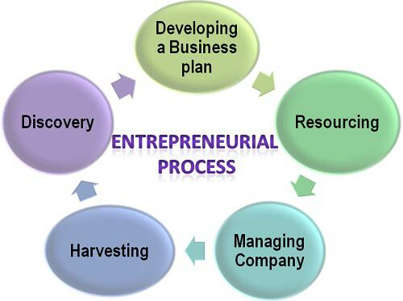

Potential Enterprises that are identified:-

* **Mushroom cultivation**
* **Nursery seedling**
* **Poultry farming**

An entrepreneurship on mushroom cultivation

* A mushroom is the fleshy, spore bearing fruiting body of a fungus, typically produced above ground on soil or on its food source.
* Mushrooms arte extensively in cooking, in mainly cuisines. Through neither meat nor vegetable, mushrooms are known as the “meat” of the vegetable world.
* Mainly cultivated species is- Plerurotus sajor-caju

**Economic intervention on mushroom production**

**Cost of Cultivation-**

The profit is earned Total number of cylinders= 800

Production per cylinder @ 1.5 kg average

Mushroom Produced = 1200 kg

Sell of Mushroom: 1200 kg@ Rs.55 = ₹ 66000

Net Profit= (Rs 66000- Rs 20000) = ₹ 46000

Percent Profit= (46000/66000) * 100= 67 %

Benefit Cost Ratio= 46000/20000 = 2.3

The Profit is earned within a period of 2 months

|  |  |  |
| --- | --- | --- |
| Material | Amount | Cost (₹) |
| Straw | 1600 bundles | 3200 |
| Spawn | 800 packet | 8000 |
| Labour | 5 no. | 1000 |
| Fungicide & Insecticide |  | 1600 |
| Polythene Packets |  | 1600 |
| Others |  | 4600 |
| Total |  | 20000 |

**Swot Analysis Of Mushroom Production In This Region**

|  |  |  |  |
| --- | --- | --- | --- |
| **STRENGHTS** | **WEAKNESS** | **OPPORTUNITIES** | **THREATS** |
| Abundance potential for product diversity in rural area | High dependency of rural income sources on Agricultural Activity | Development trends of mushroom industry | Changing trend in agriculture  Support policies |
| Rural labour potential | Low education level and low schooling ratio | Increasing tendency for demand of mushroom | Migration of young from rural  areas, loss of Productive factors |
| Low environmental pollution and existence of potential for organic farming | Inadequate of alternative Agril. Training & extension services. | Enhance opportunities to access Bhutan markets |  |
| Richness of Mushroom consumption culture |  |  |  |

**An Entrepreneurship On Plant Nursery**

* A nursery is a place where plants are propagated and grown to suitable size.
* Nursery may supply plants for gardens, for agriculture, for forestry and for conservation biology
* Plants generally found on this nursery are- Mango, guava, apple, litchi, jamun, ber, banana, roses, ornamental bulb plants, conifers, Ornamental shrubs, pine, sal, teak any many more.

**Economic intervention on plant nursery**

|  |  |
| --- | --- |
| Particular | Cost (₹) |
| Cost of Land | 120000 |
| Cost of Structure | 25000 |
| Cost of Seedling | Coconut@40 Rose@35 Pine@50, Grape@ 20, Dragon Fruit@80 , and many more |
| Cost Of Fertilizer | 3000@year |
| Cost of Pesticide | 800@year |
| Cost of Marketing | 4-5 |
| Cost of Labour | 200 @day@labour |
| Cost of Irrigation | 42@day |

* **For the marketing, the farmer sell to consumer @profit of** ₹**10-15 per plant**
* **B/C ratio is more than 1**

Beside those, the respondent farmer can earn up to ₹ 90000-100000 per year &also want to develop this business.

**SWOT ANALYSIS OF PLANT NURSERY IN THIS VILLAGE**

|  |  |  |  |
| --- | --- | --- | --- |
| **Strength** | **Weakness** | **Opportunities** | **Threats** |
| Experienced business unit | Small business unit | Venture capital | Growing competition and  lower profitability |
| High profitability and revenue |  | Growing Demand |  |
| Skilled workforce |  | New market |  |
|  |  | Growth rate & profitability |  |

**An entrepreneurship on poultry farming**

* Poultry farming is the process of raising domesticated birds like chicken for the purpose of farming meat for food. They are often called broilers.
* Meat chicken or broilers are reared indoor reach slaughter weight at 5-9 weeks of age.

Economic Intervention on Poultry farming

|  |  |
| --- | --- |
| Particular | Cost (₹) |
| Structure Cost | 145000 |
| Electricity cost | As per Season (1000-2500) |
| Cost of Chicks | Provided by company |
| Cost of feed | As per Age (5000- 12000) |
| Medicine | Provided by Company |
| Labour Cost | 250 @ Day |
| Insurance | 10000 |

* The respondent rear poultry in contract farming manner.
* Security Money- Bank Pass book, Cheque book, LAND RECORD, AGGRIMENT
* THE COST OF PRODUCTION IN WINTER SEASON IS RELATIVELY HIGHER THAN OTHER SEASON
* b/c ratio is more than 1

Beside those, the respondent farmer can earn upto ₹7000- 30000 Per 45 days (dependant upon season & other) after successful rearing

**SWOT ANALYSIS OF POULTRY FARMING IN THIS VILLAGE**

|  |  |  |  |
| --- | --- | --- | --- |
| **Strength** | **Weakness** | **Opportunity** | **Threat** |
| **Highest no. of chick production** | **Maintaining chicks quality** | **To sell more feed** | **Bird flu** |
| **Highest no. of Distributors** | **Maintaining feed quality** | **Sell grant parent** | **Neighbourhood**  **complain due to**  **bad odour** |
| **Sufficient no. of employees** | **Absent of strong distributor** | **Go for dress meat marketing** | **Increase in the**  **production Of**  **other companies.** |
| **Parent Stock** | **Late entrance in the feed marketing** |  |  |

**DISCUSSION**

* Organised entrepreneurship for commercial benefit not yet developed
* Practice of activities is scattered & concentrates a few household only
* These products are found to be used by producers for their own consumption i.e. marketable surplus was few available
* technical knowledge yet to be disseminated
* Demand & price of these product are not ascertain to them
* Package of production technology is not available in spite of kvk, university, state govt. initiative implies these villages is quite backward
* The farmer of this village follow traditional crop according to their available resources & technologies.

**CONCLUSION/SUGGESTION**

* Based on available info, it reveals that villages needs lots of attention from Govt, institute & other agencies for development of entrepreneurship in this village
* Besides, extension activity may be followed extensively to make the farmer aware about their skills, experience, resources for development of different entrepreneurship in a business mode
* in addition, farmer may take help of credit institutes, extension agencies to ensure marketing of their product

**FUTURE PROSPECTS**

● Apiculture

● Production of organic product (vermicompost)

● Selling fresh eggs

● Tea gardening

● Fishery

● Dairy production

● Food processing unit

1. **SUMMARY, CONCLUSION and SUGGESTIONS**

Findings of RAWE study which have been obtained from participatory techniques has delivered some useful information in respect of various socio-eco-technological aspects in the area under study. The information have been generated by adopting PRA and Field Study technique. These information will be helpful for adopting a long term strategy for overall growth of the village. Followings are some the salient findings :

1. **Social Aspects :**

►The area is exclusively agriculture oriented. Agriculture is the main sources of livelihood.

►Except few, majority of the villagers belong to small and marginal categories of operational farming.

►The area has school (primary and high), Farmers’ Club, SHG, Health centre, Market etc..

►Education level ranges from literate to graduation.

►Migration is witnessed to different places of the State (Siliguri & Kolkata) and country (Rajasthan, Delhi, Assam, Gujarat, Maharastra, etc.).

►Social compactness and awareness are satisfactory.

►Road (muddy and concrete), electricity, training centre are more or less available.

► Local MLA and Panchayat officials are frequently keeping contact with the farmer.

1. **Economic Aspects :**

►Agriculture is the main sources of income/livelihood.

►Land holding is very small and thus, follow diversified farming as well as cropping.

►Inadequate natural resources like water, forestry, etc.

►Very few people have service (Govt. & teaching) and business (shopping).

►Plantation crops, Fishery, Fruits, Livestocks, etc. are also practiced as secondary sources of income.

►Very few landless persons earn through casual labour.

►Labour becomes a problem during peak harvesting season.

►Marketing of agricultural products are done in either Jateswar market or Falakata market

► Earlier, a few agricultural produce were sent to Sikkim and Bhutan. But due to emphasis on organic products, this marketing facility is restricted.

1. **Agricultural Aspects :**

► Technological gap (yield, input application, etc.) was observed for all respondents.

► Climate is hot and humid but enjoying sufficient rainfall. Soil is fertile but little bit of acidic.

►Main cash crops are Paddy, Jute, Maize and Vegetables.

►Plantation crops, Fishery, Fruits, Livestock, etc. are also practiced as secondary sources of income.

►Good evidences of crop diversification and bio-diversity.

►Apiculture with wild variety of Bee are being naturally practiced.

►Received little technical guidance from Agril. Deptt., Govt. of WB

►Water table is high for irrigation by diesel pump.

►No processing units for agricultural products are available.

►Cropping Intensity is nearly 209%.

►Occurrence of usual pests and diseases have been observed.

►Encouragement for using organic manure through compost, vermicompost are increasing.

►Adequate knowledge of modern agricultural technology is needed.

►Marketing of agricultural products are done in Jateswar market or Falakata or even sometimes though less through middlemen.

► Horticultural crops may be given more emphasis.

► Farmers have shown to adopt new crop/enterprises if facilities are provided.

1. **Agriculture : Lab-vs-Land – at a glance**

The lessons on technical aspects of agriculture which have been studied at the University for last three and half years have been brought out to have an idea about the level of technological adoption or differences at the respondent-farmers field.

|  |  |
| --- | --- |
| **Technologies** | **Observations** |
| Scientific package of practices | Scientific and traditional |
| Knowledge of modern technology | Moderate |
| Sources of modern technology | Neighbour, Farmers’ Club, KVK & Mass Media |
| Sources of planting materials | Self produced or procured from middlemen |
| HYV | Local and HYV |
| Technical advice | Neighbour, Farmers’ Club, Govt., CADC and UBKV |
| Disease and pest management | Traditional or sellers of pl. protection chemical |
| Soil testing | Very seldom done (not done for last one year) |
| Use of organic manure | Increasing trend |
| Conservation technology | Awareness appearing |
| Impact of climate change | Not significant |
| Diversification | Encouraging |
| Technological gap | Existing |
| Interest for new technology | Increasing |

***SUGGESTIONS FOR AGRICULTURAL IMPROVEMENT:***

From the above findings, followings may be suggested/recommended for agriculture as well as overall development of the village Hedayetnagar of Alipurduar district. These recommendations have made on the basis of the views of the respondent-farmers.

► Necessary action for bridging up of technological gap through the appropriate intervention of research institute, Govt., KVK, NGO, NABARD, etc.

► Seed treatment should be taken up as a routine job to control crop diseases.

►Alternative employment opportunity be made through investment in processing unit or agro-industry sectors.

►Training & demonstration on modern agricultural technology may be conducted regularly.

►Emphasis on high value and quality crop production through integrated farming system.

►Efficient input supply (seed, fertilizer, plant protection chemical, etc.) mechanism.

►Diversification of crop as well as farm be followed.

►Set up of more Farmers’ Club, SHGs, etc. be initiated.

►Investment in agro-based industry from both Govt. and private sectors may be attempted.

►Arrangement for encouraging organic farming (bio-fertilizer, vermicompost, etc.).

►Technology of conservation agriculture be introduced.

►Integrated disease, pest and nutrient management be encouraged.

►Popularization of Bio-control measure be started.

►Awareness be developed to mitigate impact of climate change.

► Identification and scope for investment on new entrepreneurship like mushroom, beekeeping, livestock, etc. may be considered.

►Arrangement and awareness of institutional credit facilities in easy terms and conditions be made.

It may, thus, be concluded that there is an immense potentiality to improve agriculture in the area where RAWE programme was conducted. The village is situated not in a remote place and enjoys good agro-climatic environment. Villagers are very nice and cooperative too. Practical constraints and opportunities are also noted down for further analysis. The students learnt a lot through field visits and field day, interaction with the villager-farmers, attending various gatherings and demonstration. The gap of technological aspects between the research station/University and the field has been adequately explained by our teachers. Existence of NGO and CADC add more fruitful impact on the learning process.

In fact, on the basis of information through PRA and Field Study, some recommendations have been put forward. If these recommendations are followed in association with Govt., NGO, Financial Institutions, Research Station/University, the productivity and quality will be increased. Besides, initiative must be taken up immediately to find out feasibility of setting up few entrepreneurship which, in turn, will upgrade the livelihood status and quality of life of the people.

Lastly but not least, after attending this RAWE programme, students will be confident to assess the whole agricultural scenario in the area under study from technical, social, environmental and economic points. They could gather knowledge and exposure to contribute towards development of agriculture and allied activities. In fact, there is always scope for further improvement since agricultural education like other technical educations is a dynamic in nature. This is the essence of RAWE programme which every student have enjoyed and got benefitted the learning process through this participatory approach as well as practical exposer.